**SUBMITTED TO**:

PROFESSOR STANLEY UKAH

**Test Execution Document**

**SUBMITTED BY GROUP 1**:

AKRITI SINGH – 126774207

afreen – 142851211

Afaounodden Ahmed Mohammed – 104492210

RINI GEORGE- 137051215

**LOGIN**

|  |  |
| --- | --- |
| Test Case ID: TA1 | Test Result: Passed |
| Details: Password should not be blank | |

UserID filed is not entered:

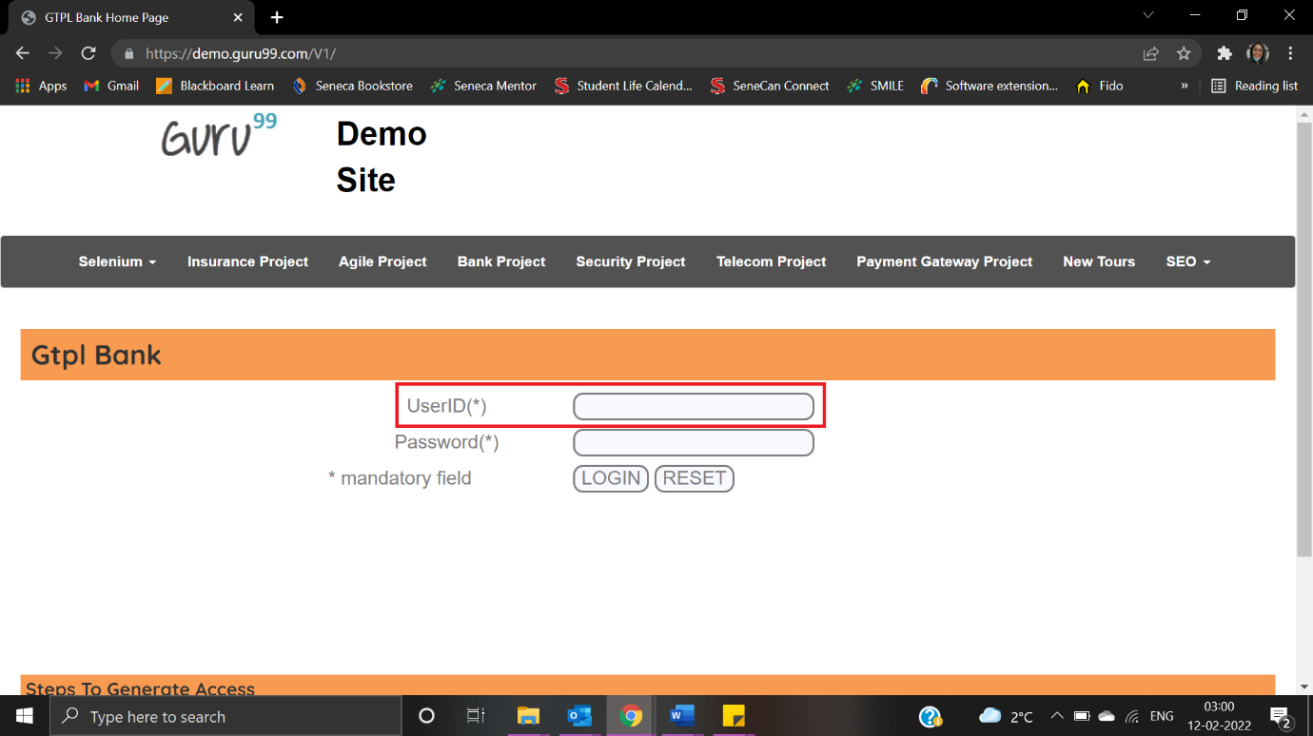

Error message is displayed as “User is not valid”:

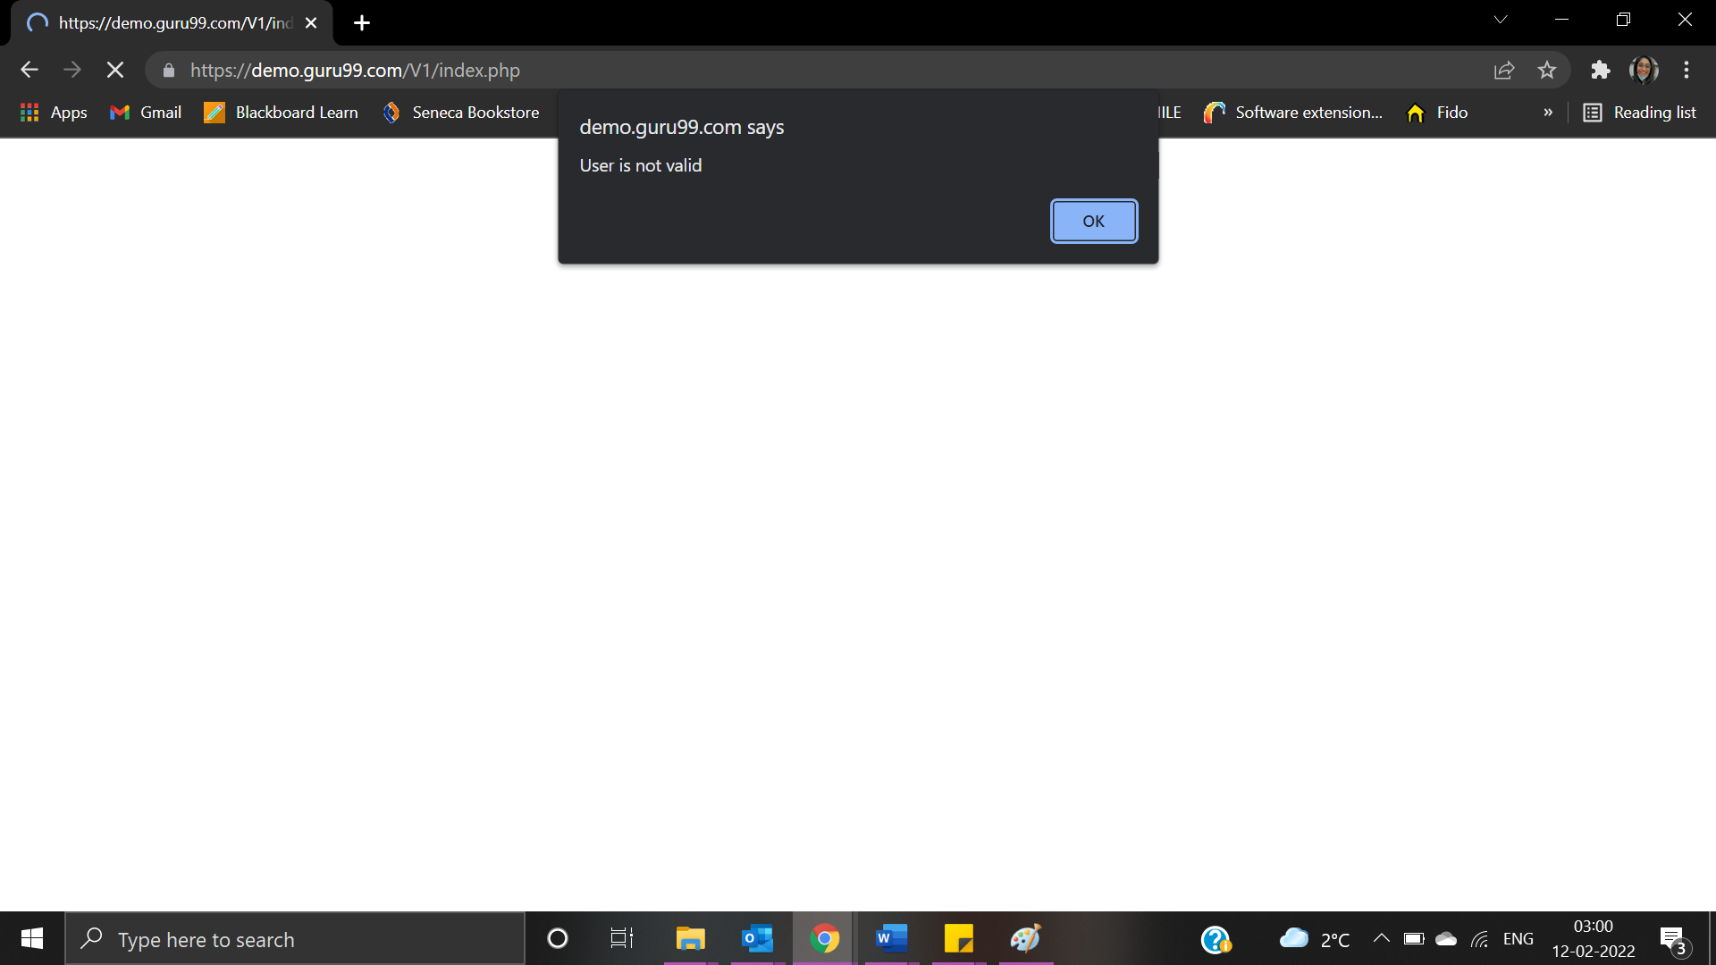

|  |  |
| --- | --- |
| Test Case ID: TA2 | Test Result: Failed |
| Details: Password should not be blank | |

Password field should be left blank:

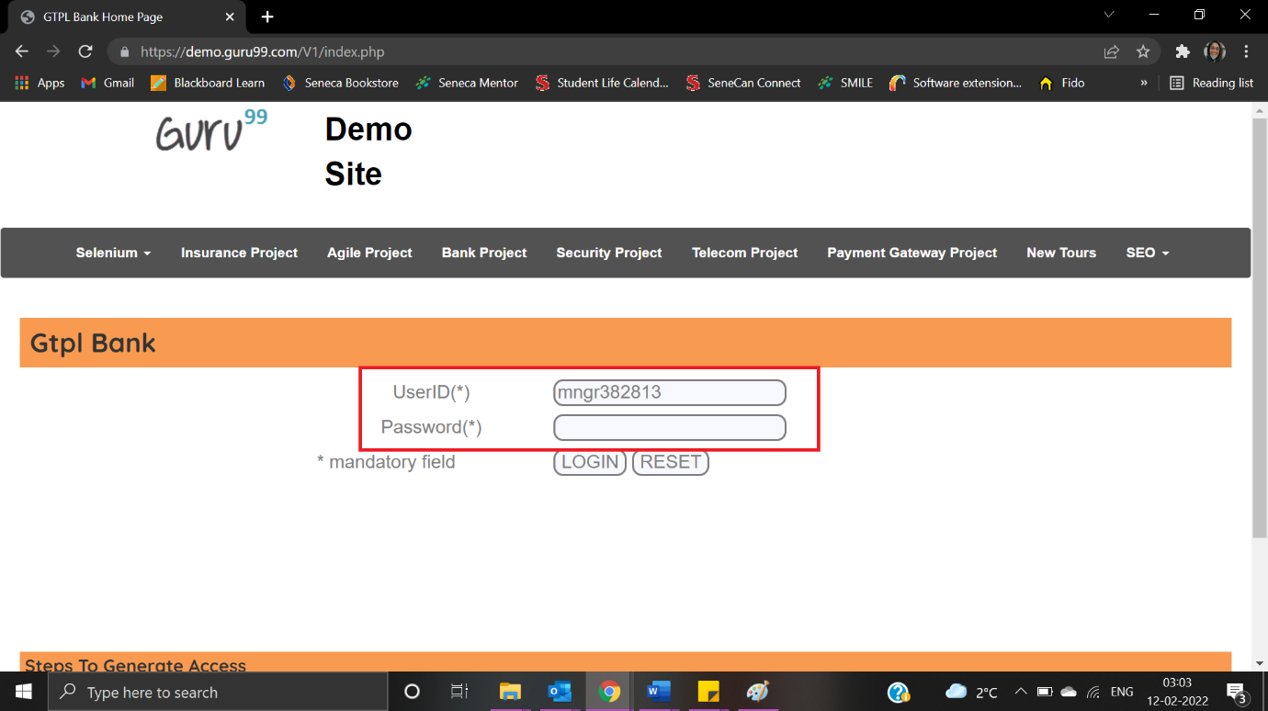

Password is not valid message is not displayed:

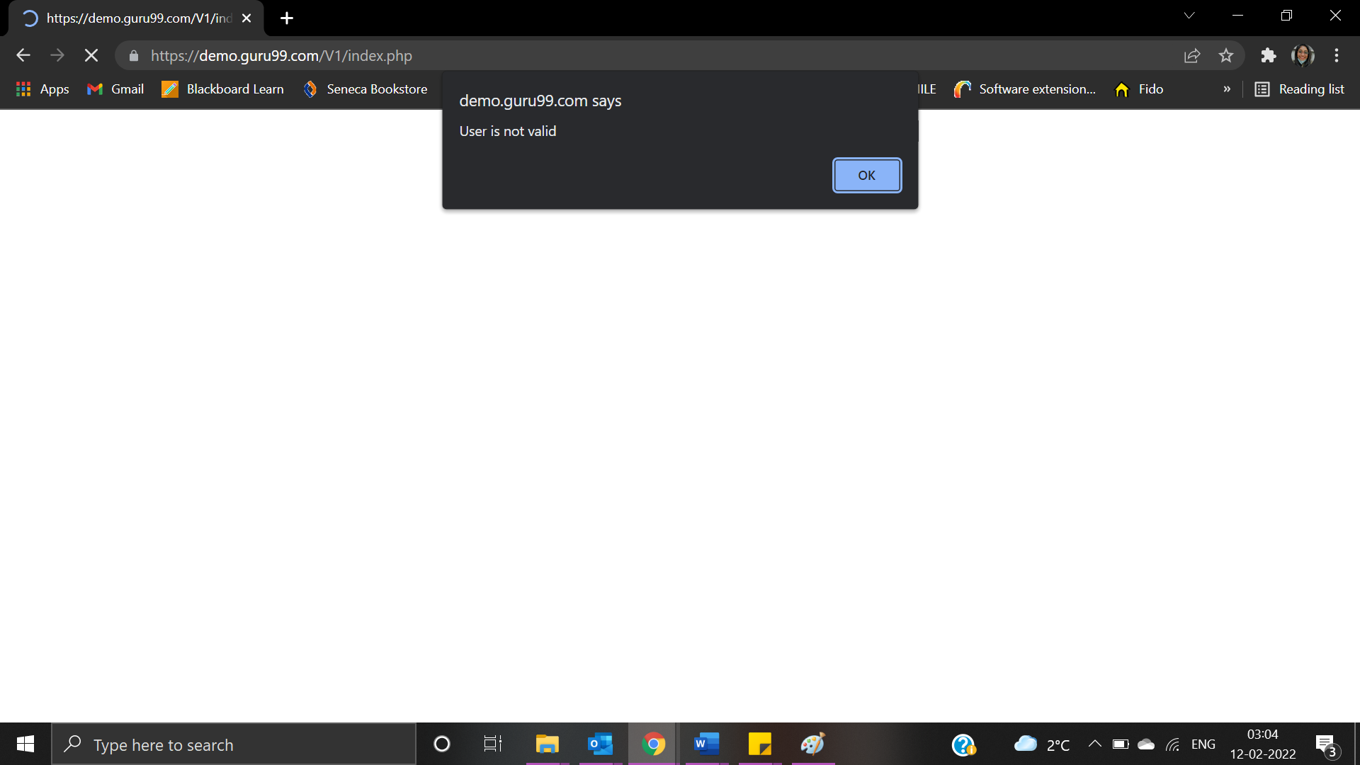

**New Account**

|  |  |
| --- | --- |
| Test Case ID: TNA1 | Test Result: Failed |
| Details: Customer ID is required | |

User clicks on New Account:

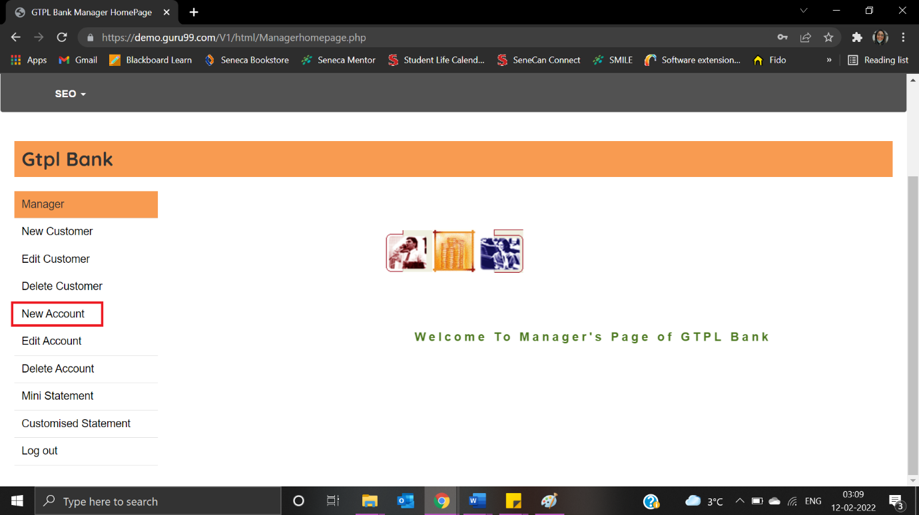

The new account form page is displayed up:

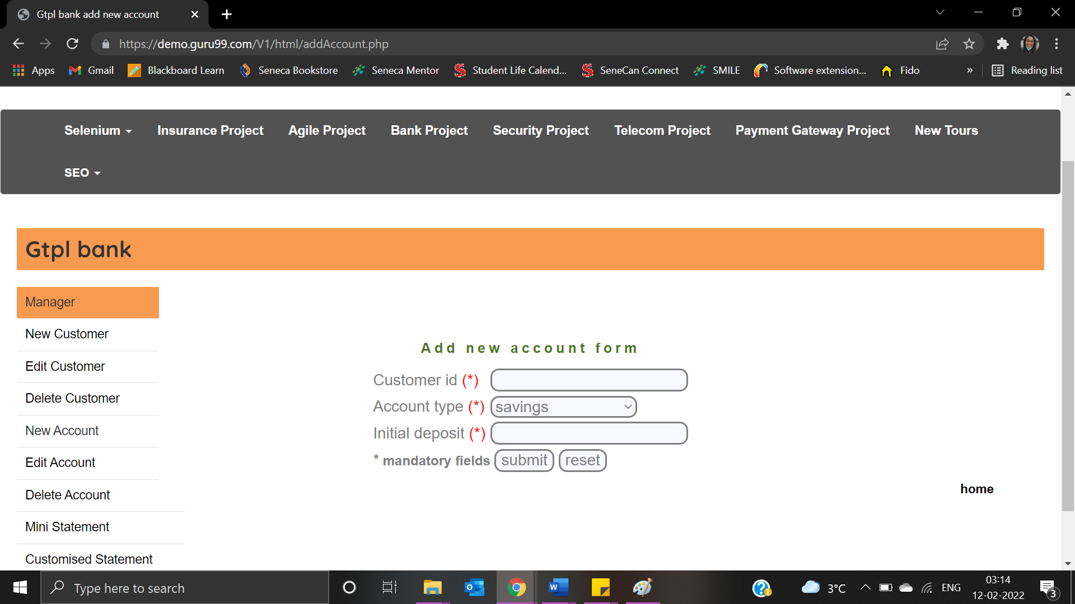

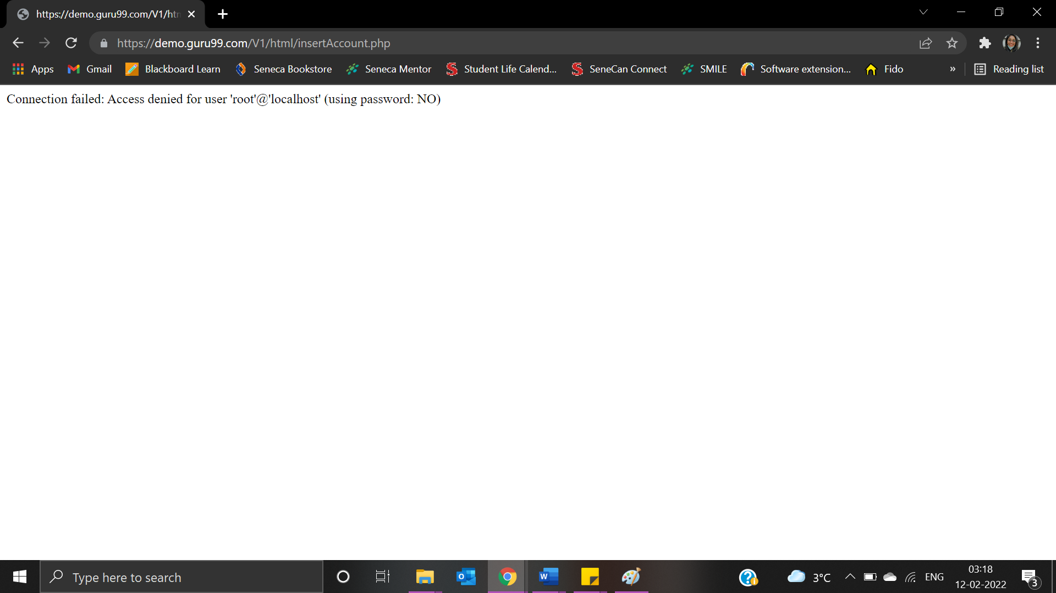

|  |  |
| --- | --- |
| Test Case ID: TNA2 | Test Result: Failed |
| Details: Special characters are not allowed | |

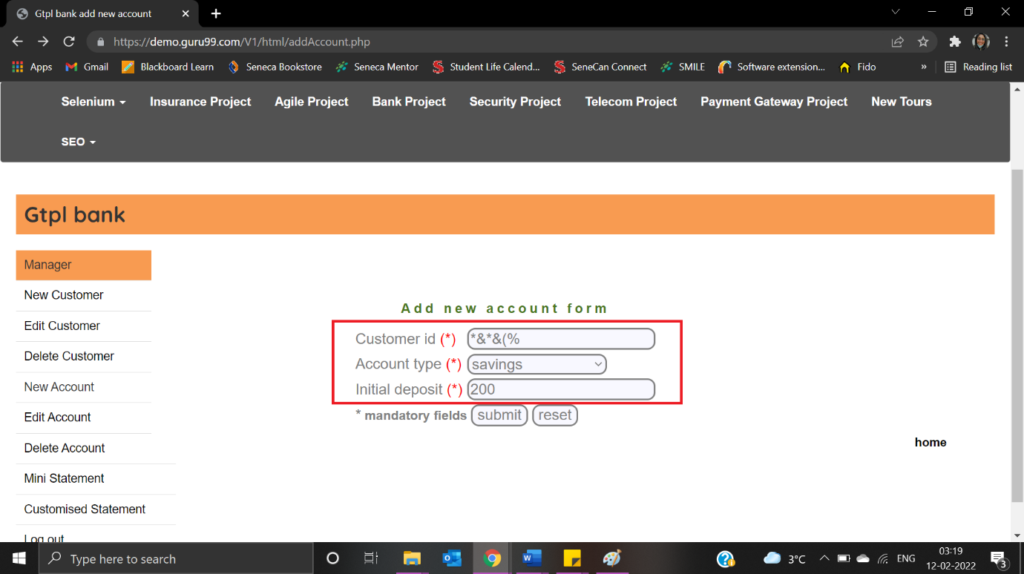

The expected result “Not valid Customer ID” is not displayed:

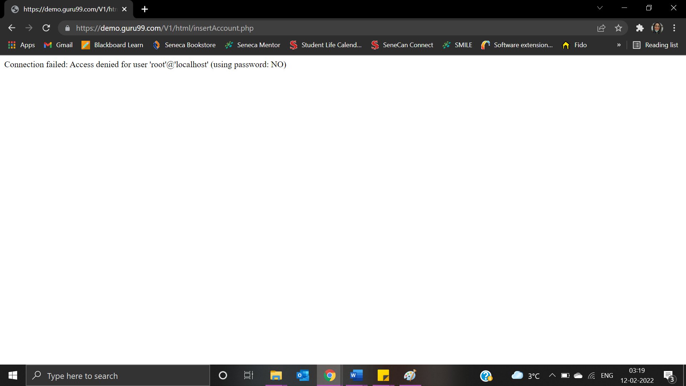

|  |  |
| --- | --- |
| Test Case ID: TNA3 | Test Result: Failed |
| Details: Characters are not allowed | |

User enters “Test” as Customer ID:

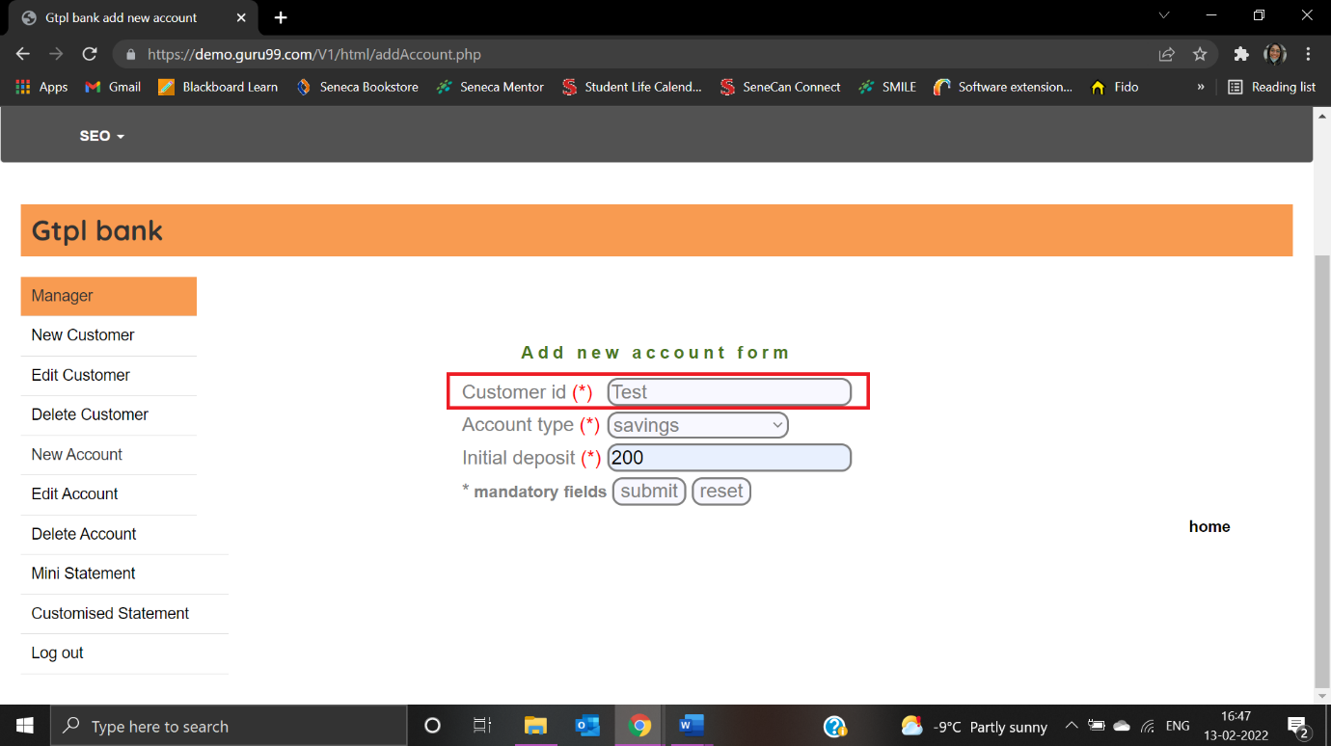

The expected result “Not valid Customer ID” is not displayed:

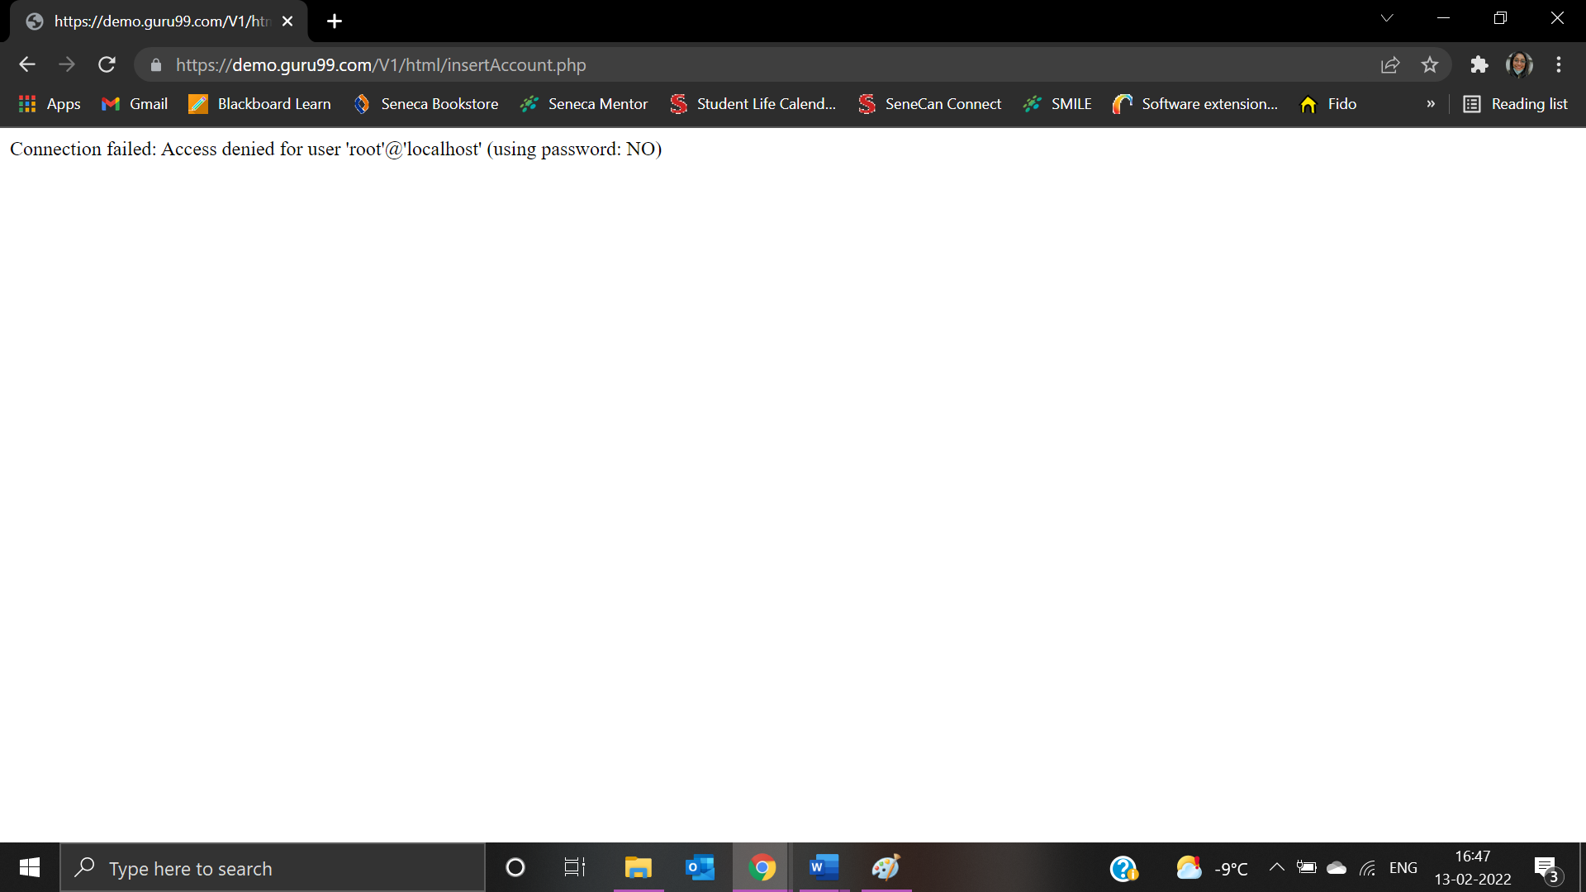

|  |  |
| --- | --- |
| Test Case ID: TNA4 | Test Result: Failed |
| Details: The first character cannot have space | |

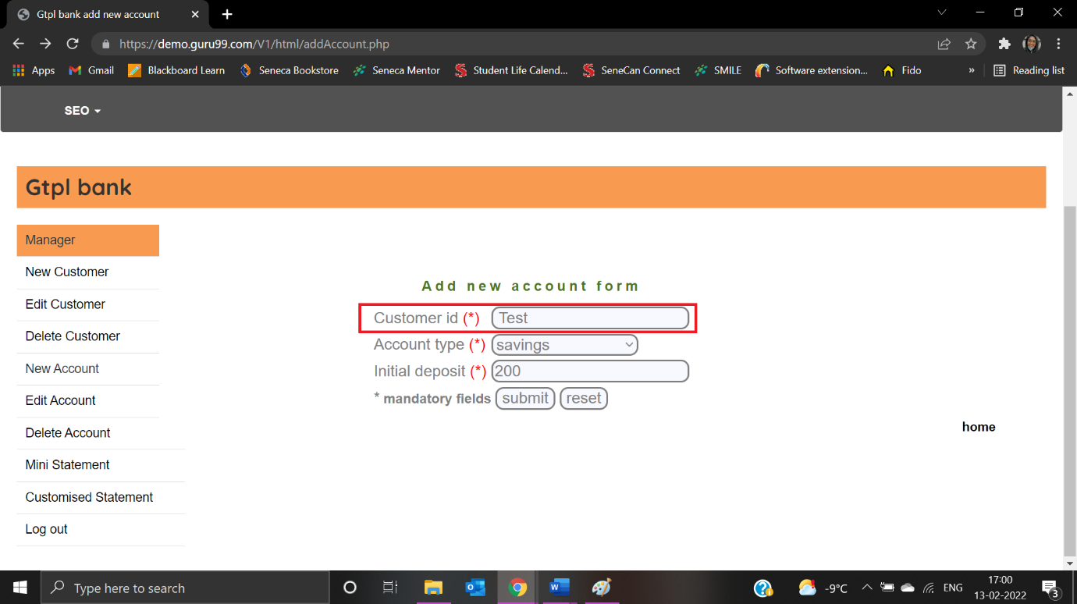

The expected result “Not valid Customer ID” is not displayed:

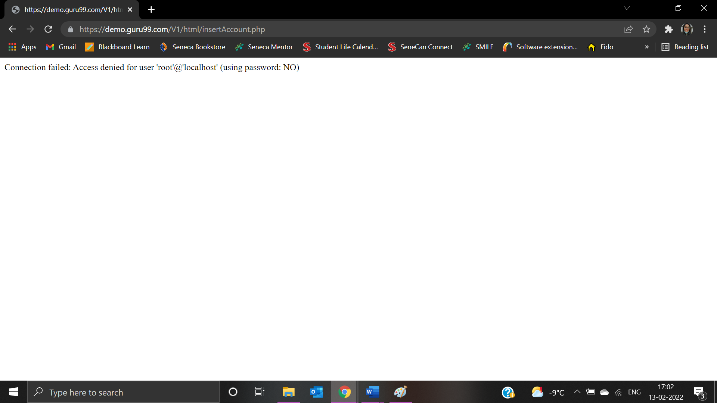

**New Customer**

|  |  |
| --- | --- |
| Test Case ID: TNC2 | Test Result: Passed |
| Details: Numbers are not allowed | |

User clicks on “New Customer”:

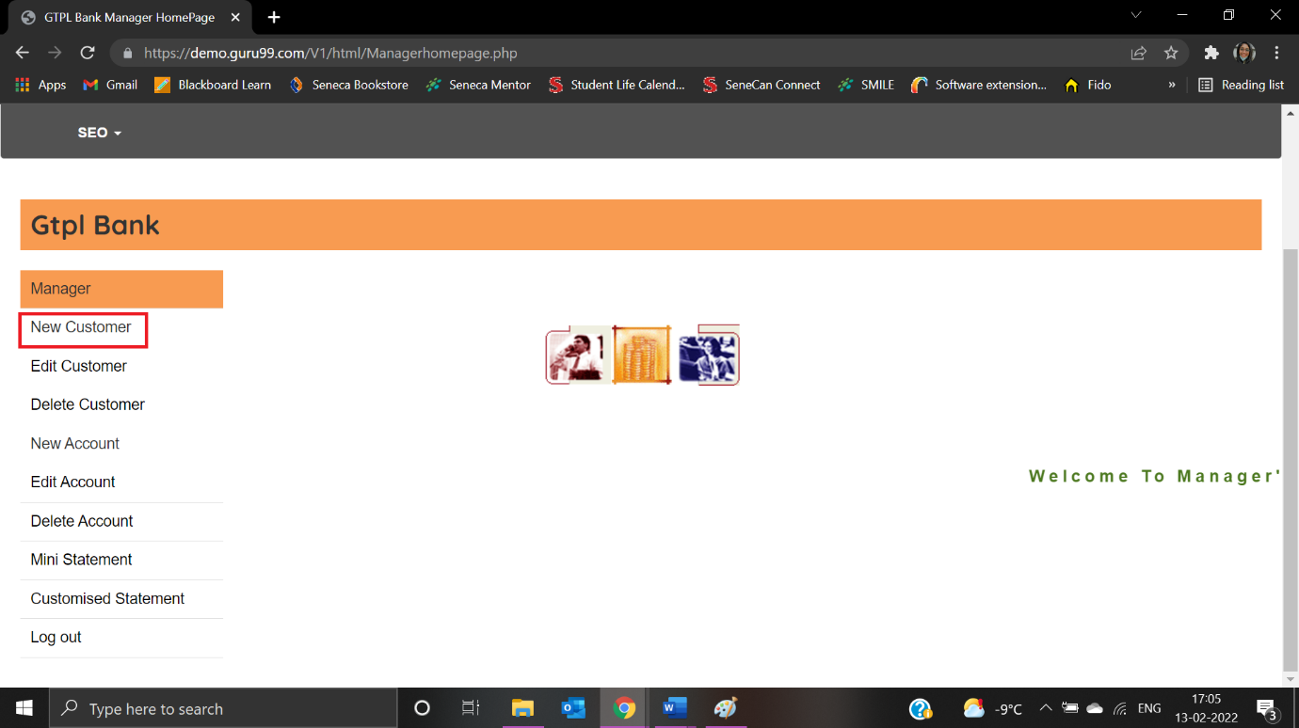

User is navigated to the New Customer page:

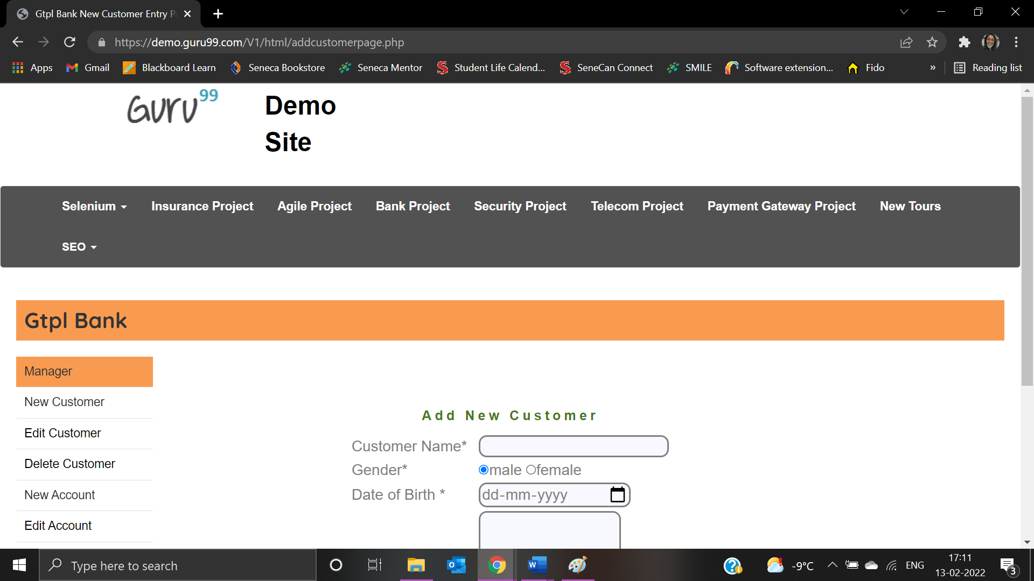

User enters a number in Customer Name and error message “Numbers are not allowed”:

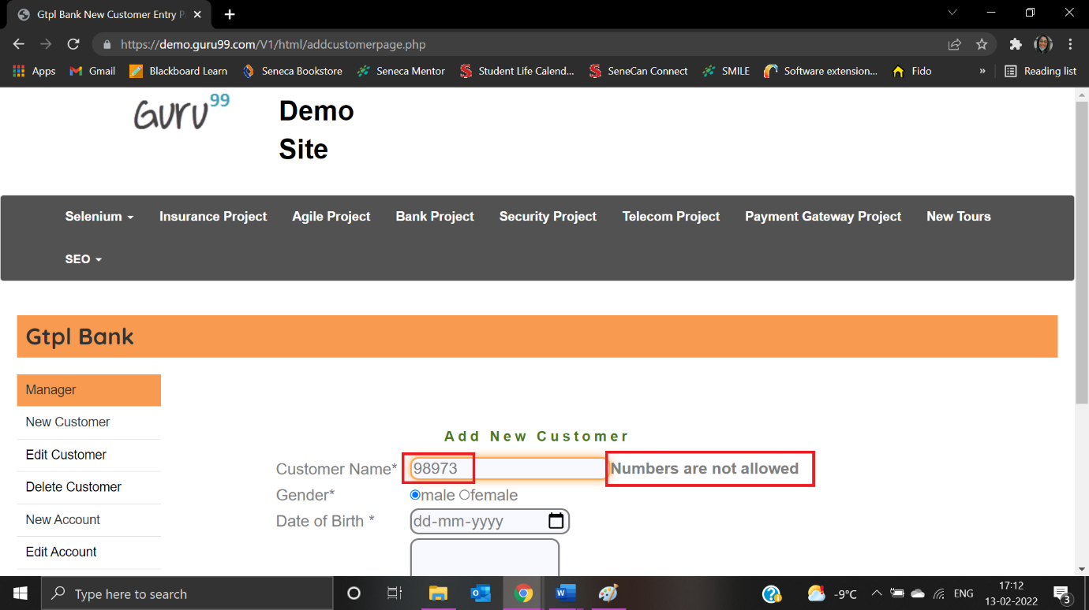

|  |  |
| --- | --- |
| Test Case ID: TNC4 | Test Result: Passed |
| Details: Special characters are not allowed | |

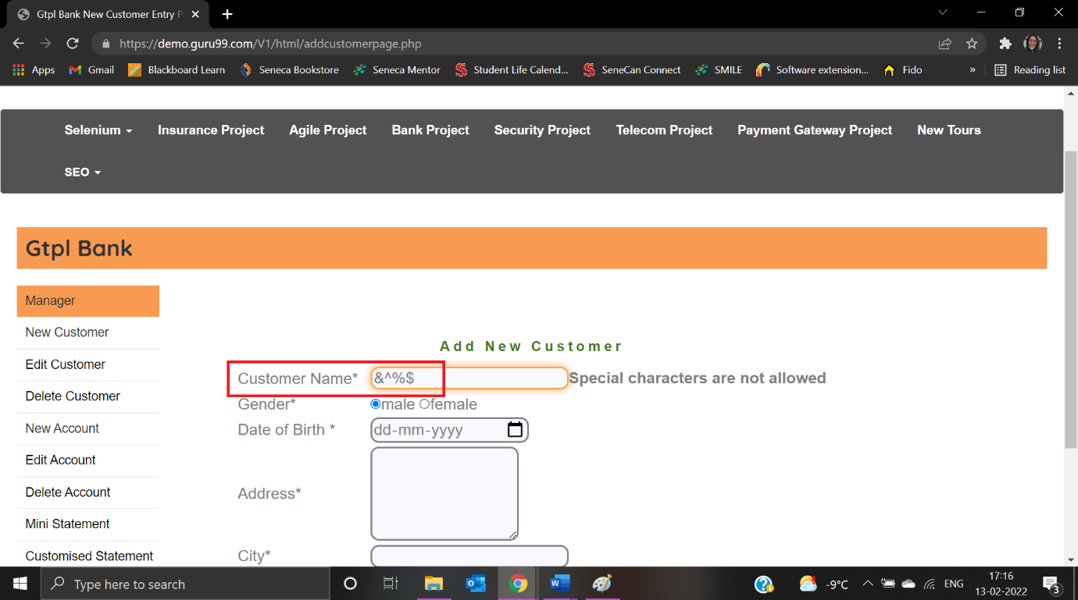

“Special Characters are not allowed” is displayed:

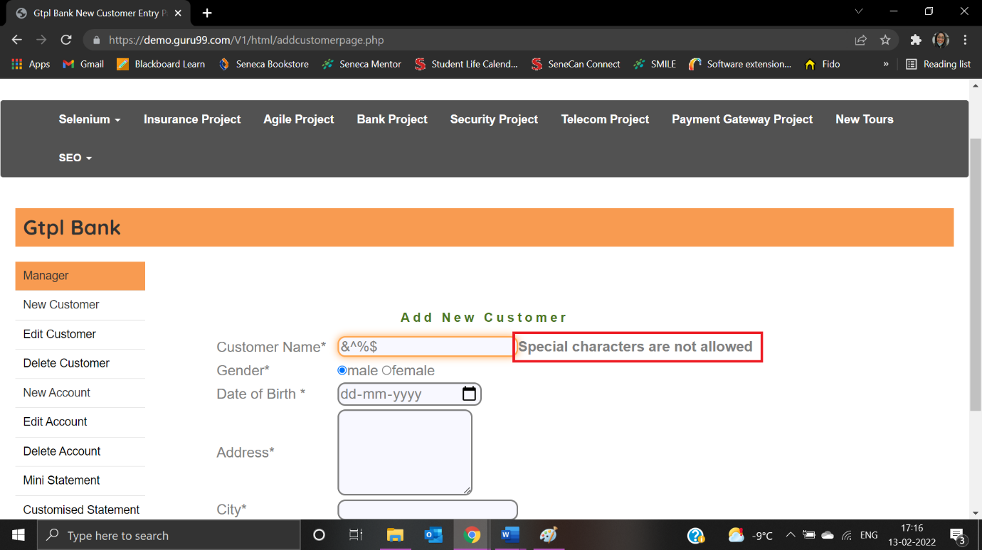

|  |  |
| --- | --- |
| Test Case ID: TNC1 | Test Result: Passed |
| Details: Customer name must not be blank | |

Customer Name is not entered:

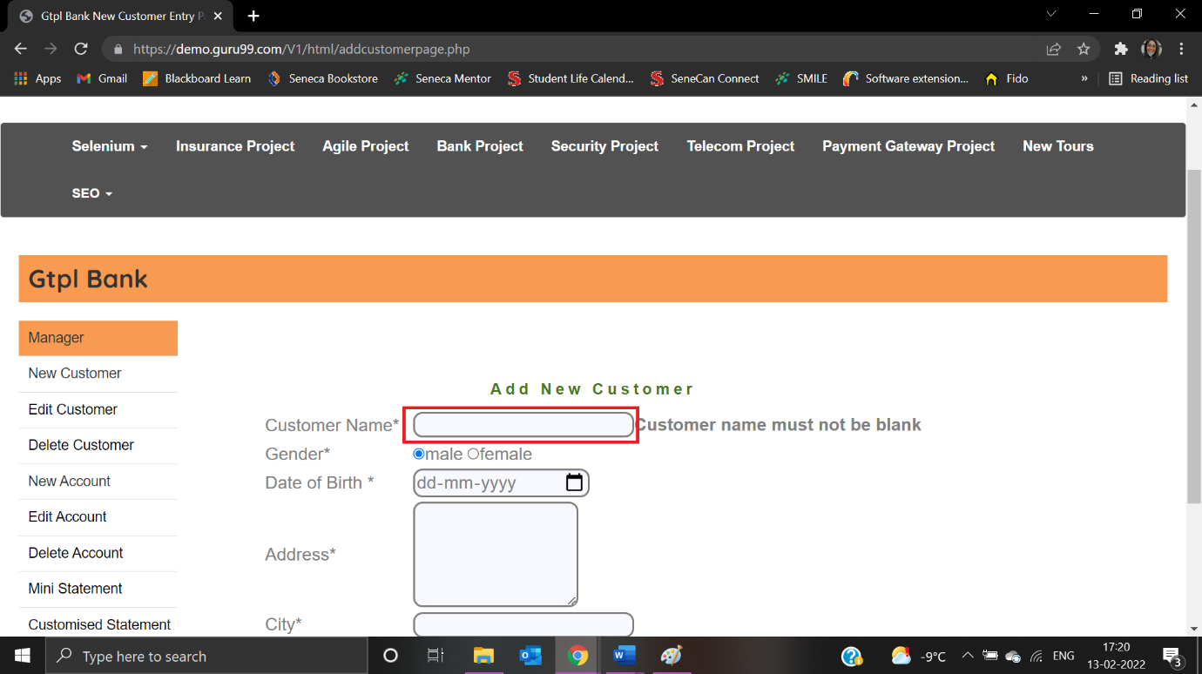

“Customer name must not be blank” is displayed:

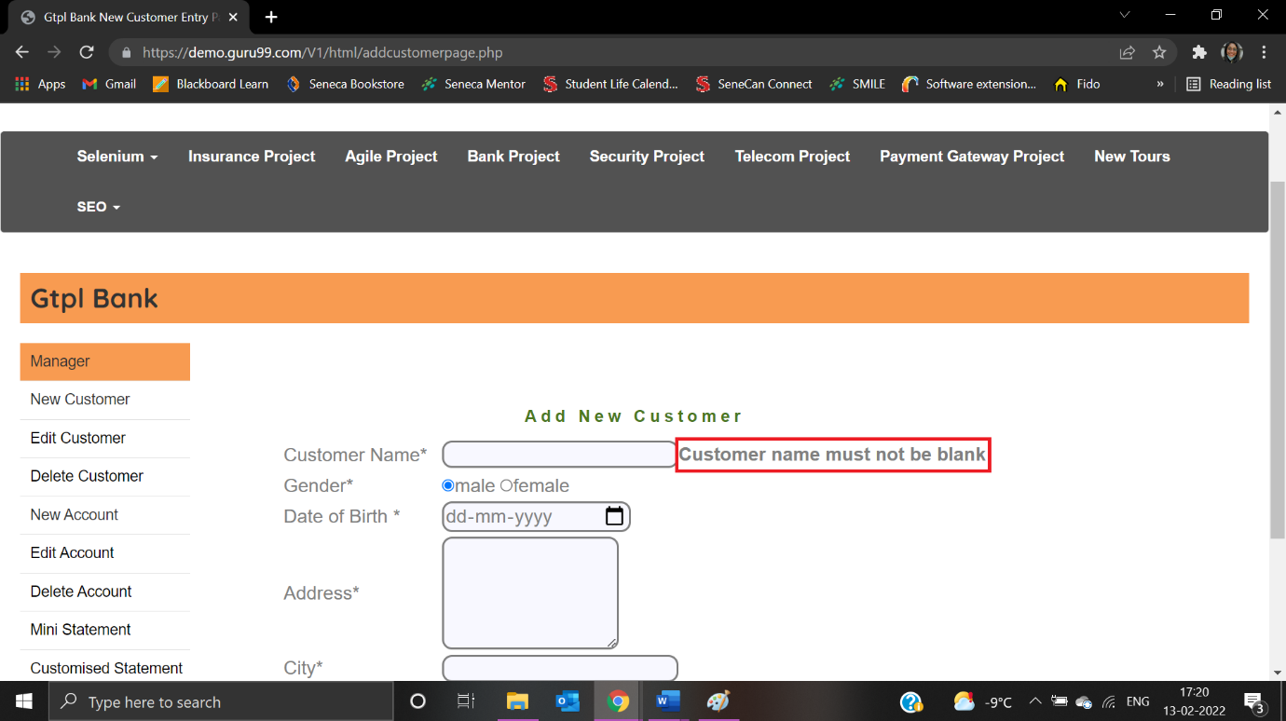

|  |  |
| --- | --- |
| Test Case ID: TNC3 | Test Result: Failed |
| Details: The first character cannot have space | |

User enters the first character as space:

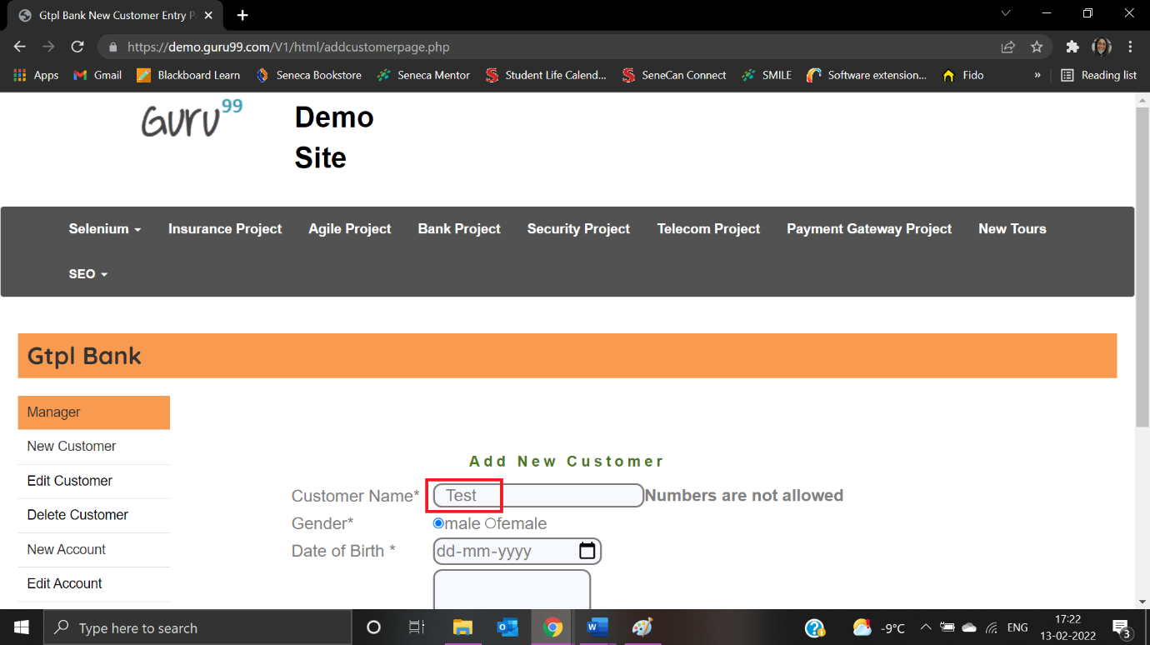

Error message is not appropriate:

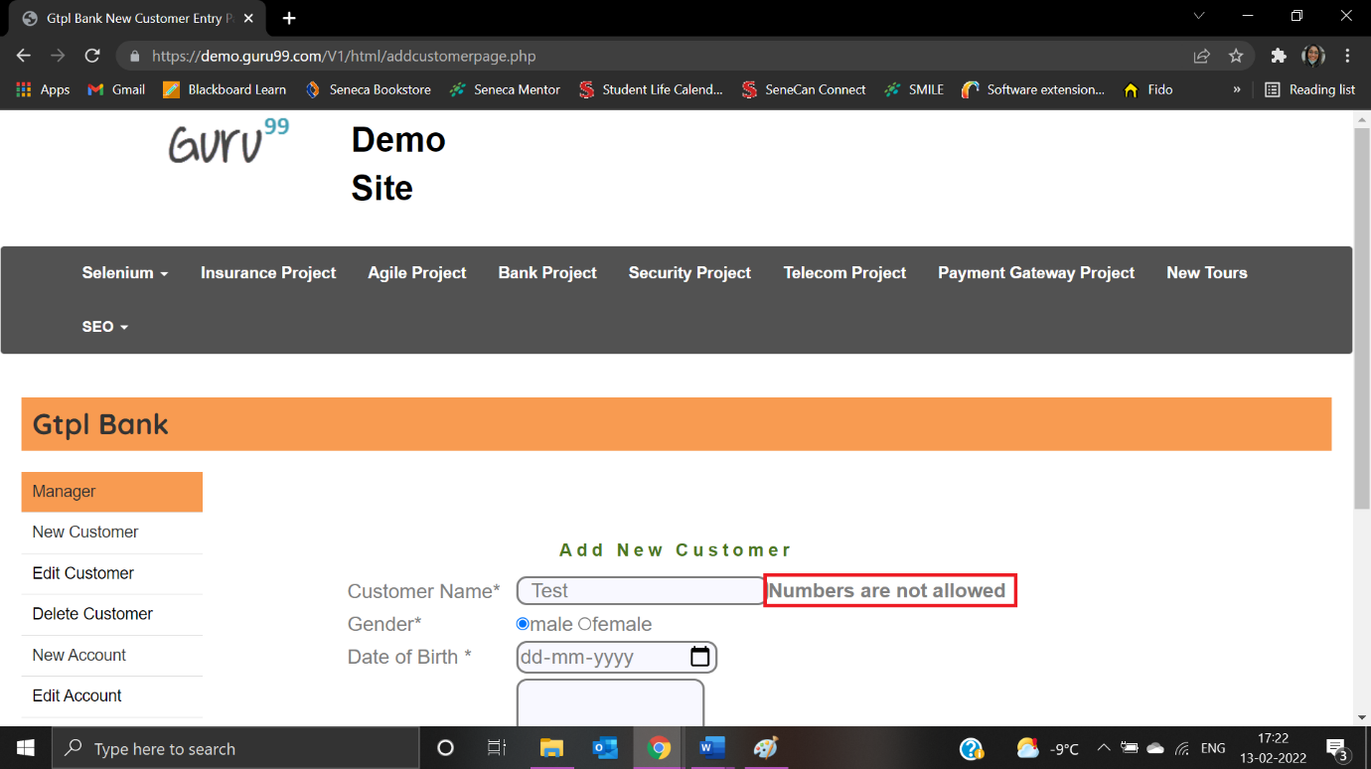

|  |  |
| --- | --- |
| Test Case ID: TNC5 | Test Result: Failed |
| Details: Address Field must not be blank | |

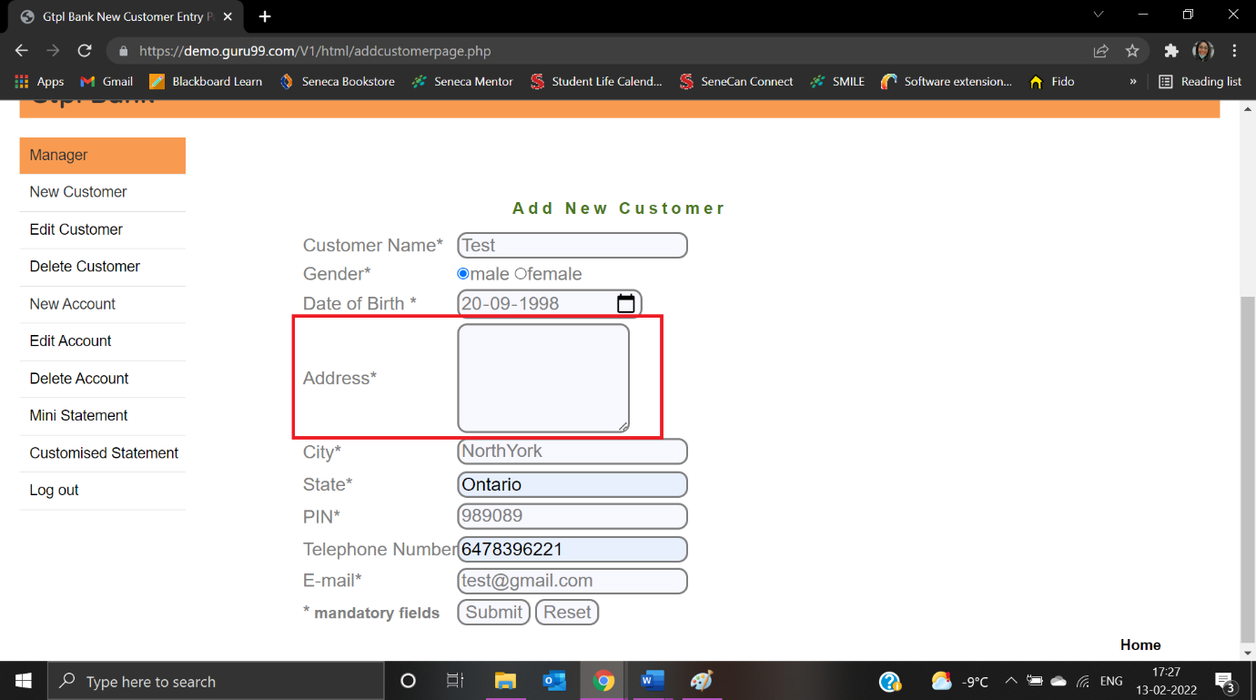

The error message is not displayed:

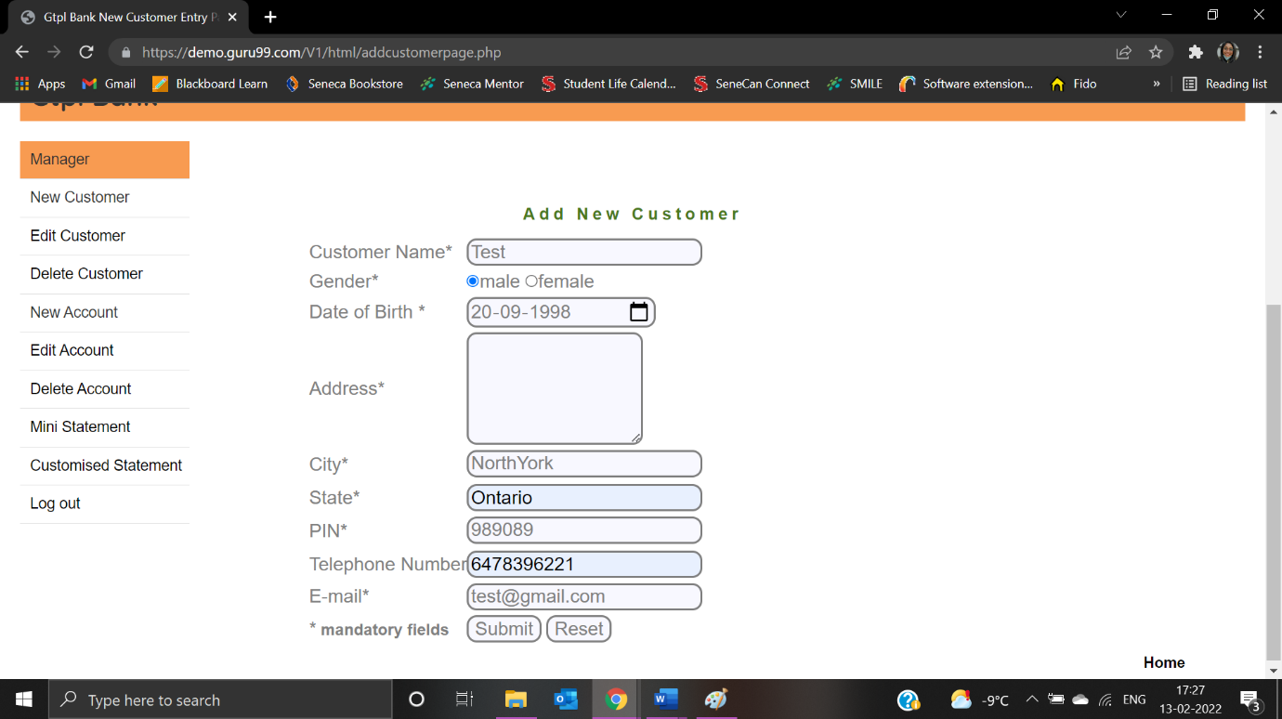

User doesn’t receive any message when clicked on submit button:

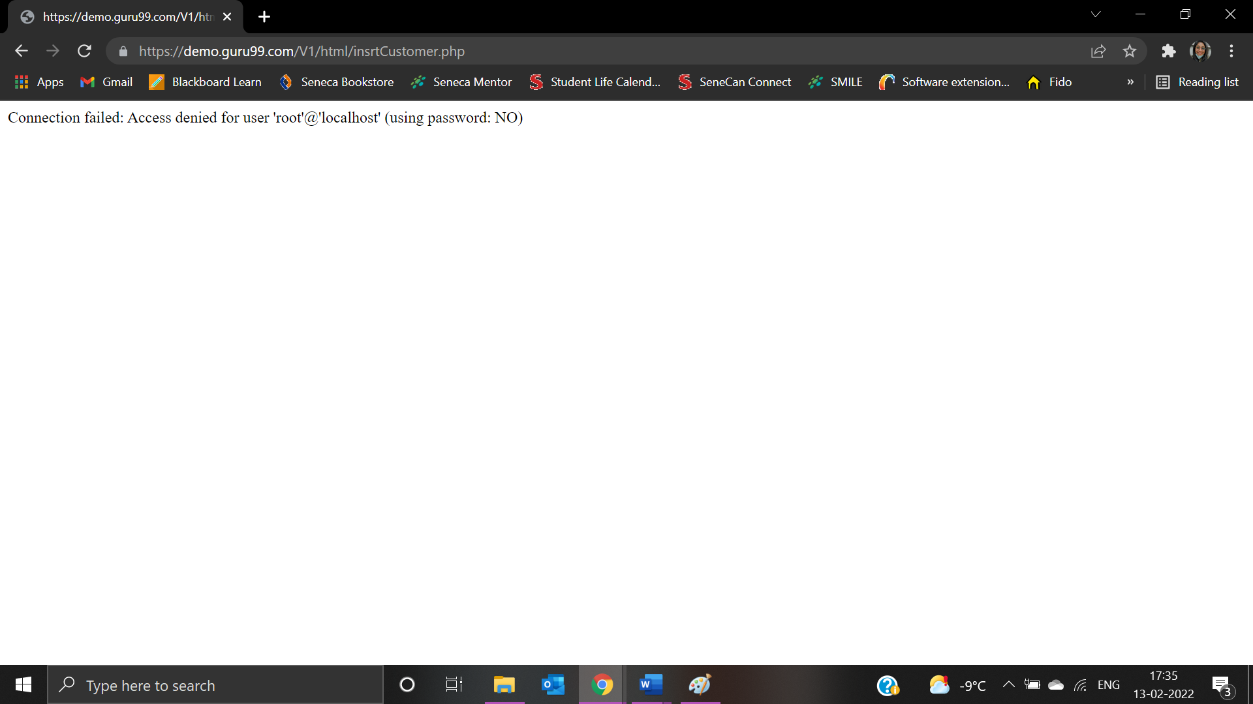

|  |  |
| --- | --- |
| Test Case ID: TNA1 | Test Result: Failed |
| Details: The first character cannot have space | |

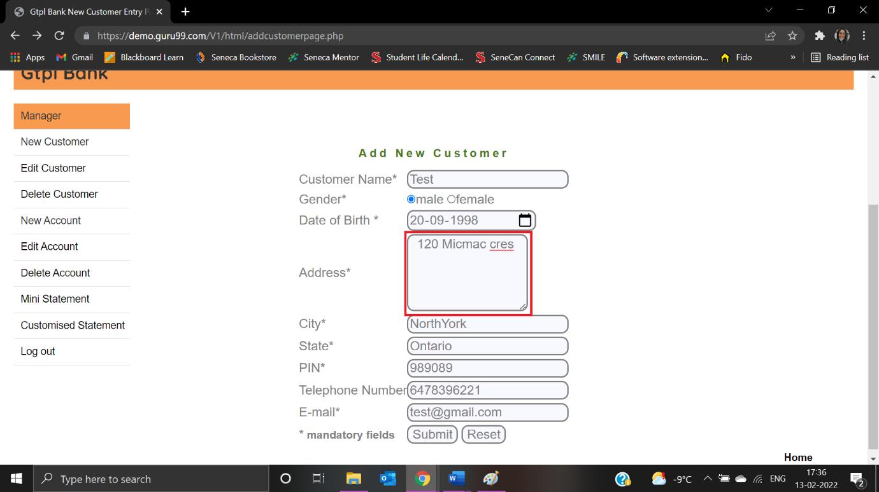

Error message is not displayed:

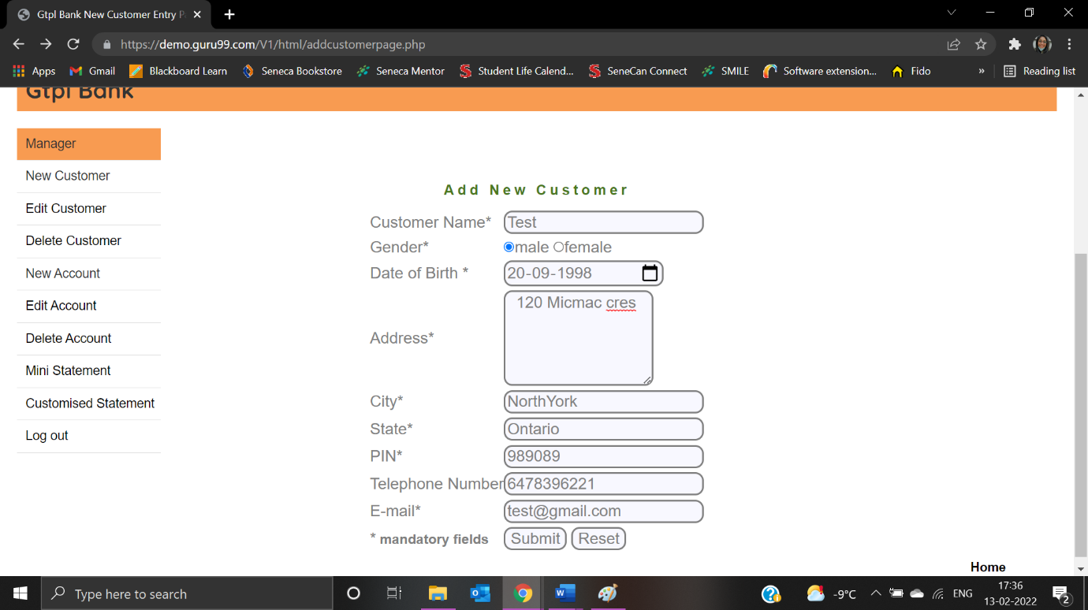

The user doesn’t receive any message when clicked on submit button:



|  |  |
| --- | --- |
| Test Case ID: TNC6 | Test Result: Failed |
| Details: Special characters are not allowed | |

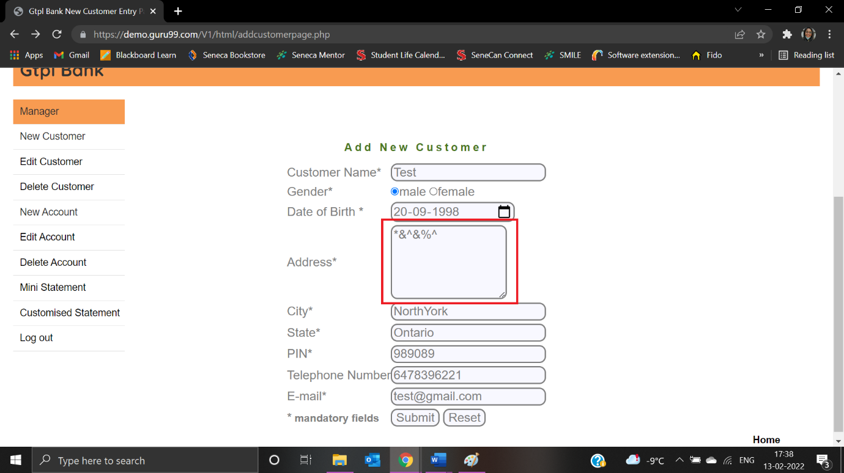

Error message is not displayed:

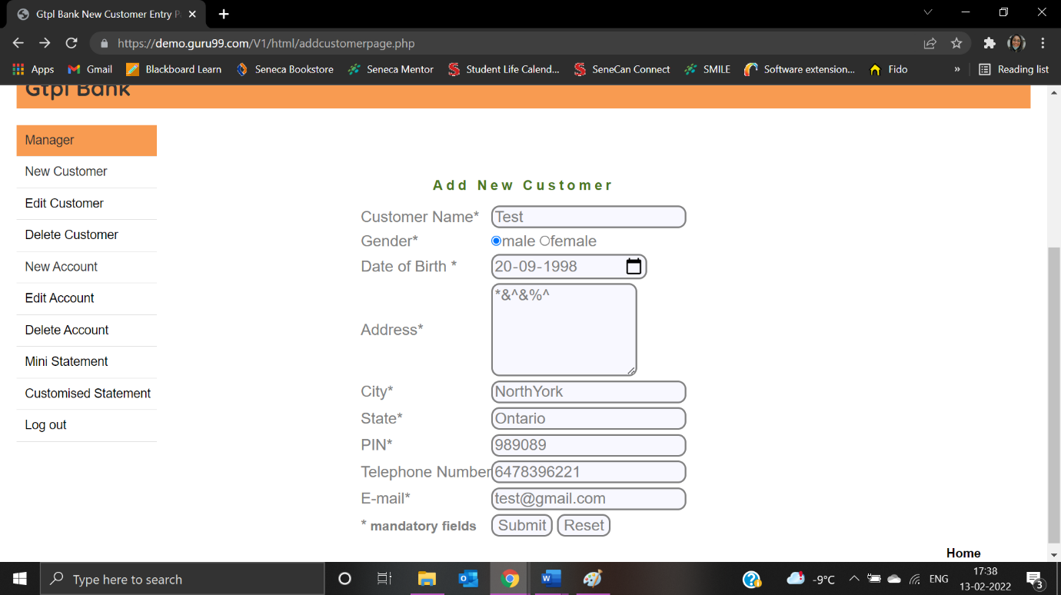

The user doesn’t receive any message when clicked on submit button:



|  |  |
| --- | --- |
| Test Case ID: TNC8 | Test Result: Passed |
| Details: Special characters are not allowed for city | |

User enters special characters for city:

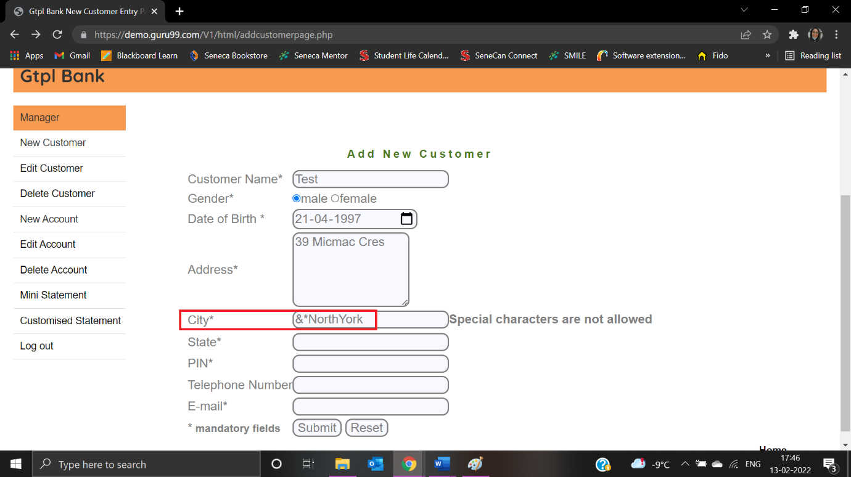

Error message is displayed:

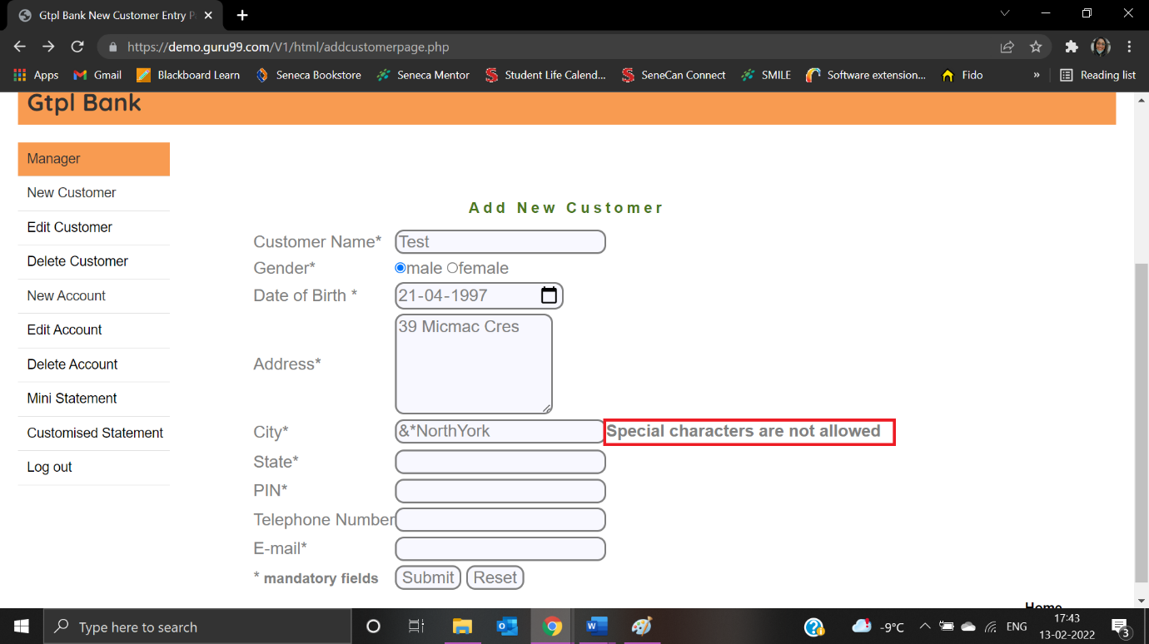

|  |  |
| --- | --- |
| Test Case ID: TNC7 | Test Result: Passed |
| Details: City Field must not be blank | |

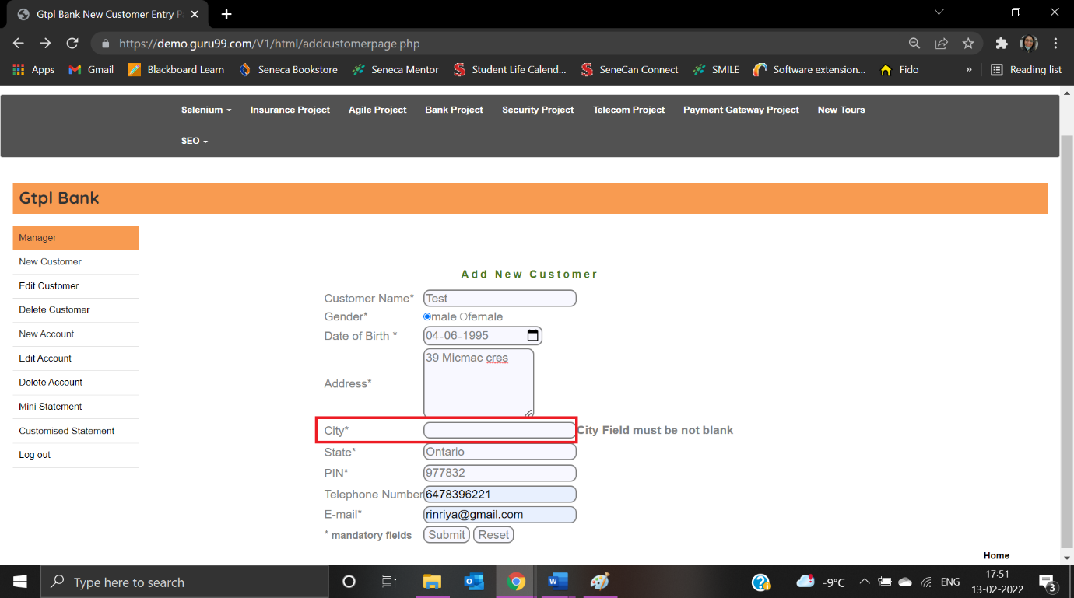

Error message is displayed:

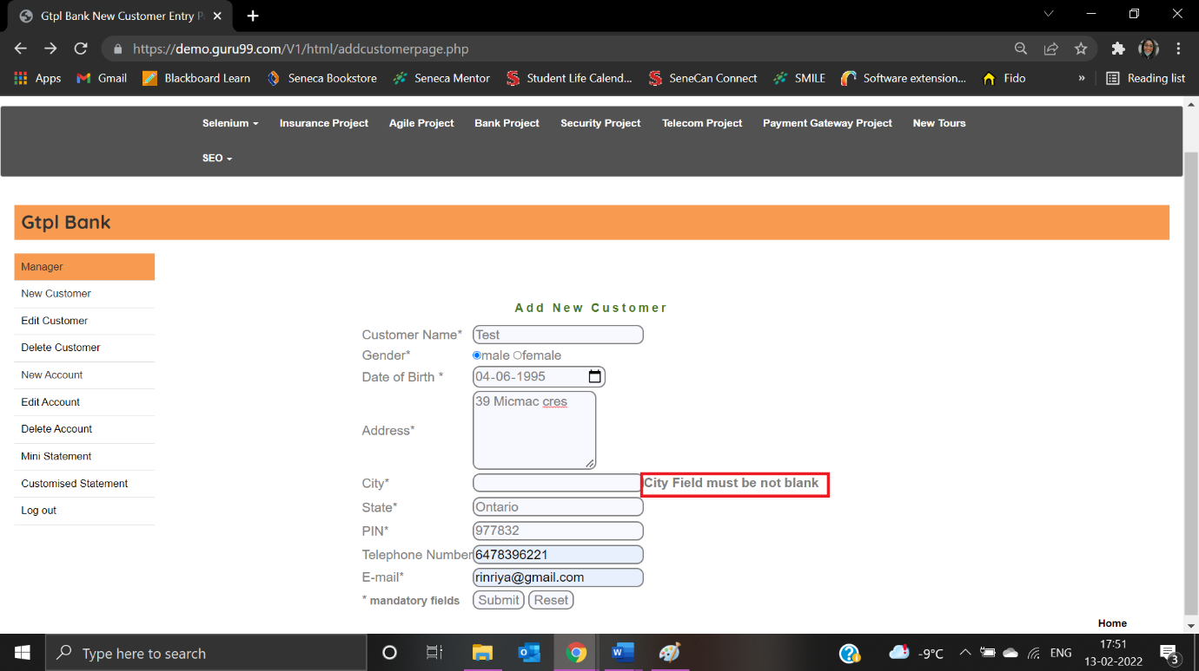

|  |  |
| --- | --- |
| Test Case ID: TNC9 | Test Result: Passed |
| Details: City Field must not contain Numbers | |

Users enter numbers in the City field:

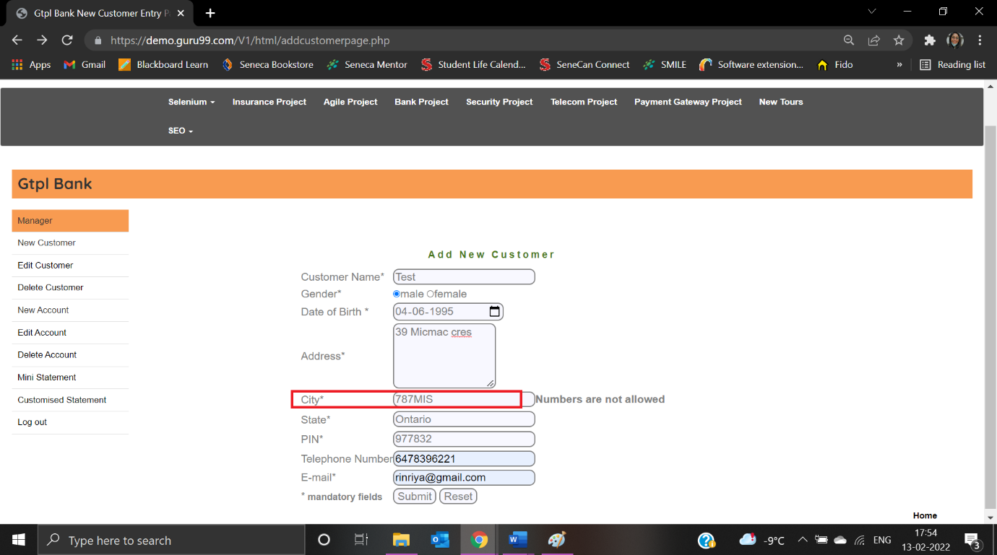

Error message is displayed:

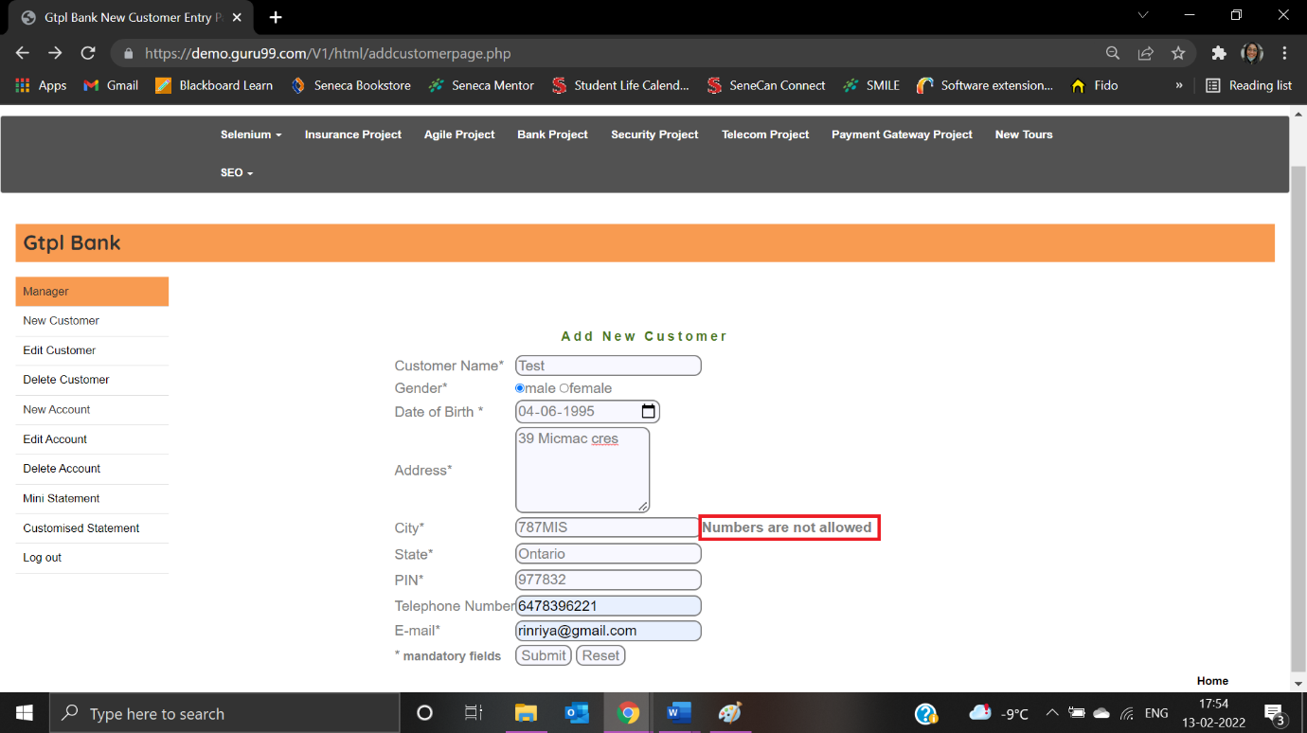

|  |  |
| --- | --- |
| Test Case ID: TNC10 | Test Result: Failed |
| Details: The first character of the city must not be blank | |

The user enters “ NorthYork” as the city:

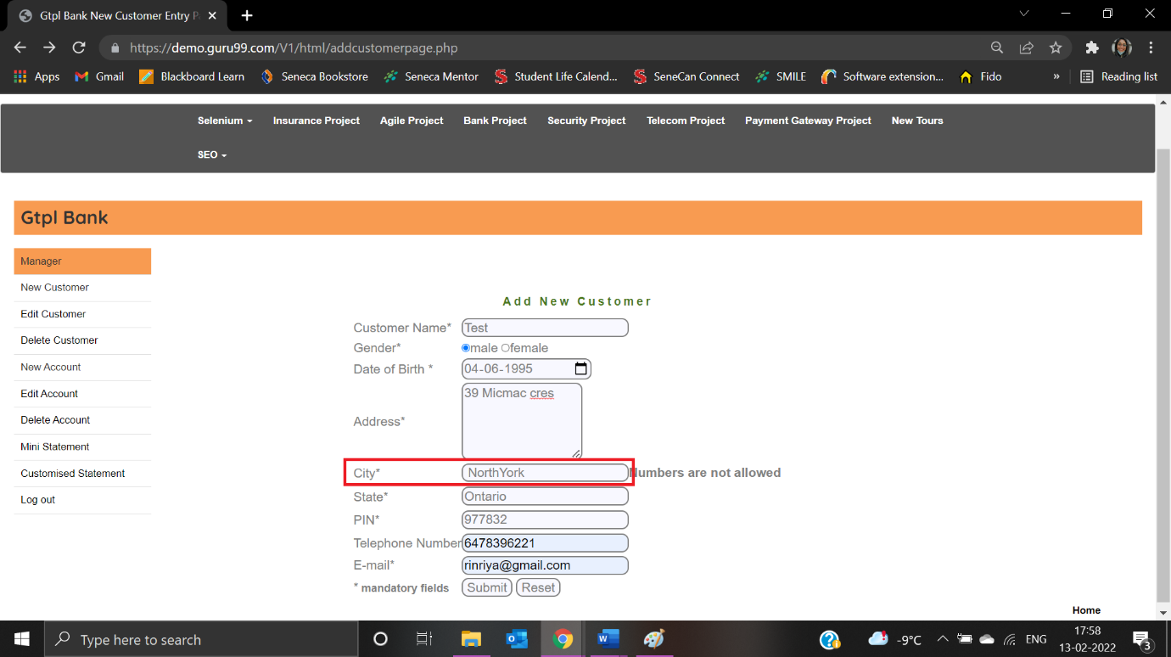

Error displayed is not appropriate:

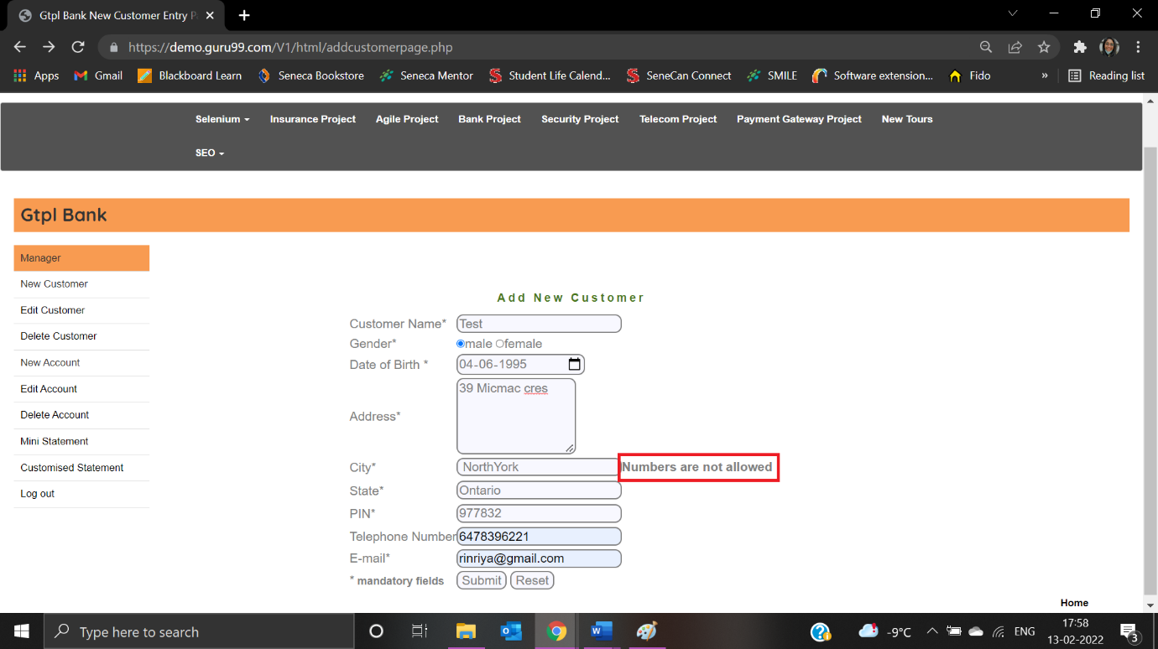

|  |  |
| --- | --- |
| Test Case ID: TNC13 | Test Result: Passed |
| Details: Numbers are not allowed for State field | |

User enters “8787Ontario” as State:

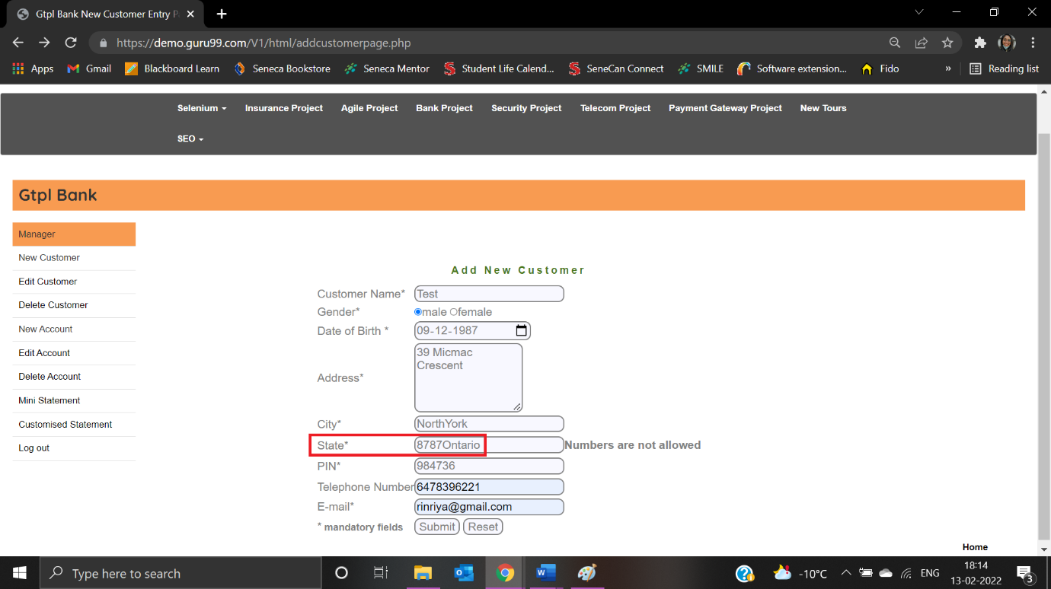

Error message is displayed:

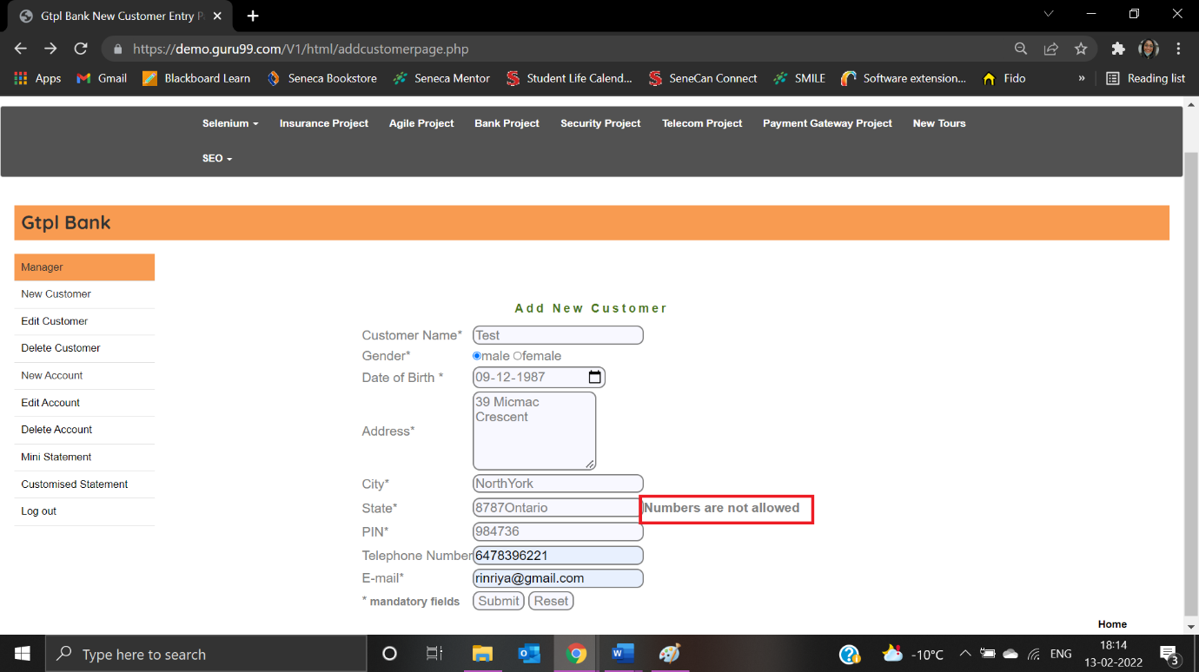

|  |  |
| --- | --- |
| Test Case ID: TNC11 | Test Result: Passed |
| Details: State field must not be blank | |

User doesn’t enter anything in State field:

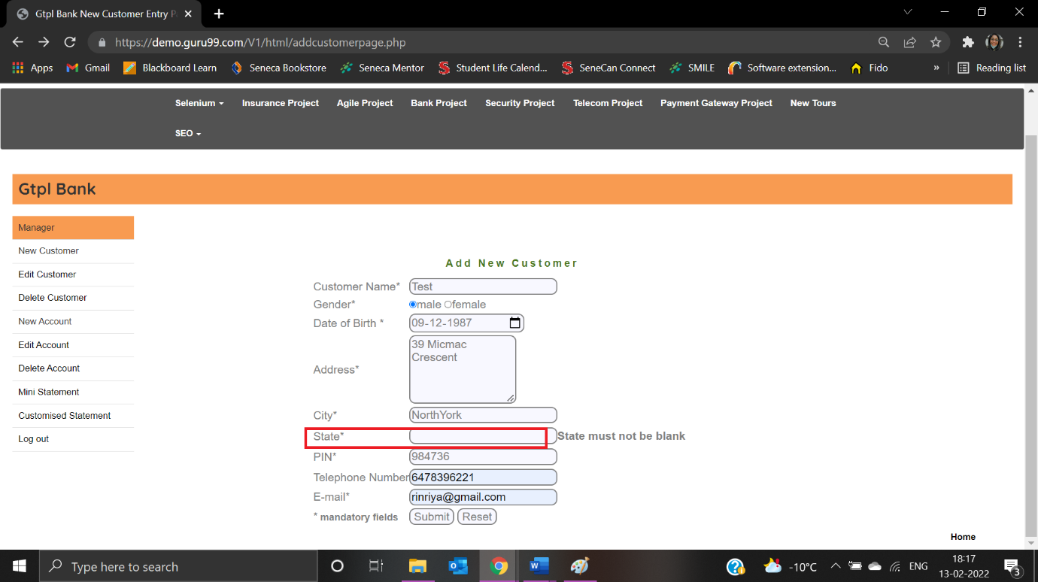

Error message is displayed:

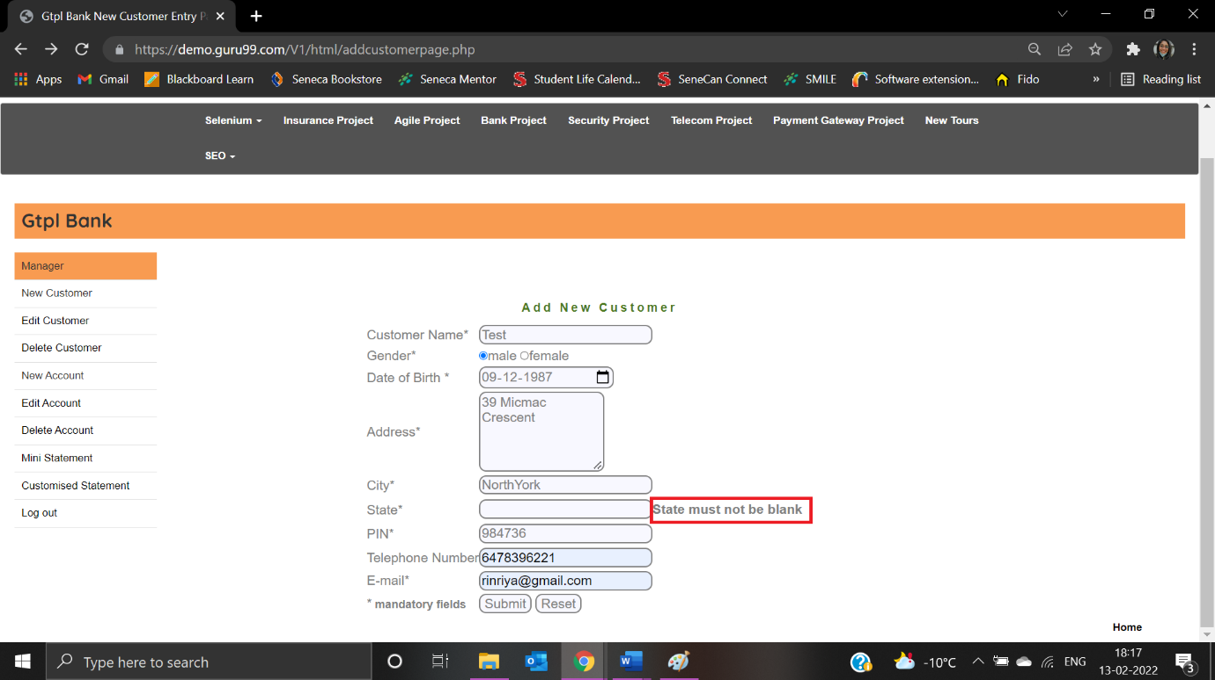

|  |  |
| --- | --- |
| Test Case ID: TNC12 | Test Result: Passed |
| Details: Special Characters is not allowed in State field | |

User enters special characters in State field:

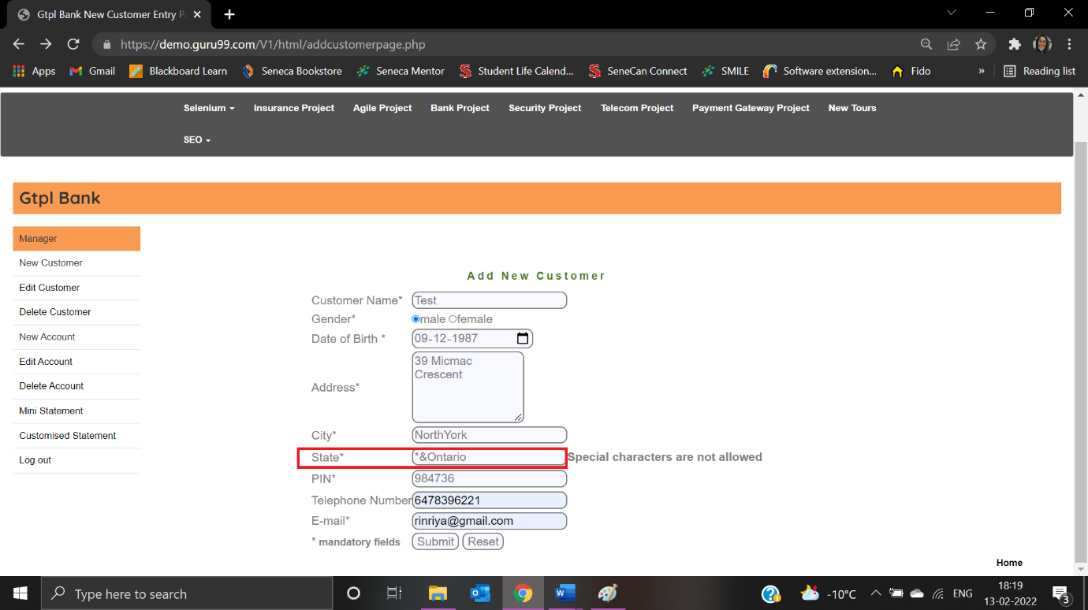

Error message is displayed:

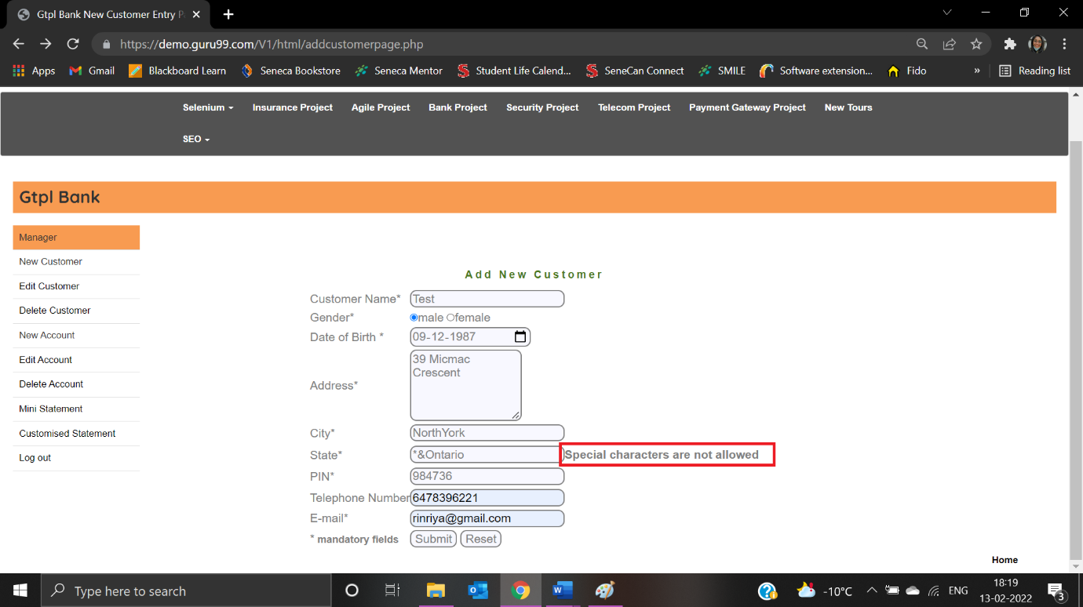

|  |  |
| --- | --- |
| Test Case ID: TC01 | Test Result: Failed |
| Details: The first character cannot have space in the State field | |

User enters “ Ontario” as State:

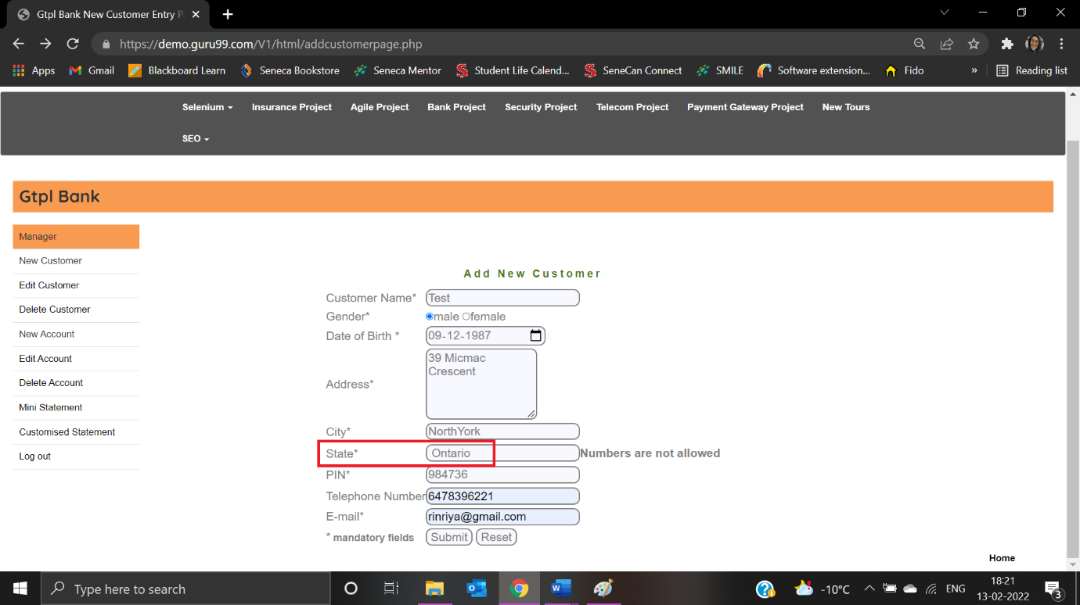

Error message displayed is not correct:

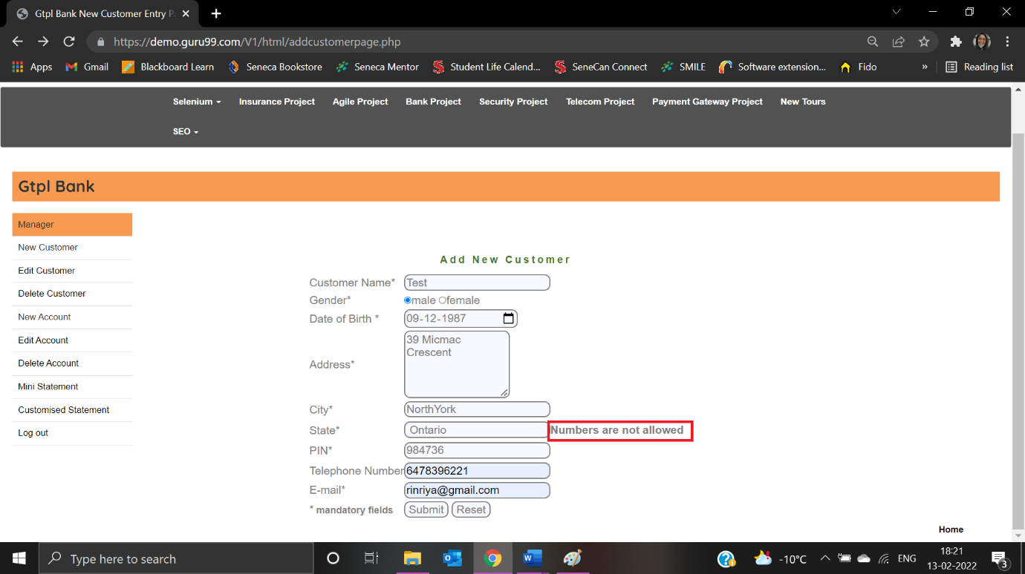

|  |  |
| --- | --- |
| Test Case ID: TNC20 | Test Result: Passed |
| Details: Characters are not allowed in the Pin field | |

User enters pin as “M2H2K1”:

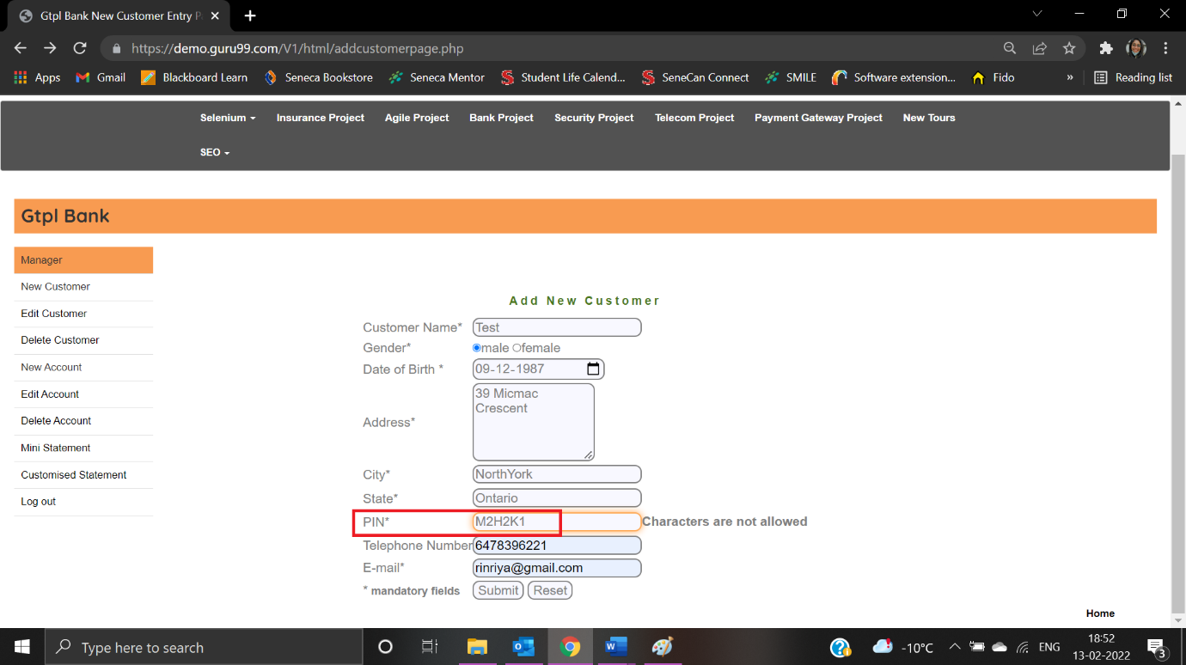

Error message is displayed:

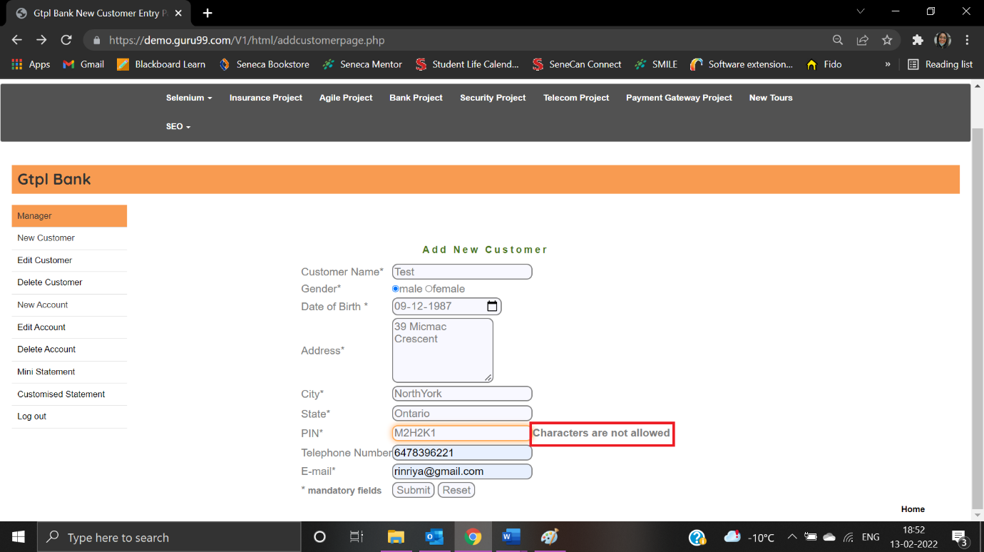

|  |  |
| --- | --- |
| Test Case ID: TNC19 | Test Result: Passed |
| Details: PIN Code must not be blank | |

The user doesn’t enter anything in the PIN Code field:

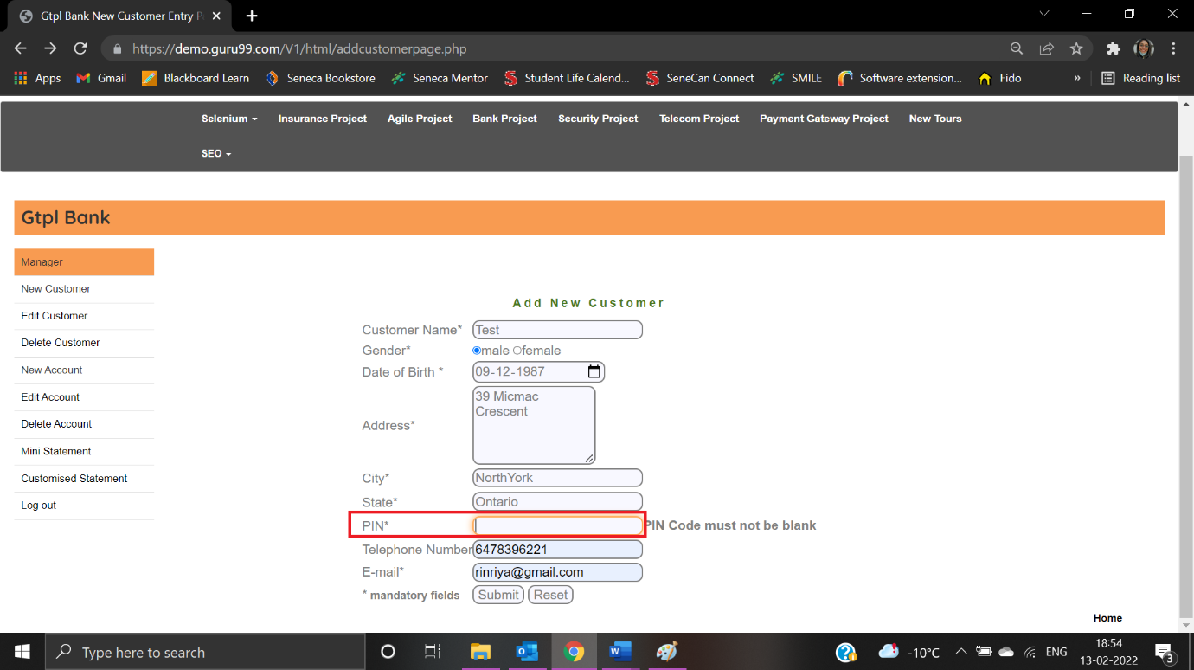

Error message is displayed:

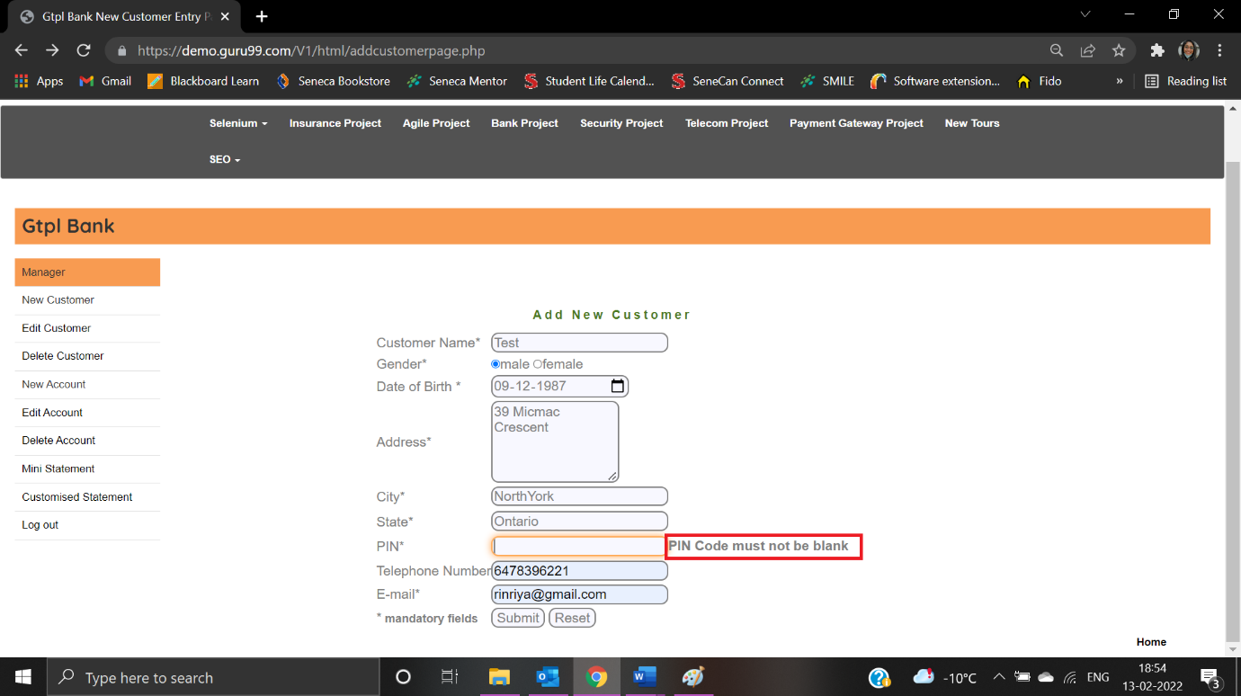

|  |  |
| --- | --- |
| Test Case ID: TNC20 | Test Result: Passed |
| Details: Special characters are not allowed in the PIN Code field | |

User should enter as “&*9877”:

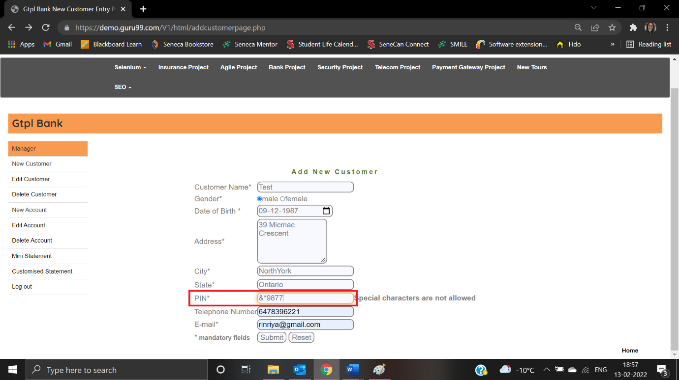

Error message is displayed:

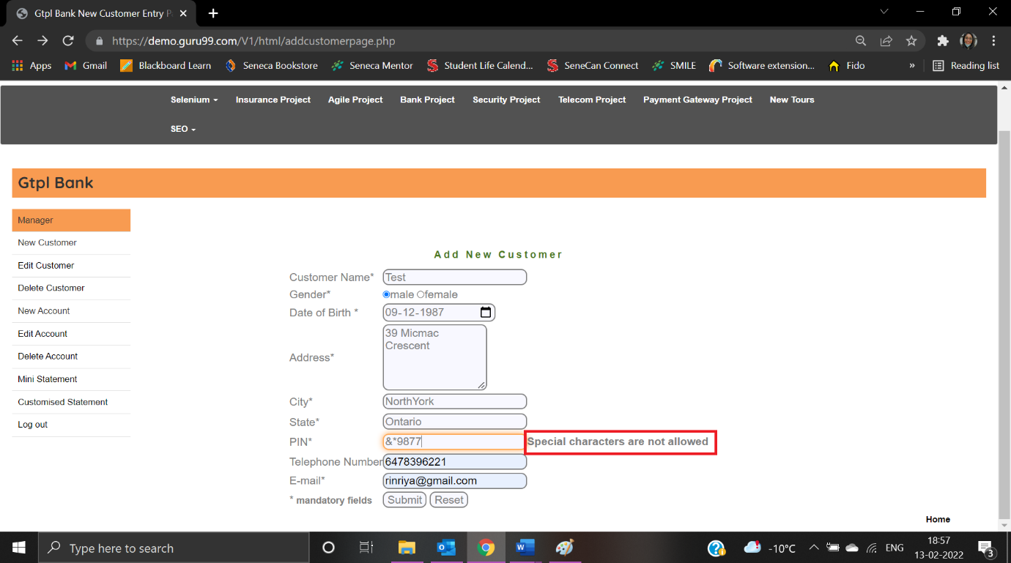

|  |  |
| --- | --- |
| Test Case ID: TNC21 | Test Result: Passed |
| Details: PIN Code must have 6 Digits | |

The user enters pin as “946”:

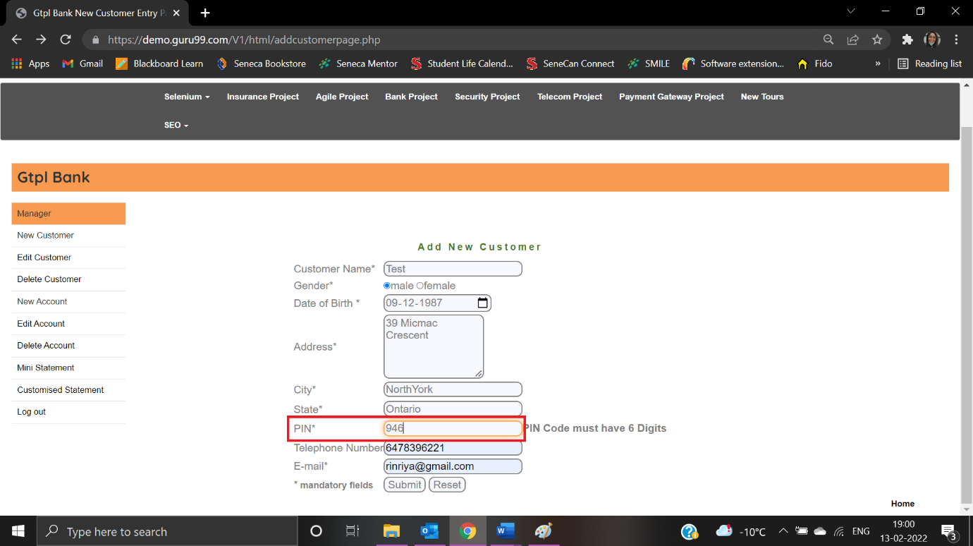

Error message is displayed:

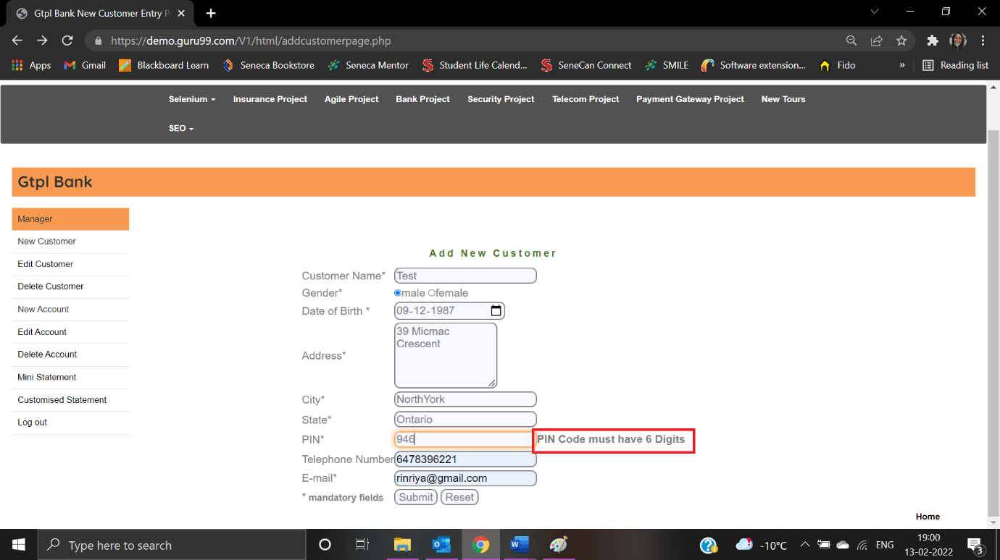

|  |  |
| --- | --- |
| Test Case ID: TC02 | Test Result: Failed |
| Details: The first character cannot have space | |

User is able to enter pin with the first character as space:

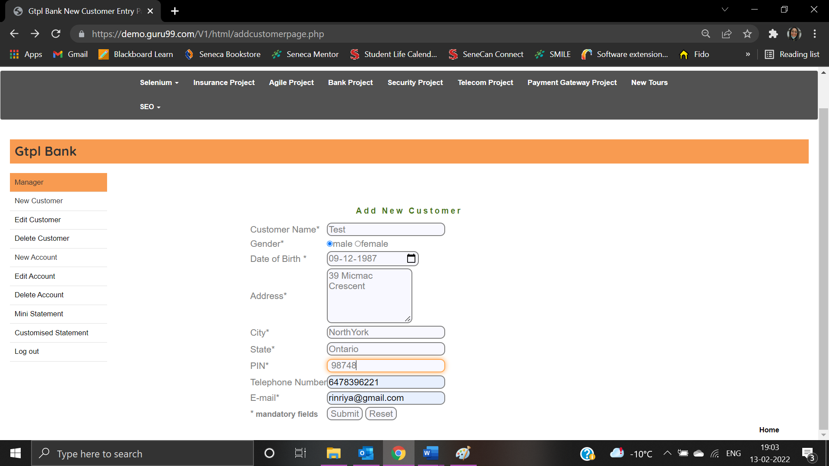

Error message is not displayed:



|  |  |
| --- | --- |
| Test Case ID: TNC19 | Test Result: Passed |
| Details: Telephone Number – Mobile no must not be blank | |

Telephone number field is left blank:

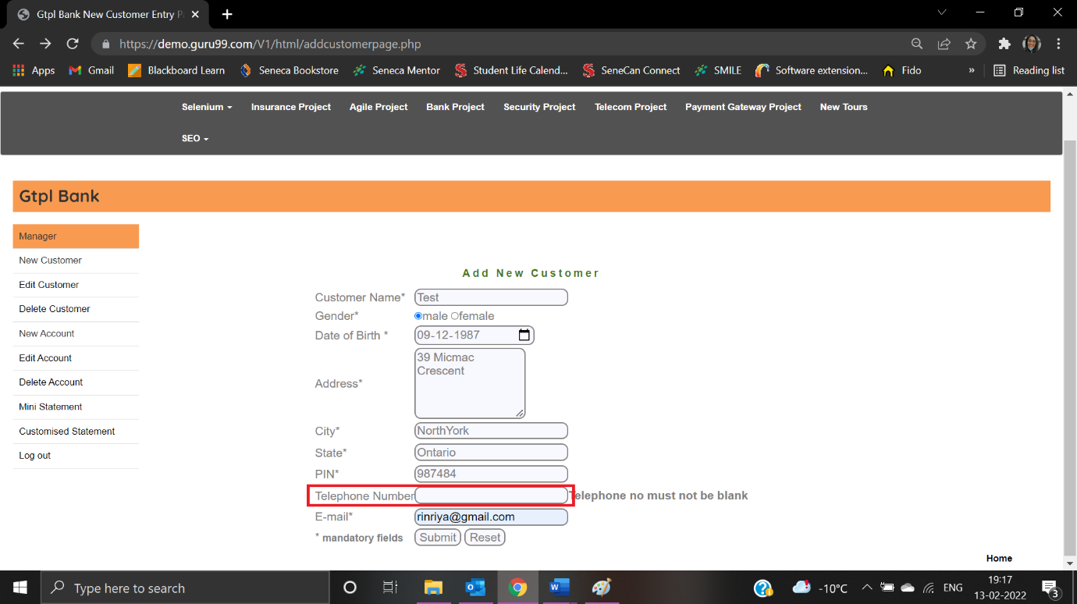

Error message is displayed:

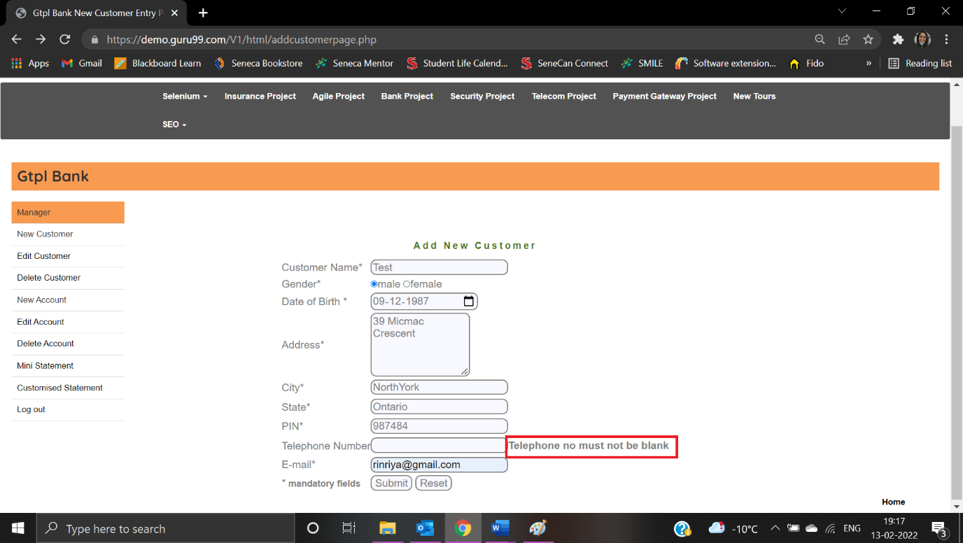

|  |  |
| --- | --- |
| Test Case ID: TC03 | Test Result: Passed |
| Details: Telephone Number – Special characters are not allowed | |

User enters “&%9899”:

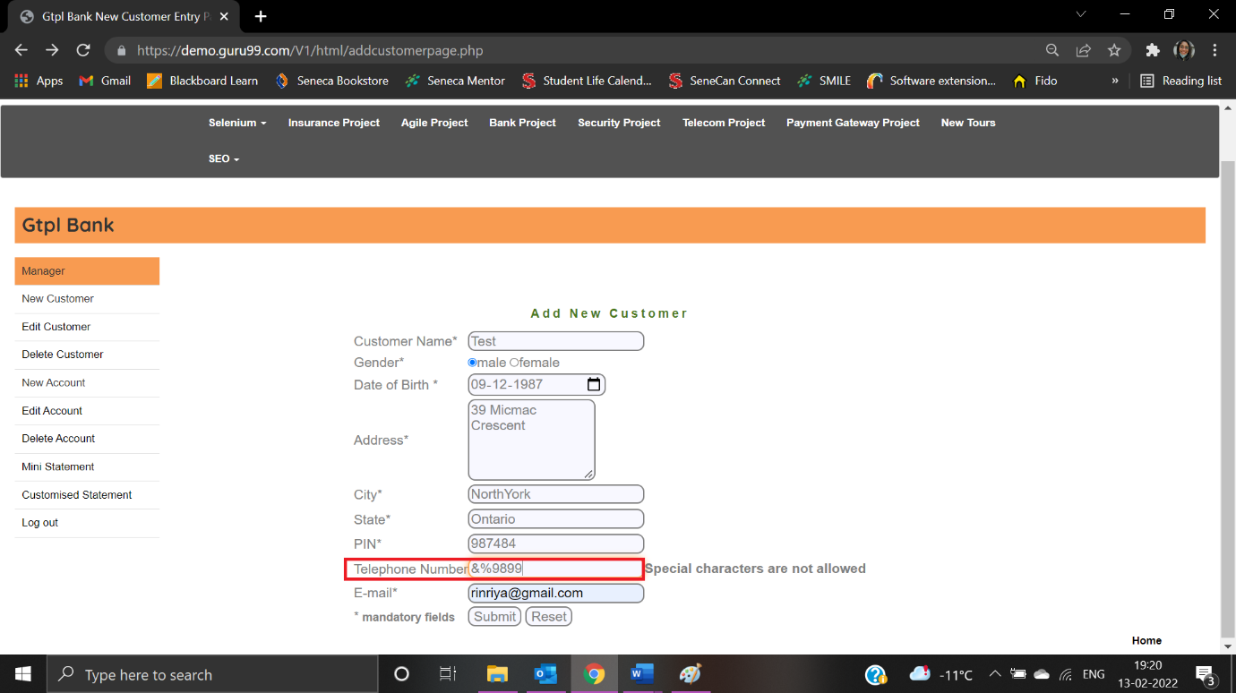

Error message is displayed:

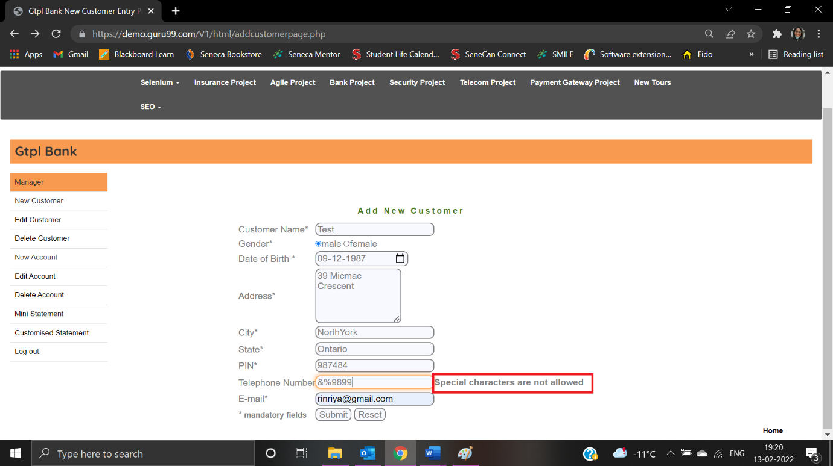

|  |  |
| --- | --- |
| Test Case ID: TNC20 | Test Result: Passed |
| Details: Telephone Number – Character are not allowed | |

User is entered as “M2H9898”:

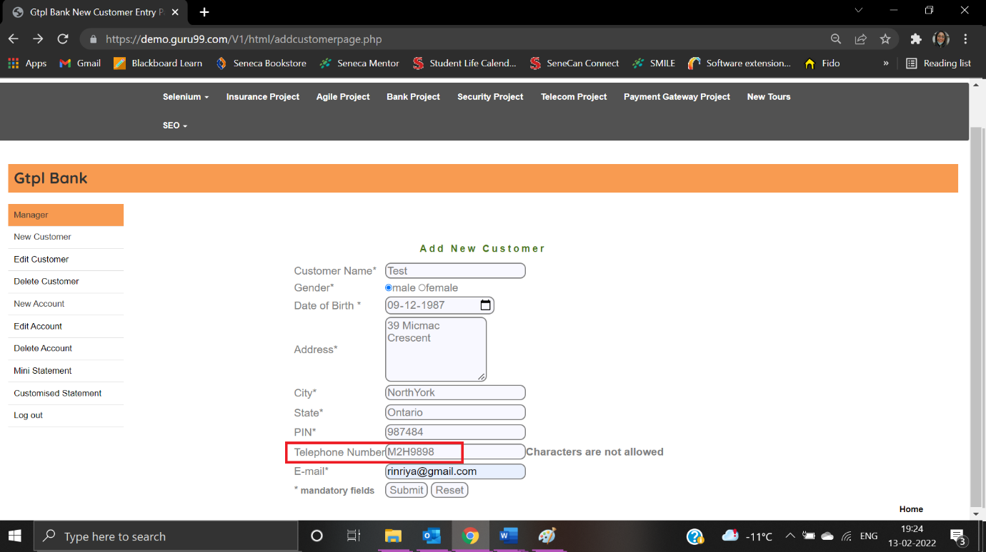

Error message is displayed:

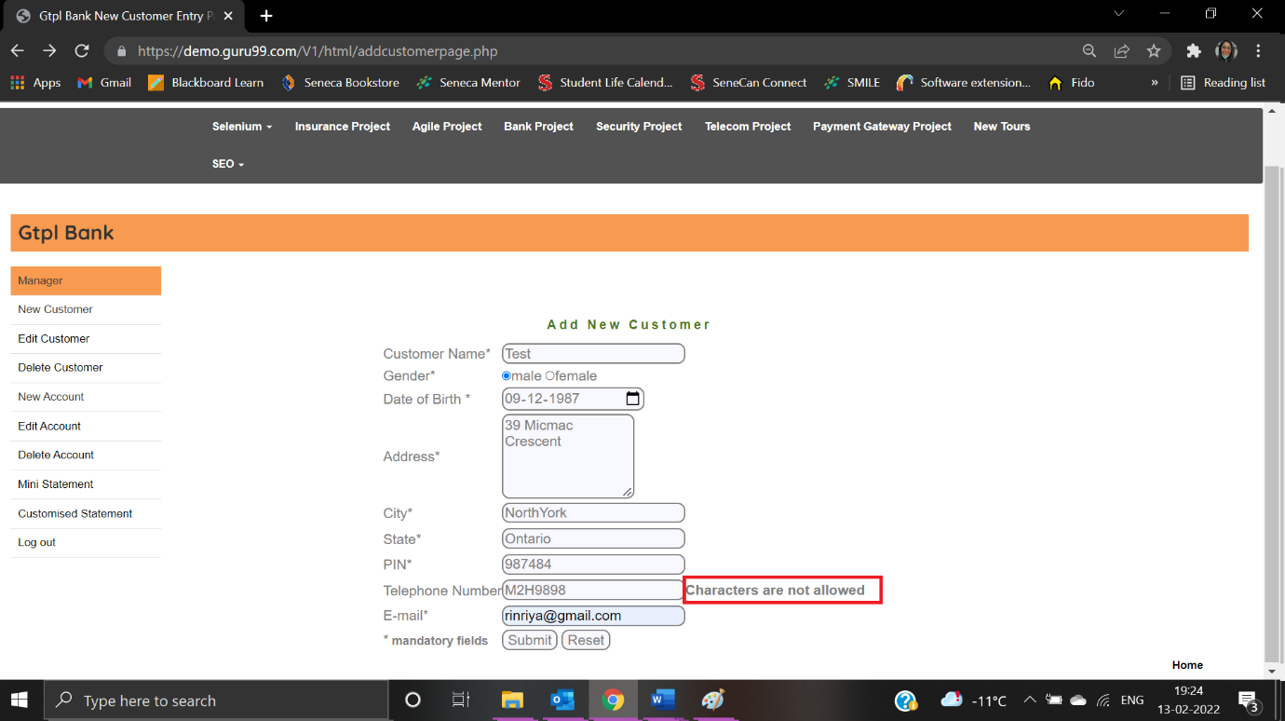

|  |  |
| --- | --- |
| Test Case ID: TNC21 | Test Result: Failed |
| Details: Telephone Number – First character cannot have space | |

User enters as “ 9889999905”:

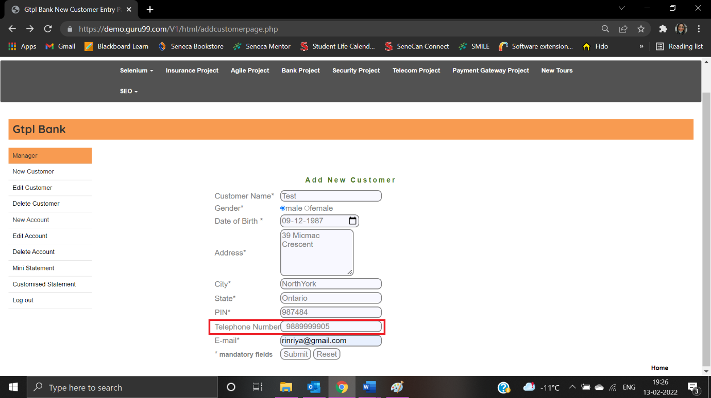

Error message is not displayed:



|  |  |
| --- | --- |
| Test Case ID: TNC27 | Test Result: Passed |
| Details: Email: Email ID must not be blank | |

User left Email field blank:

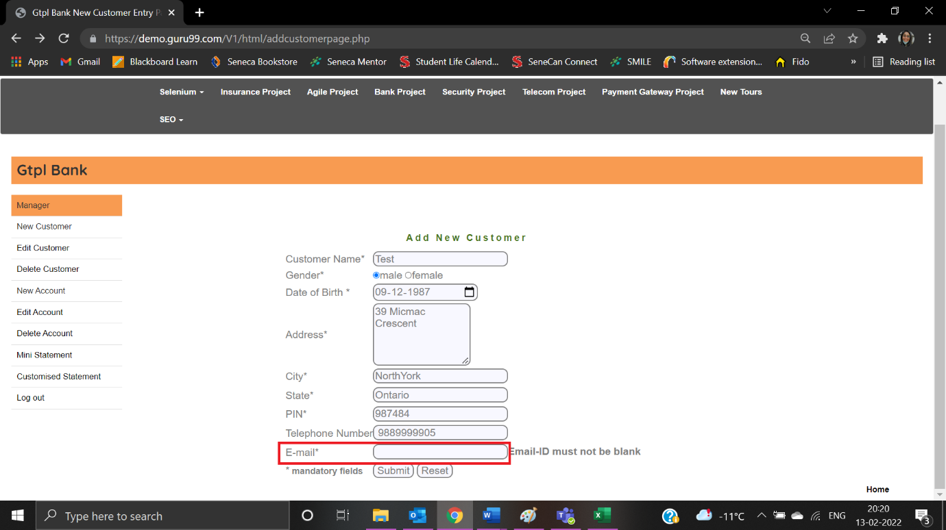

Error message is displayed:

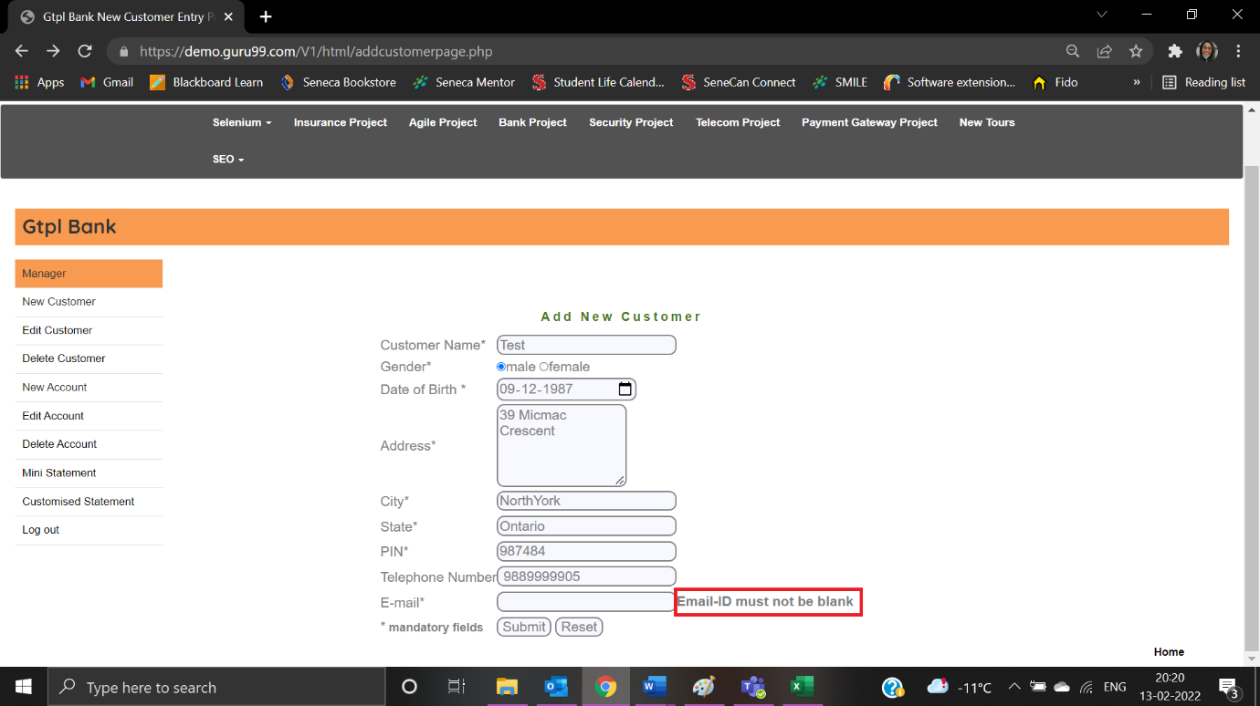

|  |  |
| --- | --- |
| Test Case ID: TNC28 | Test Result: Passed |
| Details: Email: Email ID must be a valid format | |

User enters email id as “test.com”:

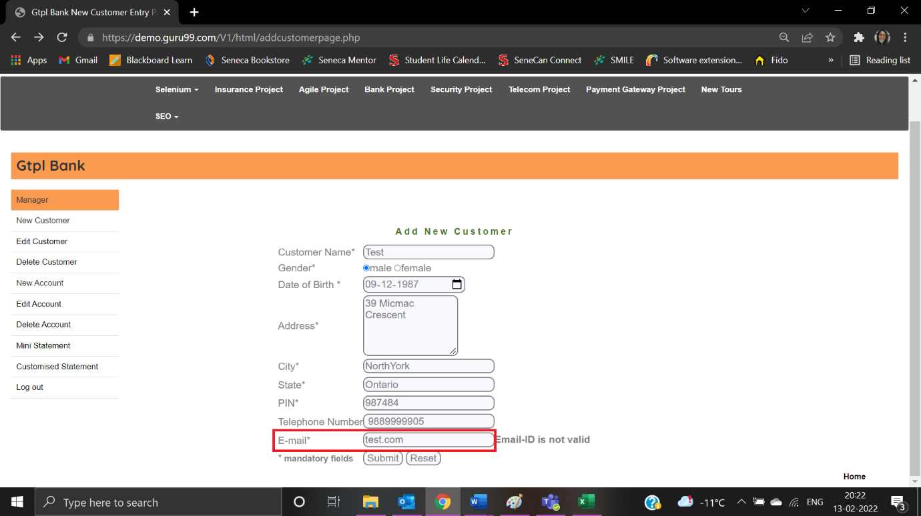

Error message is displayed:

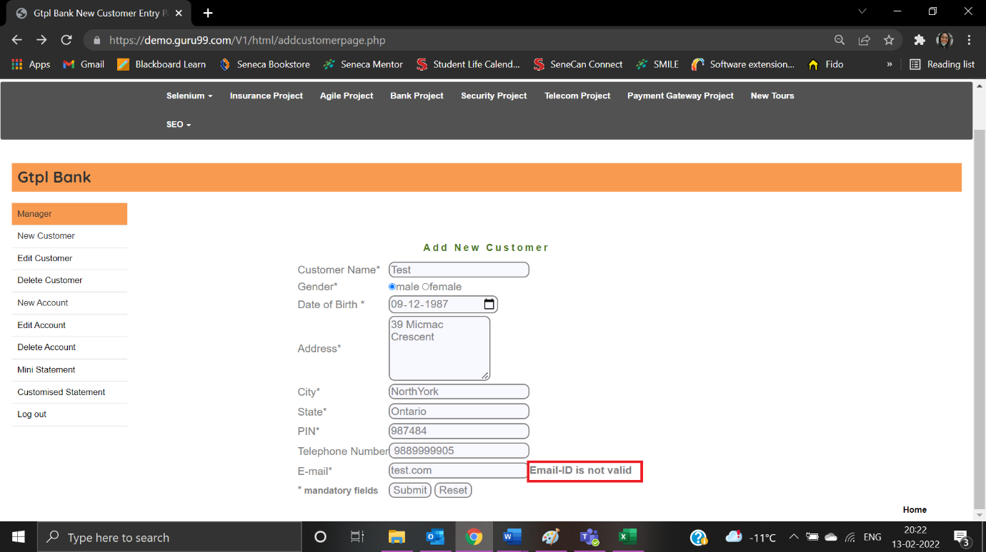

|  |  |
| --- | --- |
| Test Case ID: TC04 | Test Result: Failed |
| Details: Email: The first character cannot have space | |

User enters email id as “ [Test@gmail.com](mailto:Test@gmail.com)”:

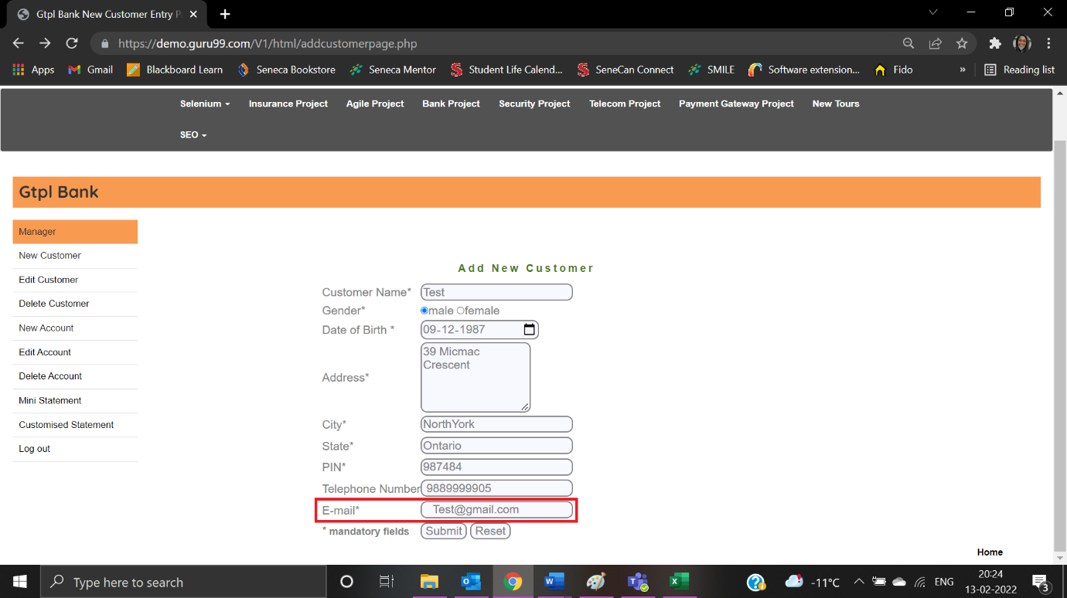

Error message is not displayed:

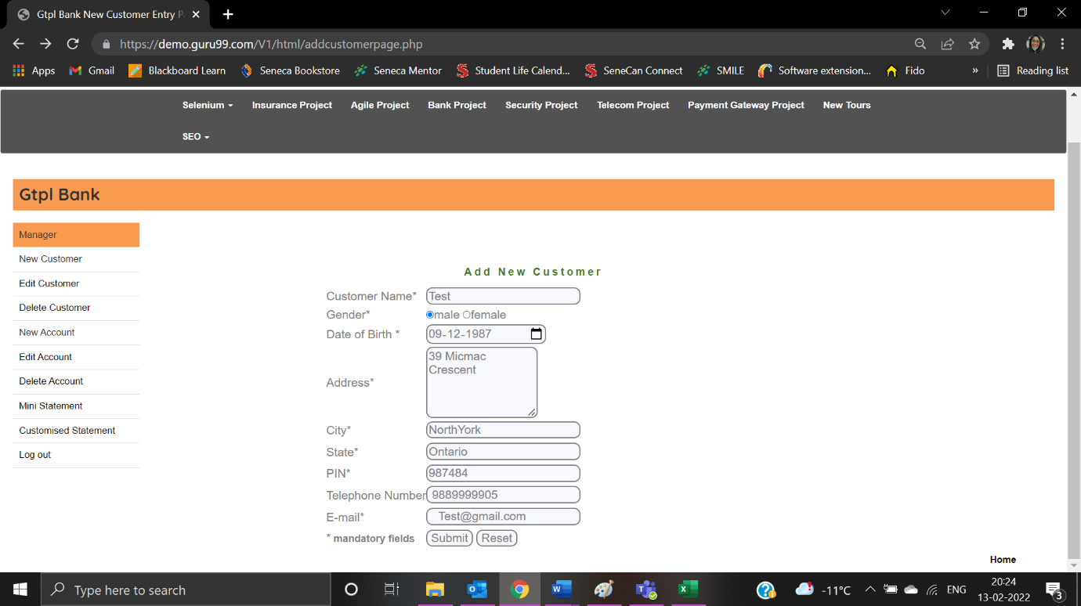

**Customized Statement Form**

|  |  |
| --- | --- |
| Test Case ID: TCS1 | Test Result: Passed |
| Details: Account No - Account Number must not be blank | |

User clicks on Customised Statement:

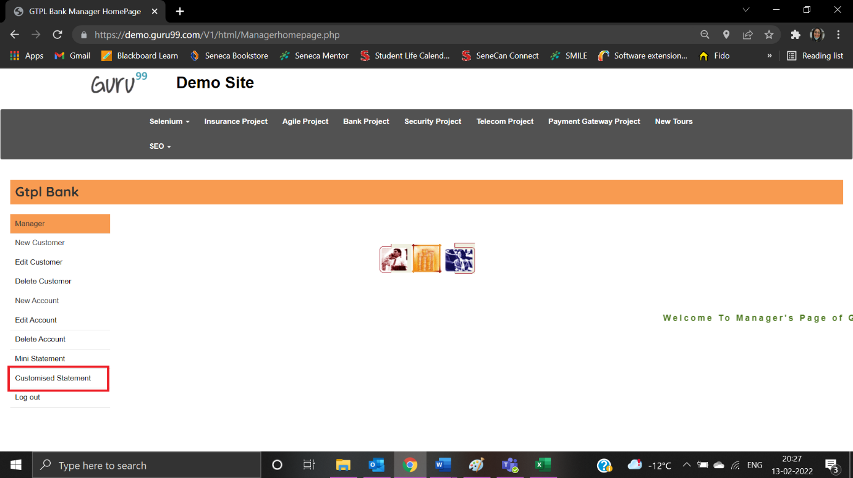

User is navigated to Customised Statement:

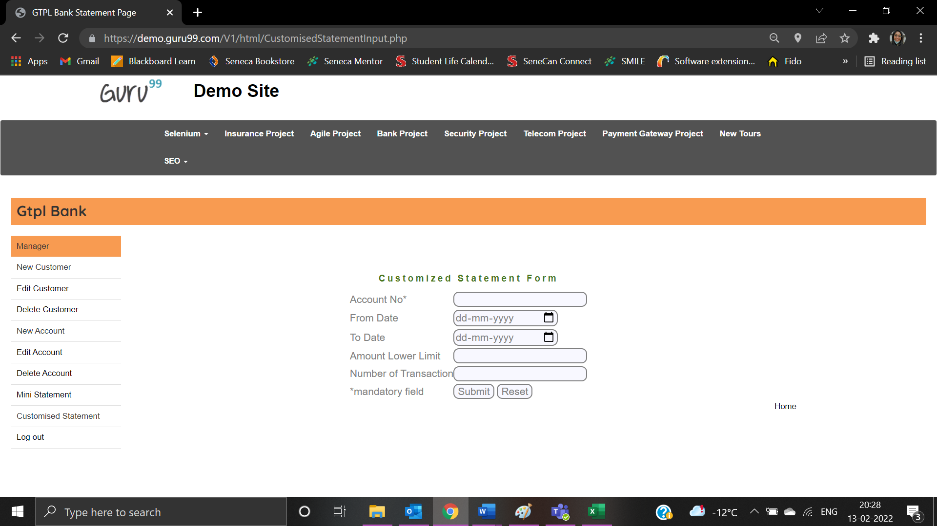

Error message is displayed when Account No: is not populated:

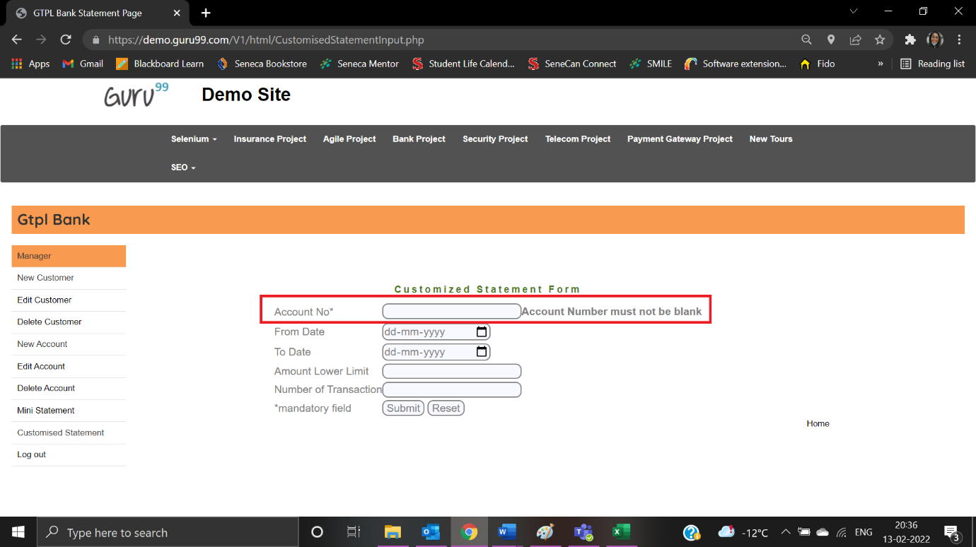

|  |  |
| --- | --- |
| Test Case ID: TCS2 | Test Result: Passed |
| Details: Account No - Characters are not allowed | |

User enters Account No: as “YTY9876”:

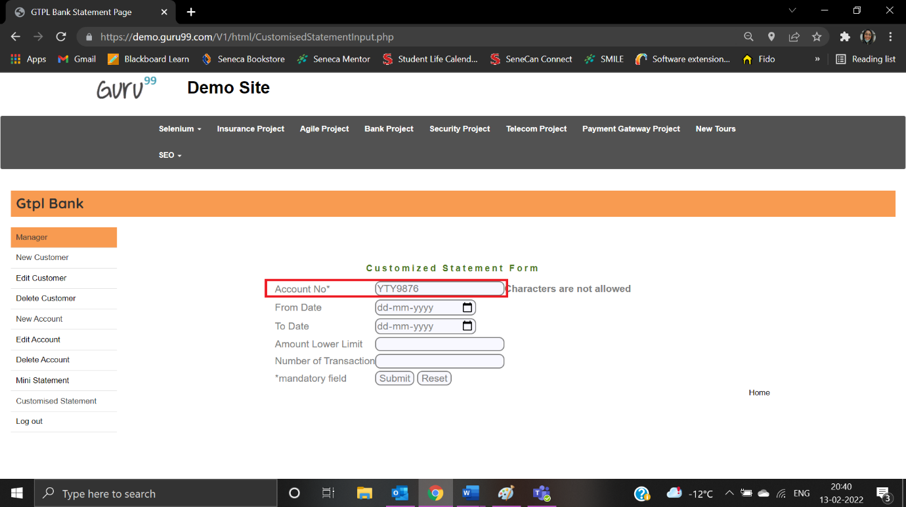

Error message is displayed:

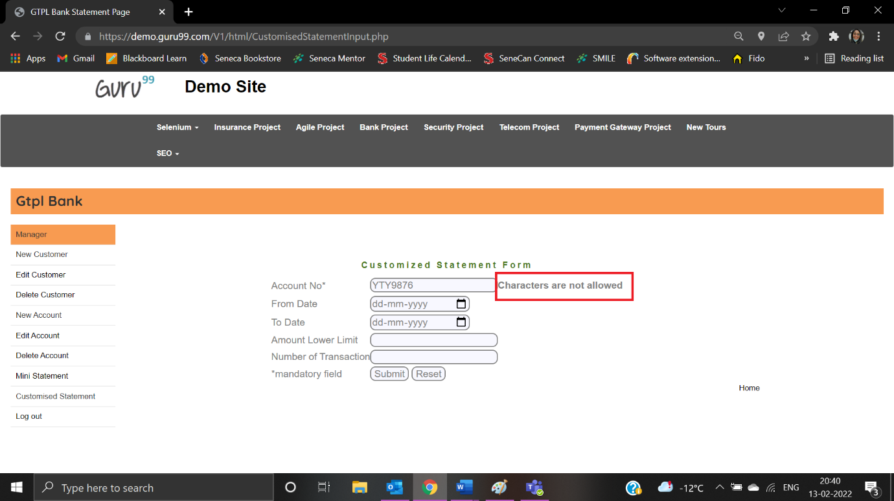

|  |  |
| --- | --- |
| Test Case ID: TNA1 | Test Result: Passed |
| Details: Account No - Special characters are not allowed | |

User enters account number as “*&*774”:

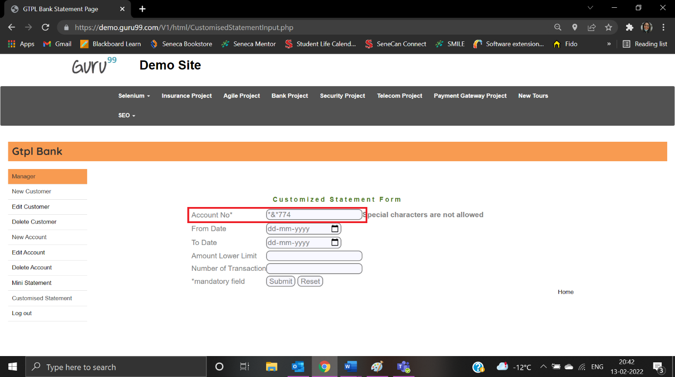

Error message is displayed:

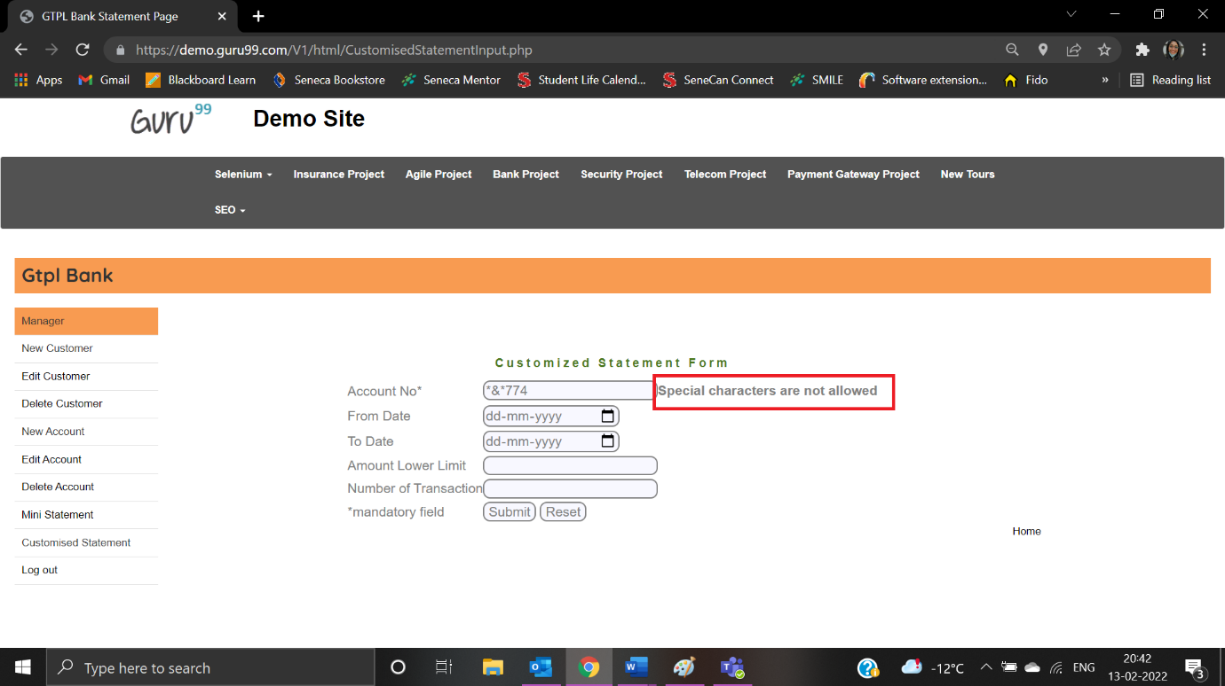

|  |  |
| --- | --- |
| Test Case ID: TNA1 | Test Result: Failed |
| Details: Amount Lower Limit – Special characters are not allowed | |

Users enter Amount Lower limit as “*&878”:

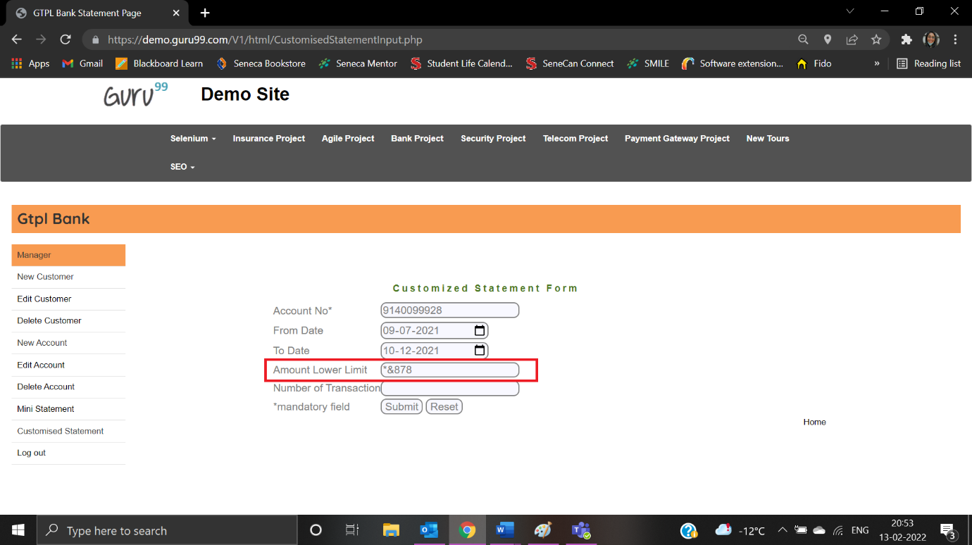

Error message is not displayed:

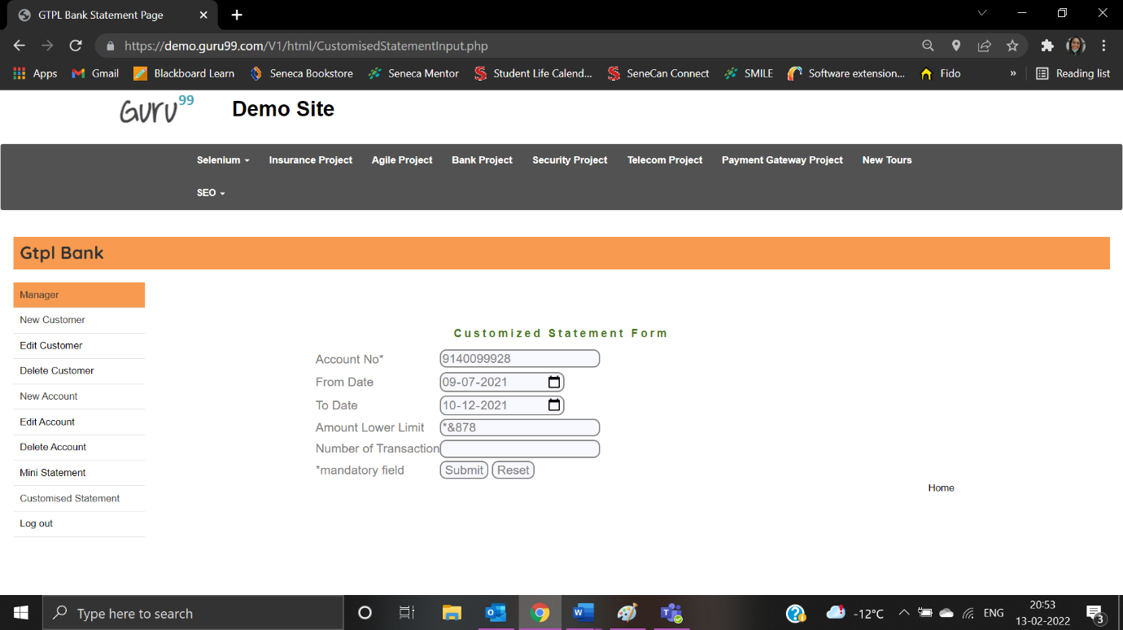

|  |  |
| --- | --- |
| Test Case ID: TC05 | Test Result: Failed |
| Details: Amount Lower Limit – Amount Lower Limit is required | |

User left the amount lower limit field blank:

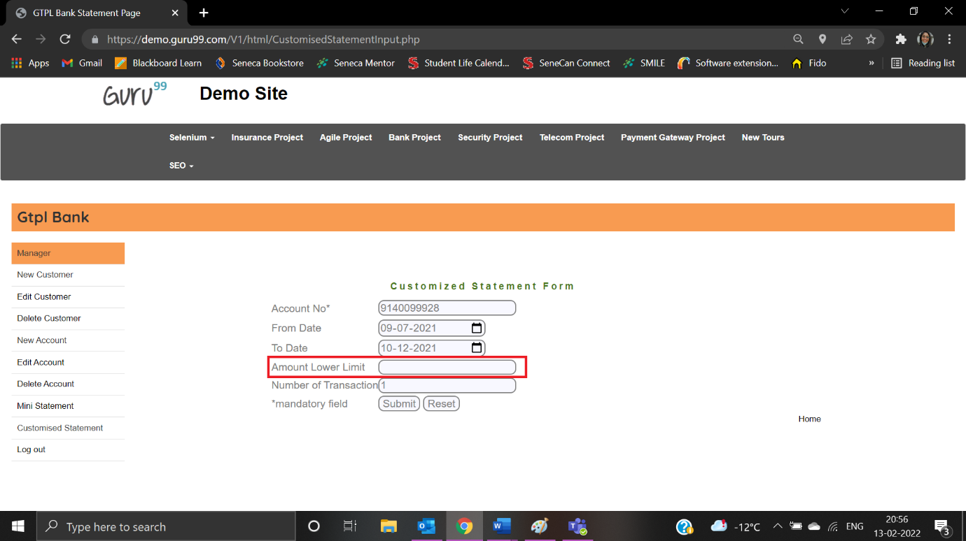

Error message is not displayed:

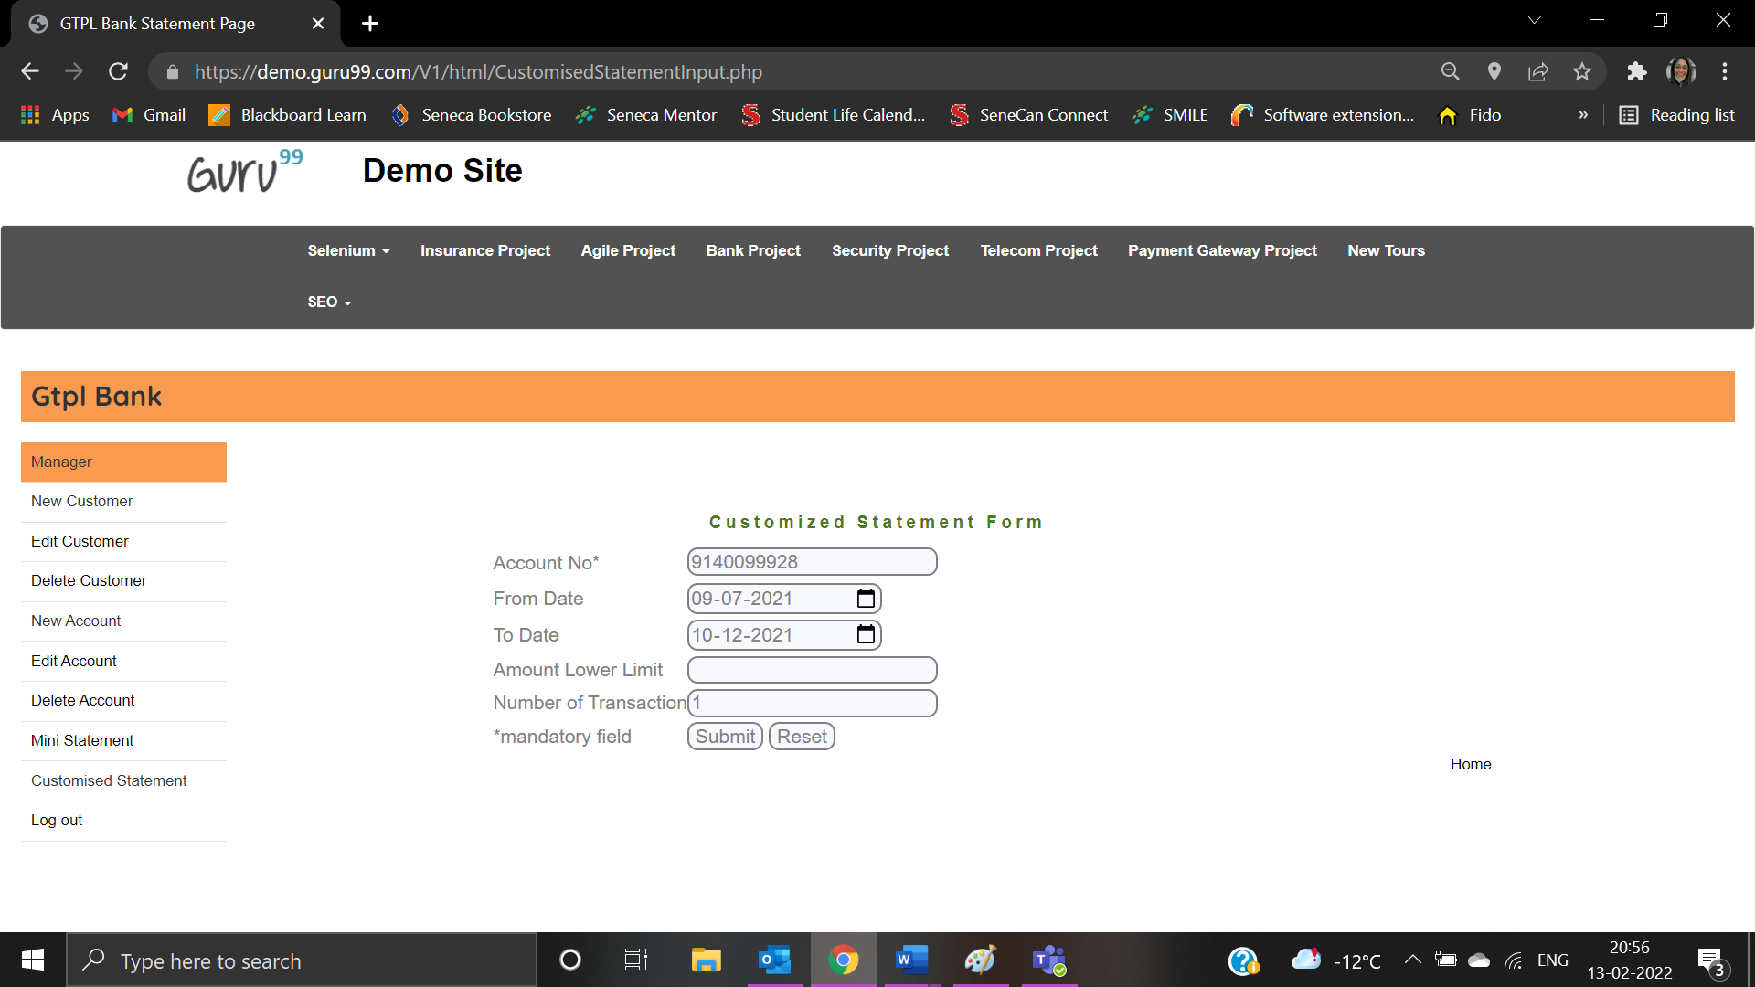

|  |  |
| --- | --- |
| Test Case ID: TC06 | Test Result: Failed |
| Details: Amount Lower Limit – Special characters are not allowed | |

User enter Amount Lower Limit as “*&77”:

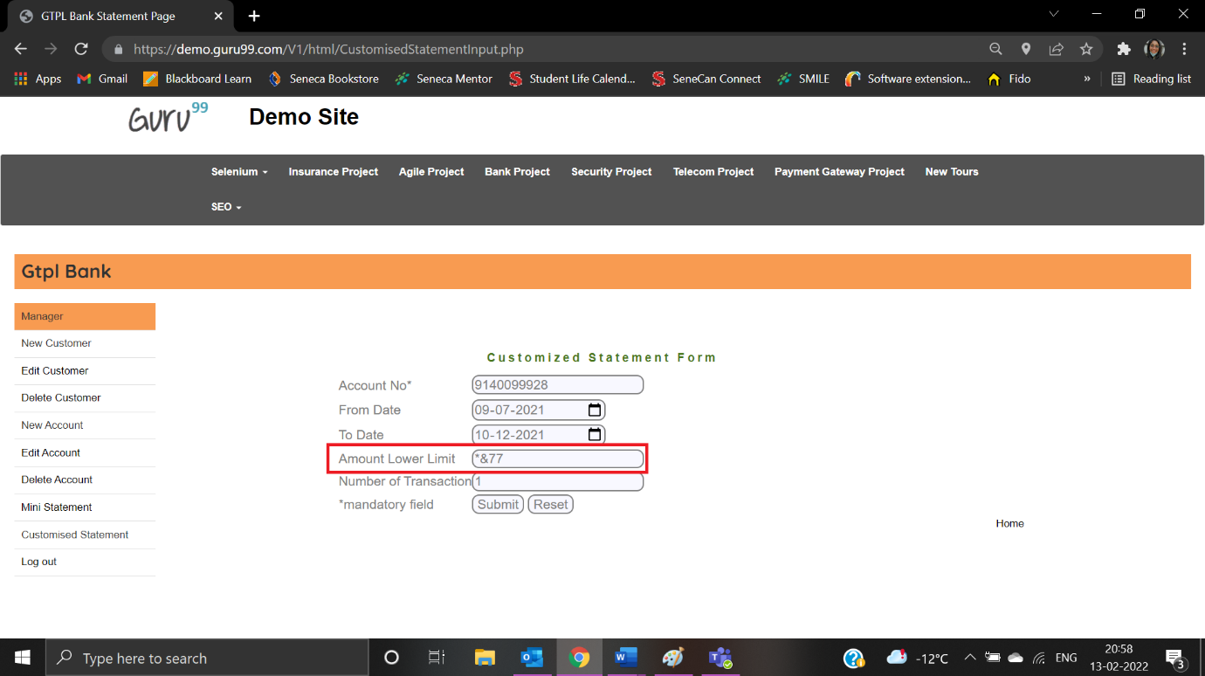

Error message is not displayed:

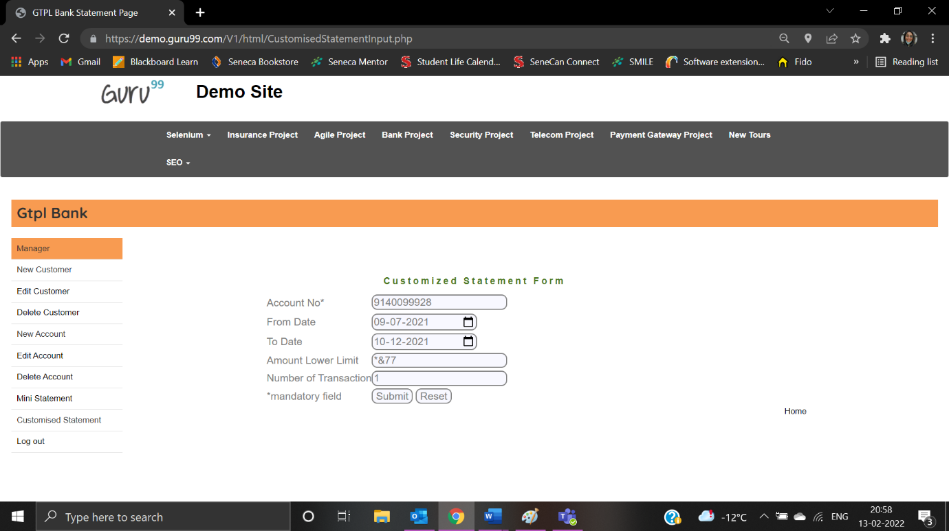

|  |  |
| --- | --- |
| Test Case ID: TCS5 | Test Result: Failed |
| Details: Number of Transaction – Special characters are not allowed | |

User enter transaction as “*(*(*1”:

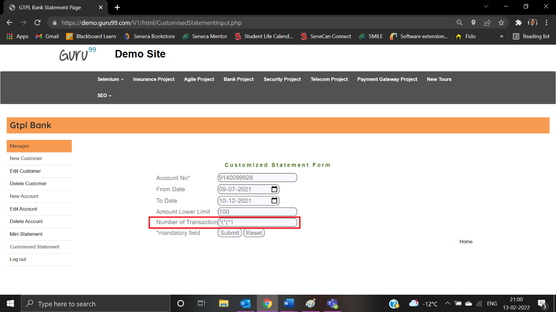

Error message is not displayed:

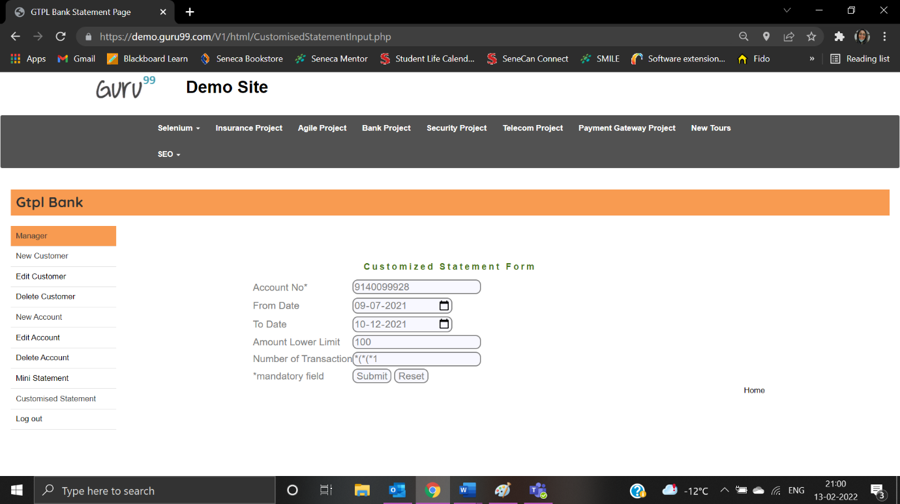

|  |  |
| --- | --- |
| Test Case ID: TC07 | Test Result: Failed |
| Details: Number of Transaction - Amount of Transaction must not be blank | |

User left the Number of transactions blank:

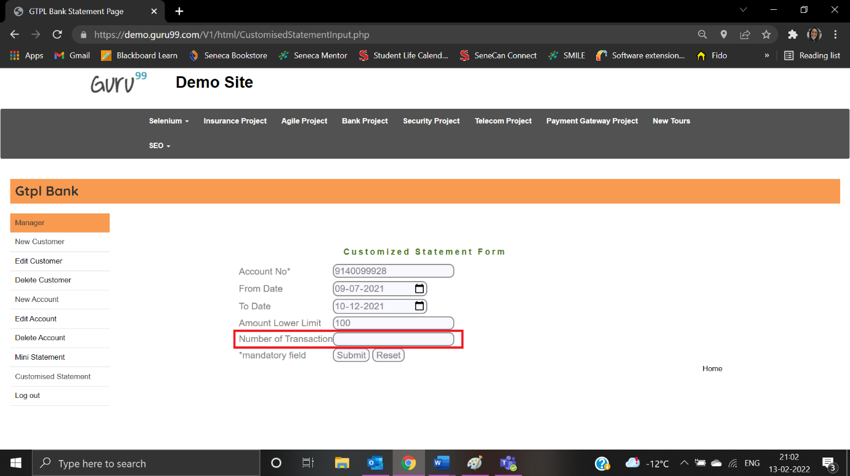

Error message is not displayed:

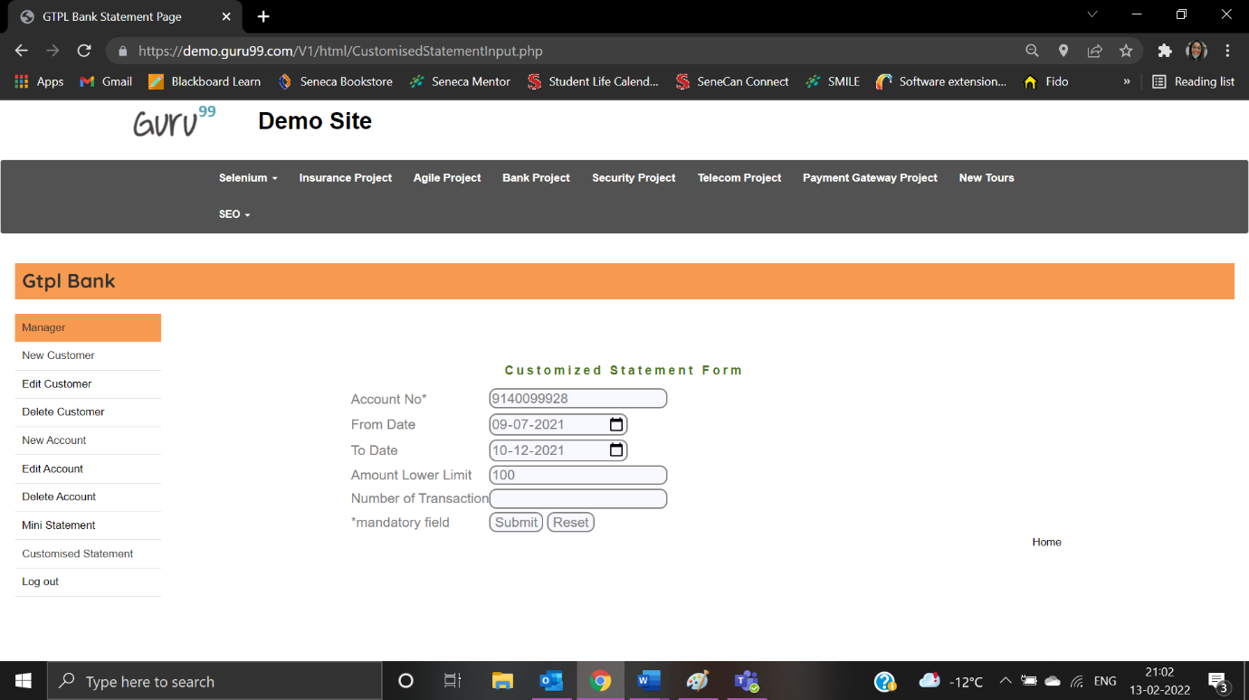

|  |  |
| --- | --- |
| Test Case ID: TC08 | Test Result: Failed |
| Details: Number of Transaction – Special characters are not allowed | |

User enter Number of transactions as “*&%9”:

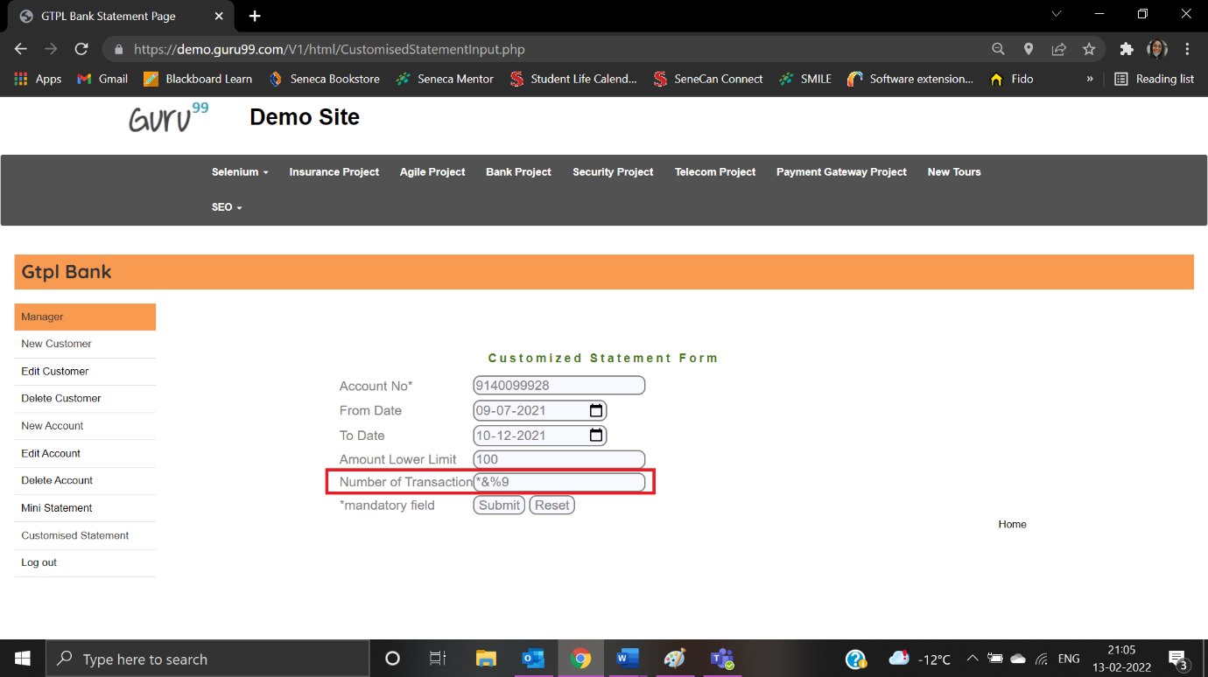

Error message is not displayed:

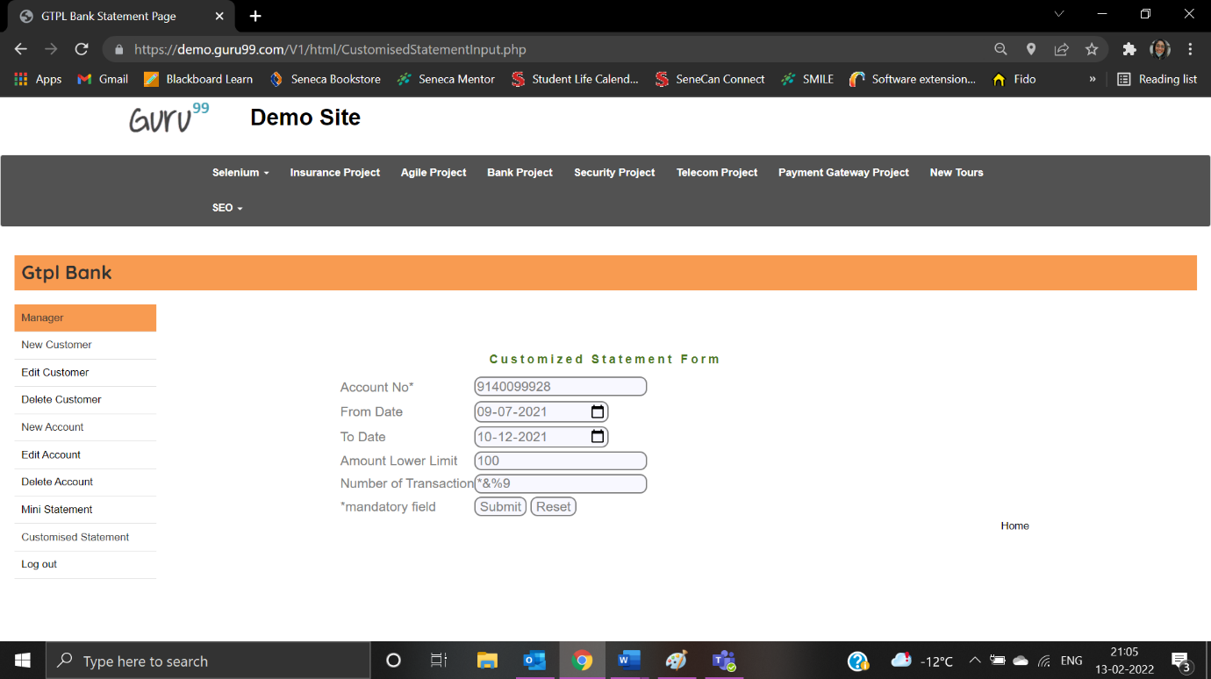

**Delete Account Form**

|  |  |
| --- | --- |
| Test Case ID: TDA1 | Test Result: Passed |
| Details: Account Number must not be blank | |

User clicks on User Account:

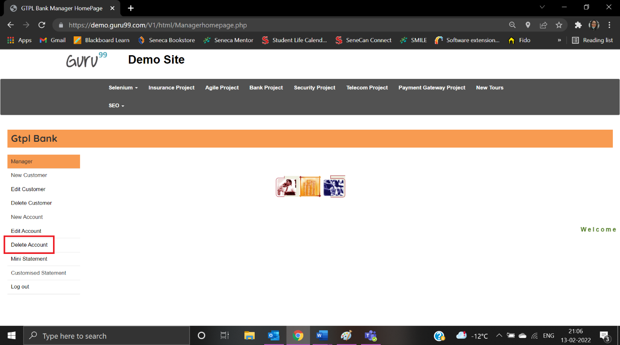

User is navigated to Delete Account Form:

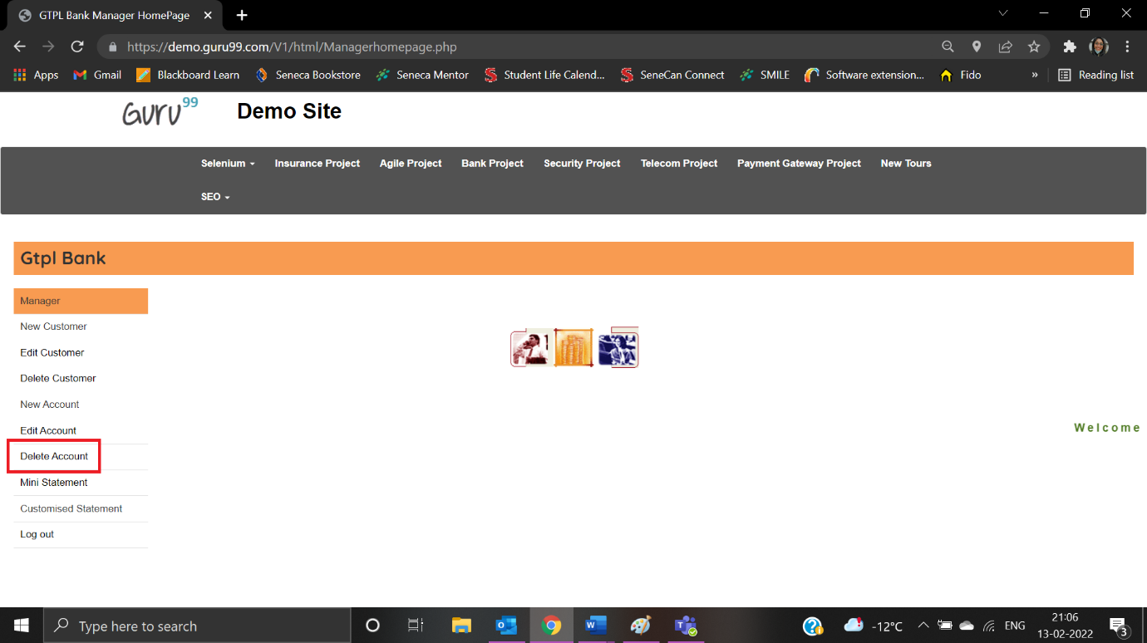

The user left the account number field as blank:

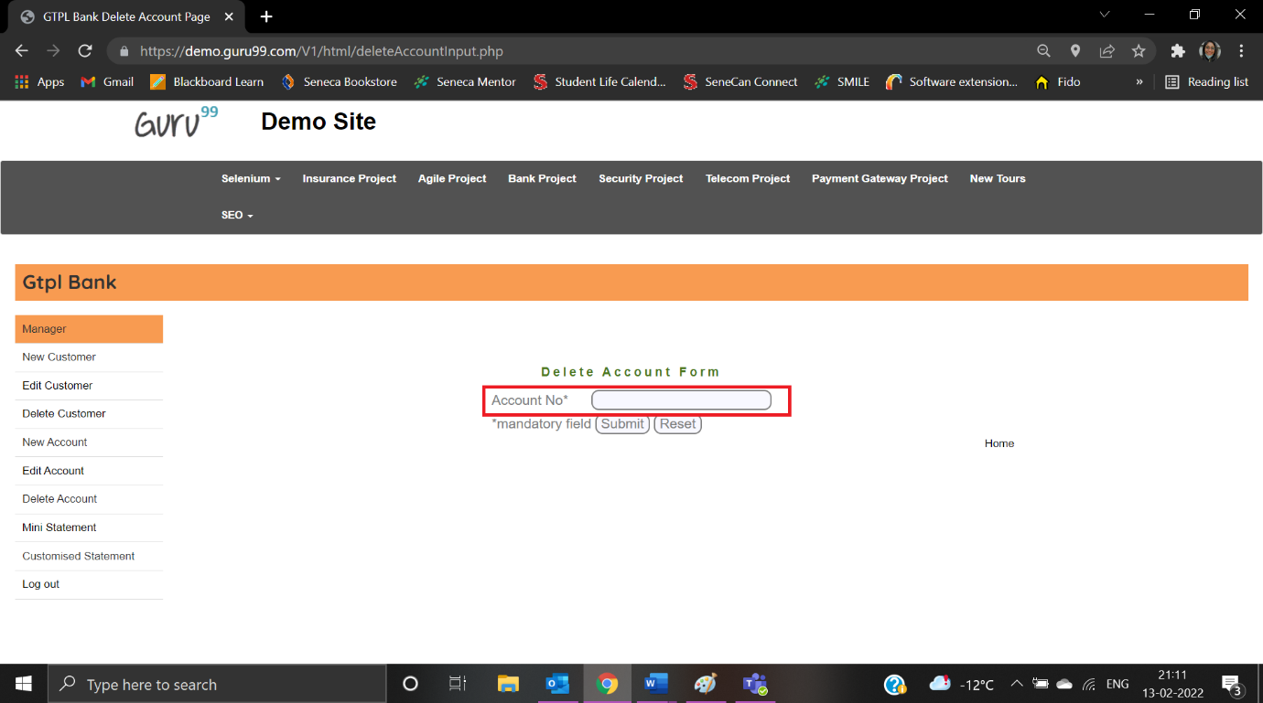

Error message is displayed:

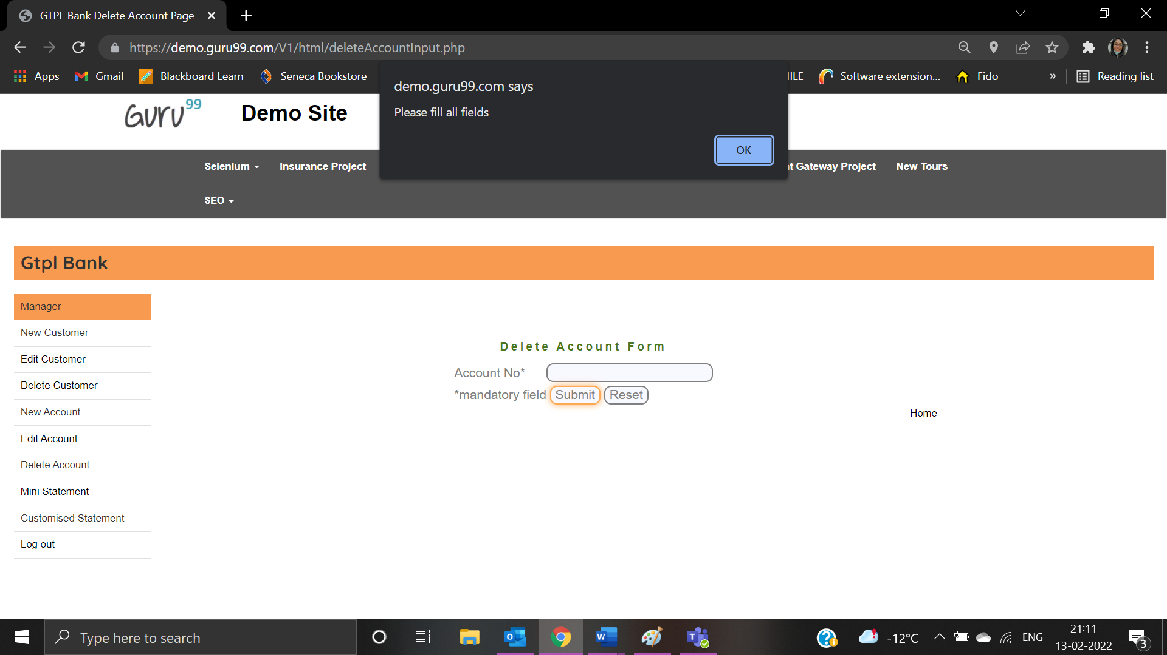

|  |  |
| --- | --- |
| Test Case ID: TDA3 | Test Result: Passed |
| Details: Account Number - Special characters are not allowed | |

User enters account number as “*&588999”:

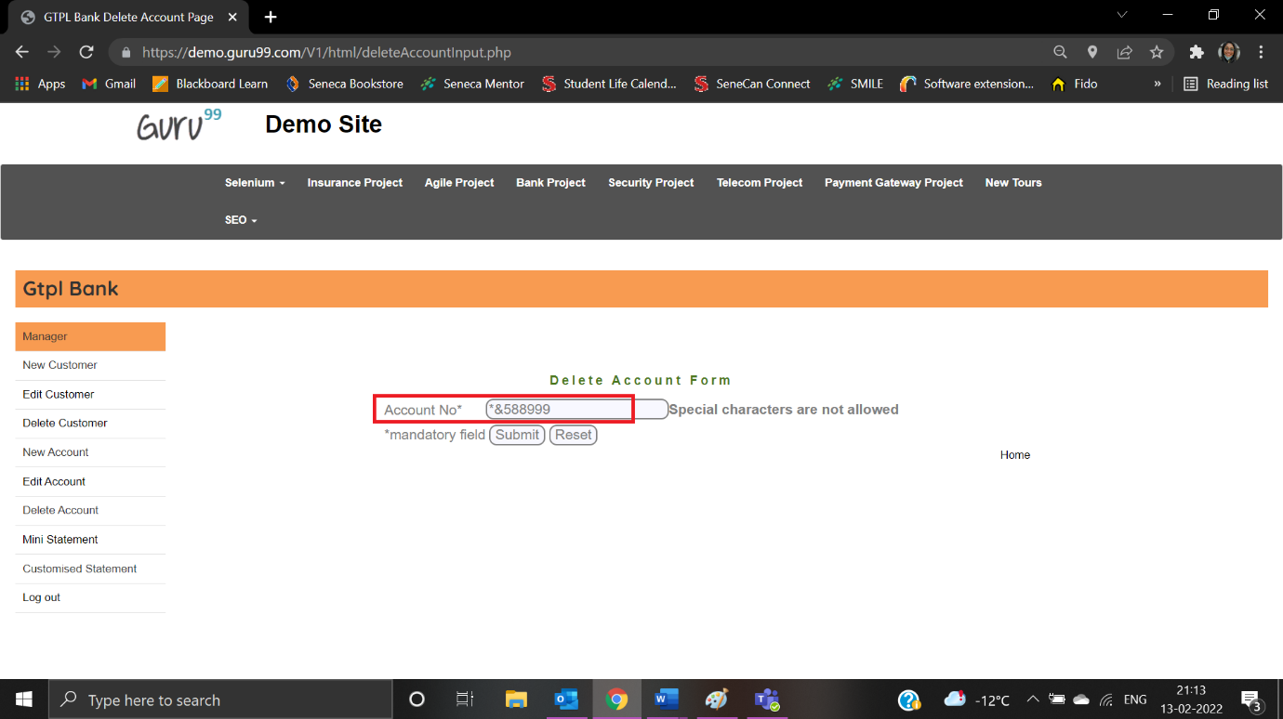

Error message is displayed:

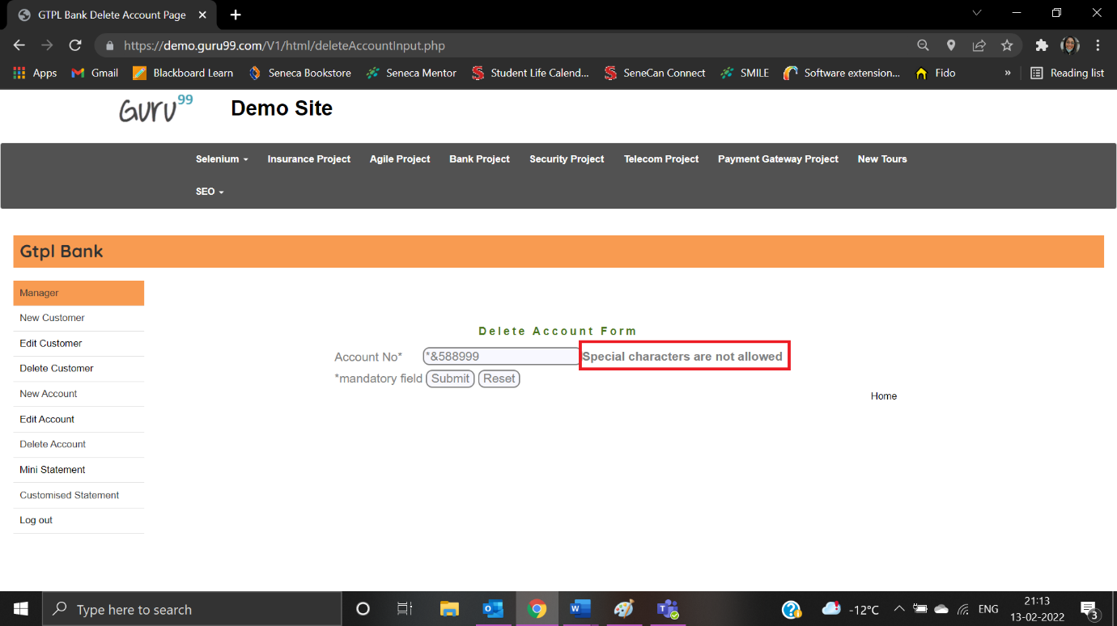

|  |  |
| --- | --- |
| Test Case ID: TDA2 | Test Result: Passed |
| Details: Account Number - Letter characters are not allowed | |

User enters account number as “7878M8B”:

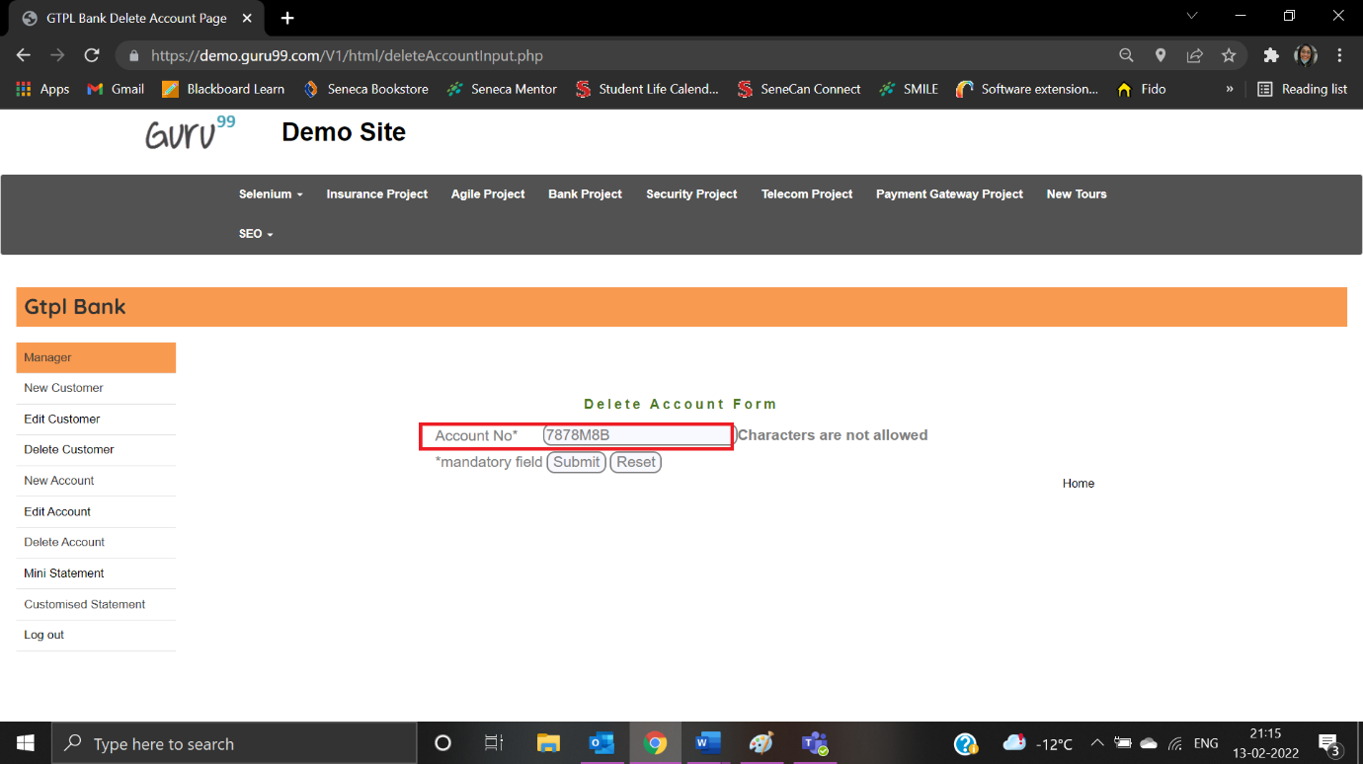

Error message is displayed:

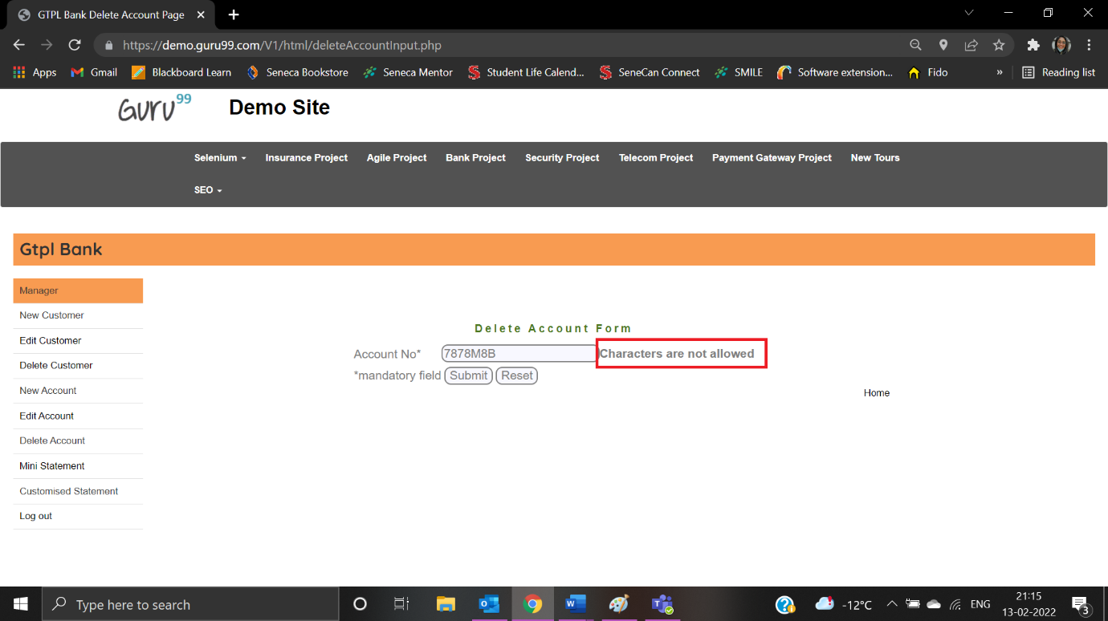

**Delete Customer**

|  |  |
| --- | --- |
| Test Case ID: TDC1 | Test Result: Passed |
| Details: Customer Id - Customer ID is required | |

User clicks on Delete Customer:

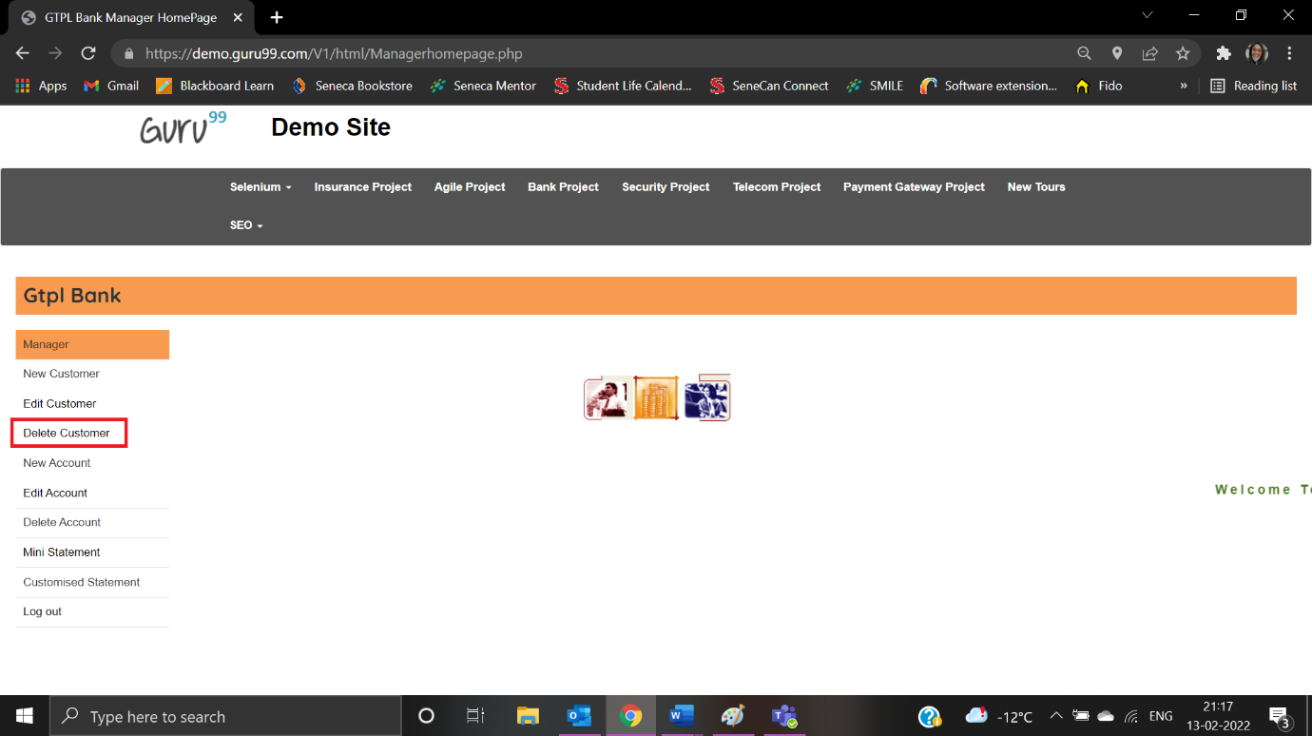

User is navigated to Delete Customer Form:

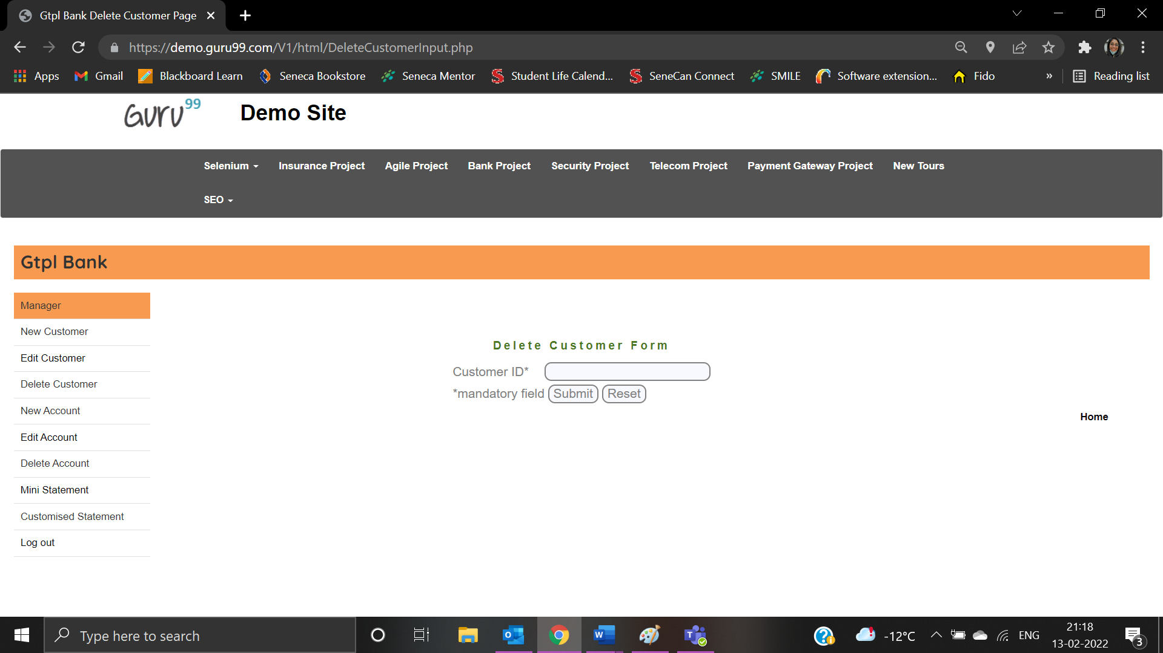

|  |  |
| --- | --- |
| Test Case ID: TDC2 | Test Result: Passed |
| Details: Customer Id - Special characters are not allowed | |

User enters Customer id as “*&%#99”:

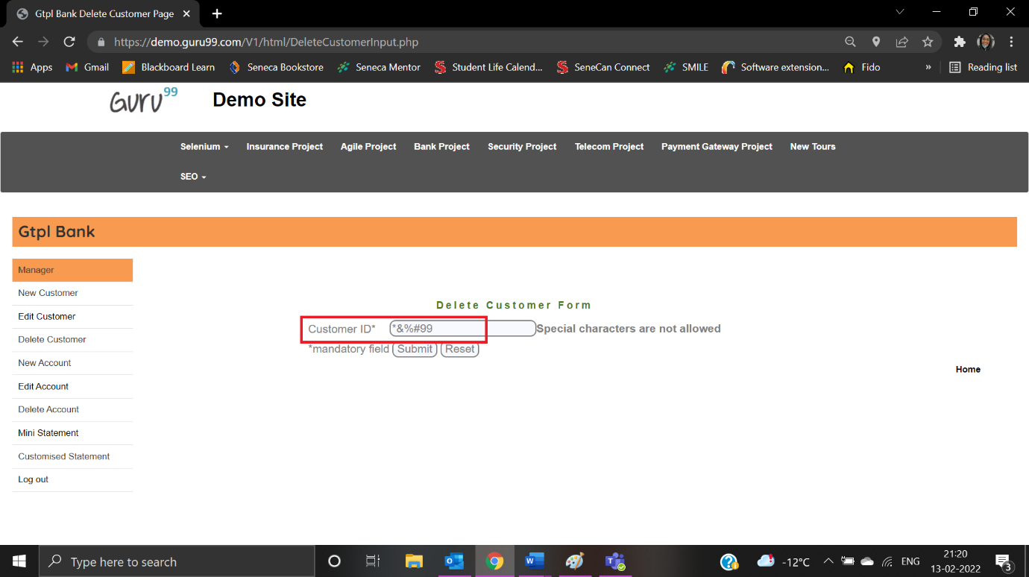

Error message is displayed:

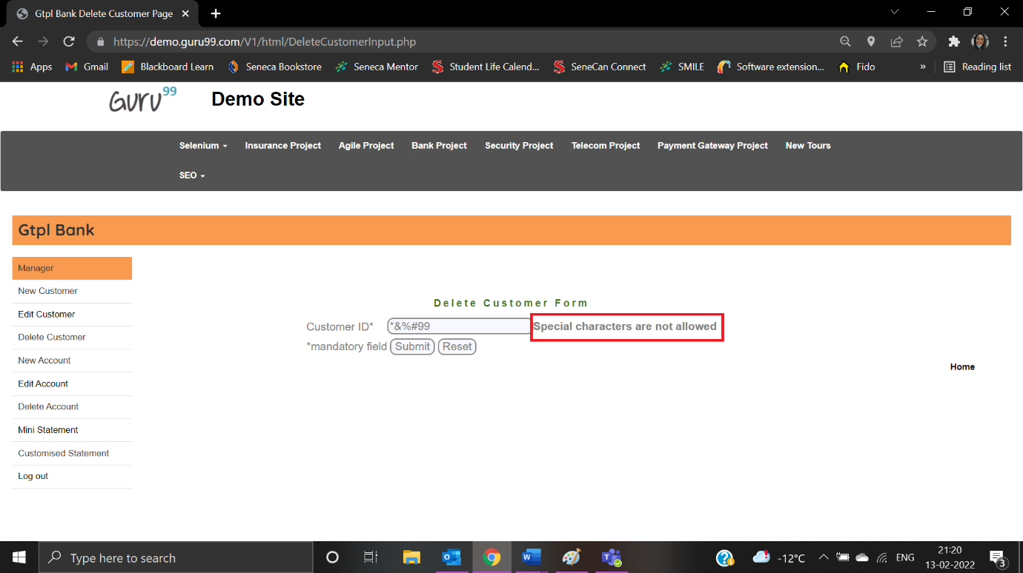

|  |  |
| --- | --- |
| Test Case ID: TDC3 | Test Result: Failed |
| Details: Customer Id - Letter Characters are not allowed | |

User enters Customer id as “878HGF3”:

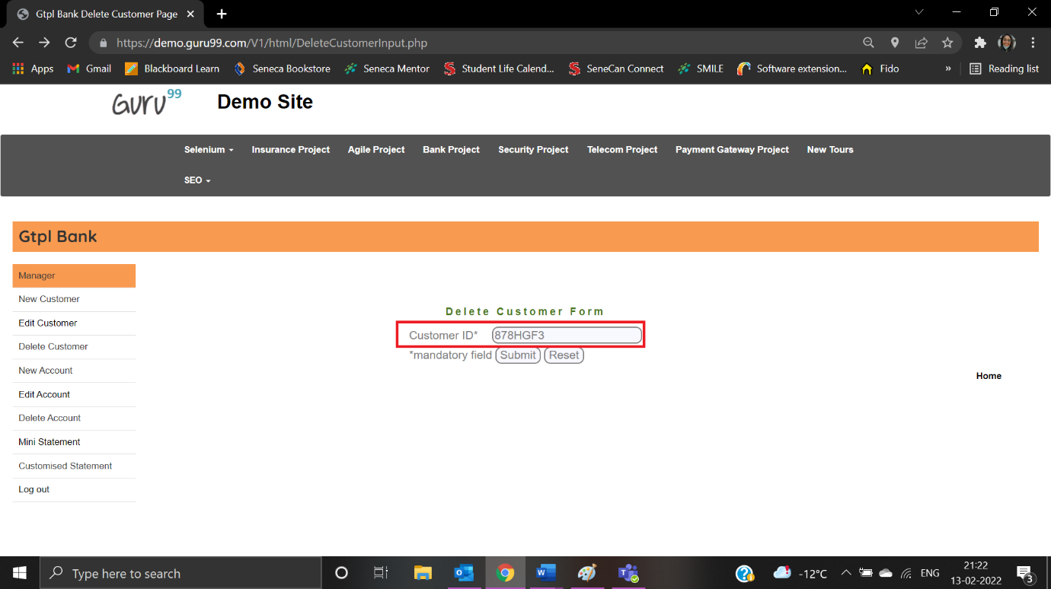

Error message is not displayed:

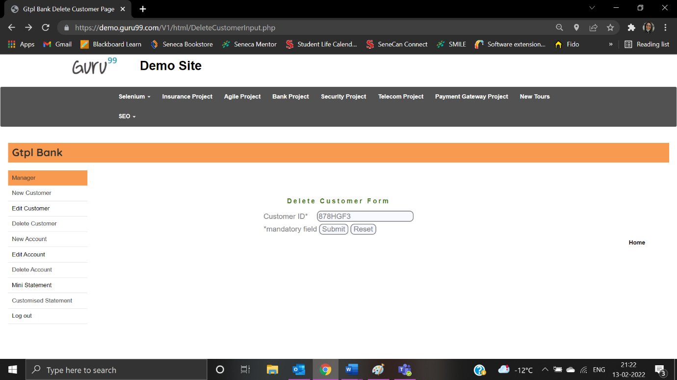

|  |  |
| --- | --- |
| Test Case ID: TC09 | Test Result: Failed |
| Details: Customer Id – The first character cannot have space | |

User enters customer id as “ 7878655”:

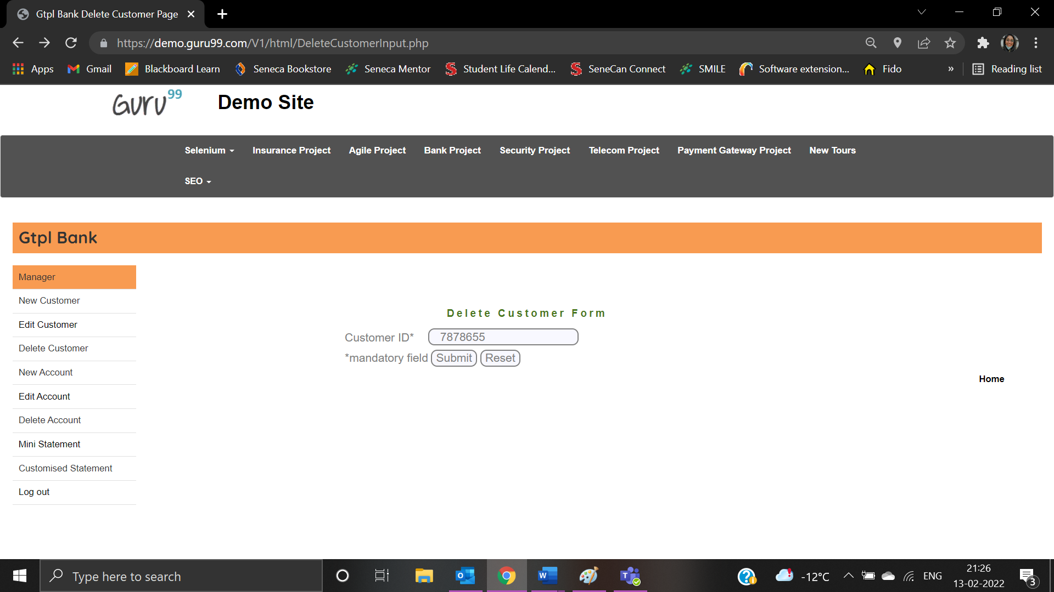

Error message is not displayed:



**Edit Account**

|  |  |
| --- | --- |
| Test Case ID: TEA1 | Test Result: Passed |
| Details: Account No must not be blank | |

User clicks on Edit Account:

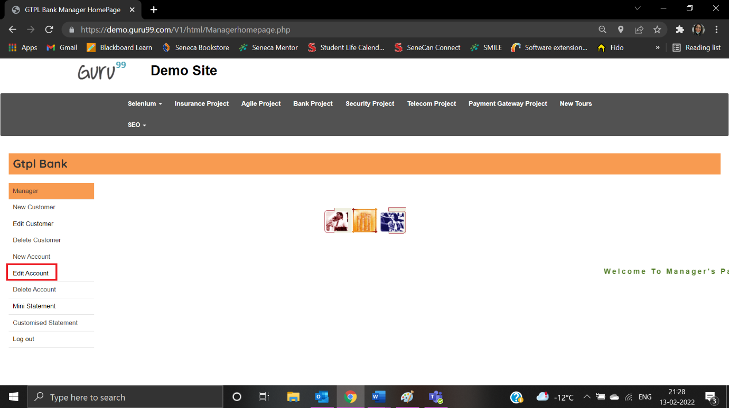

User is navigated to Edit Account Form:

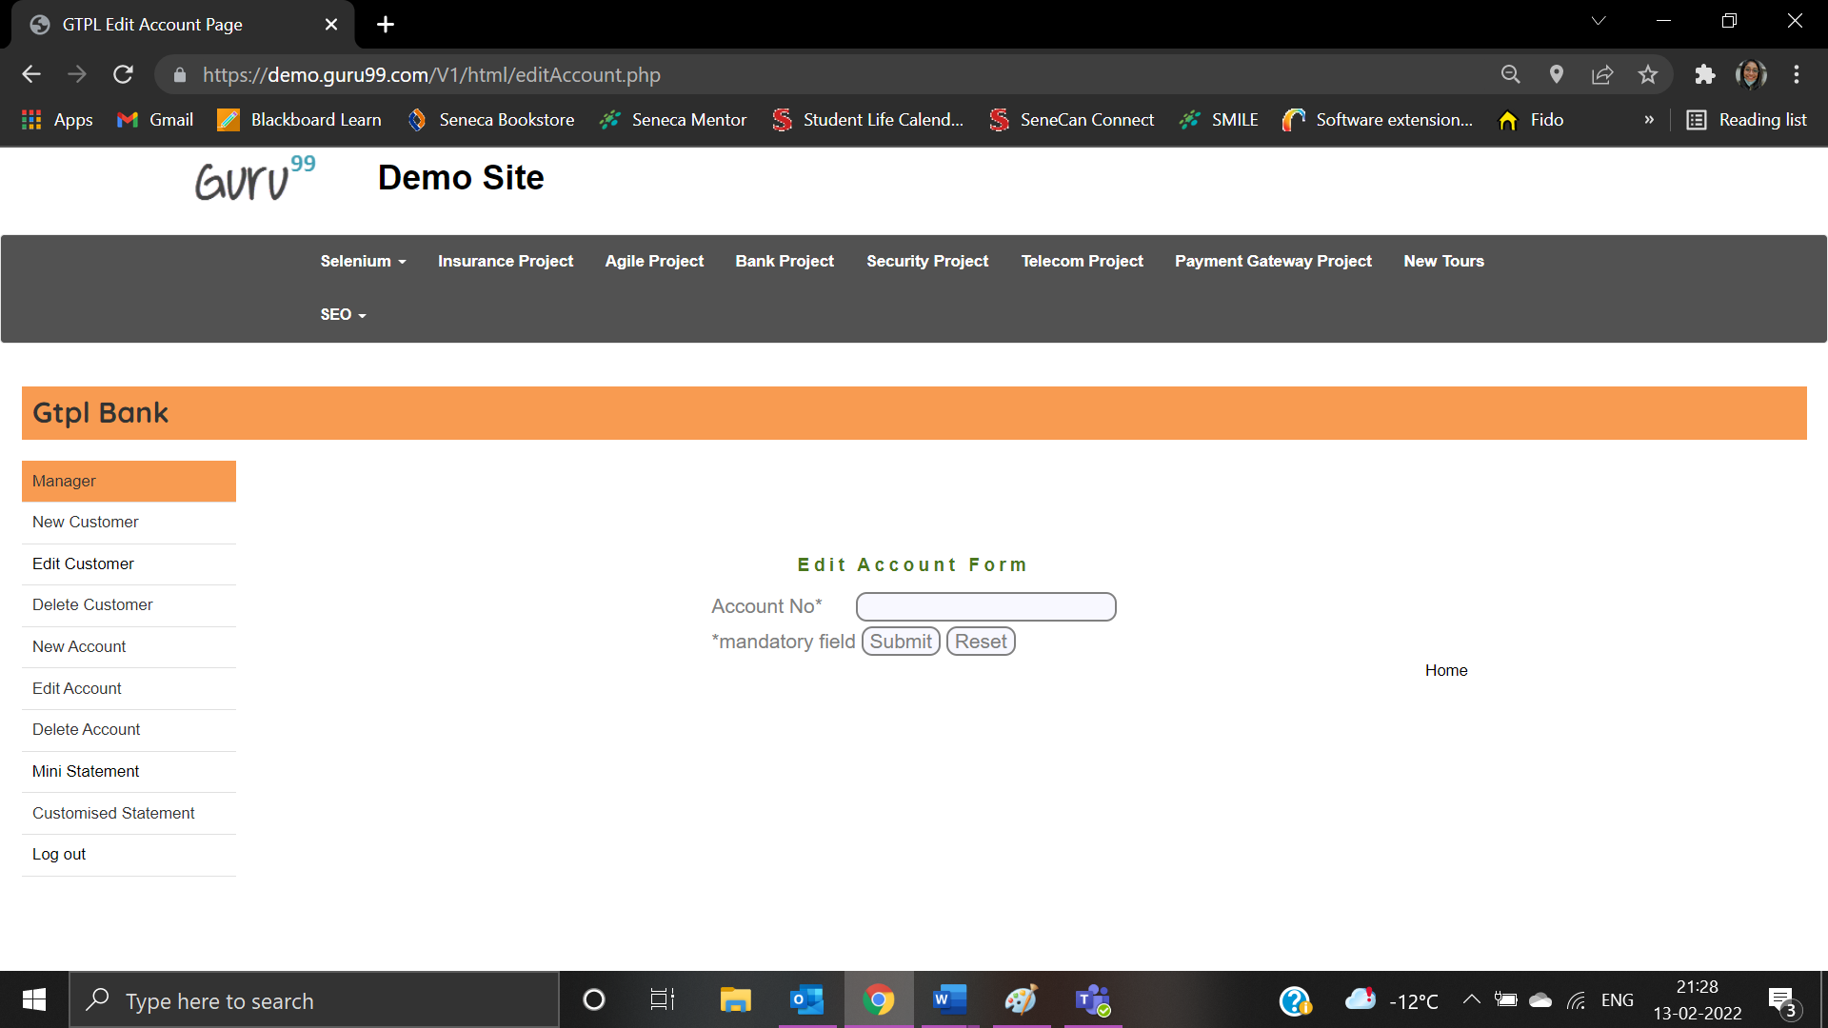

User left account number as blank:

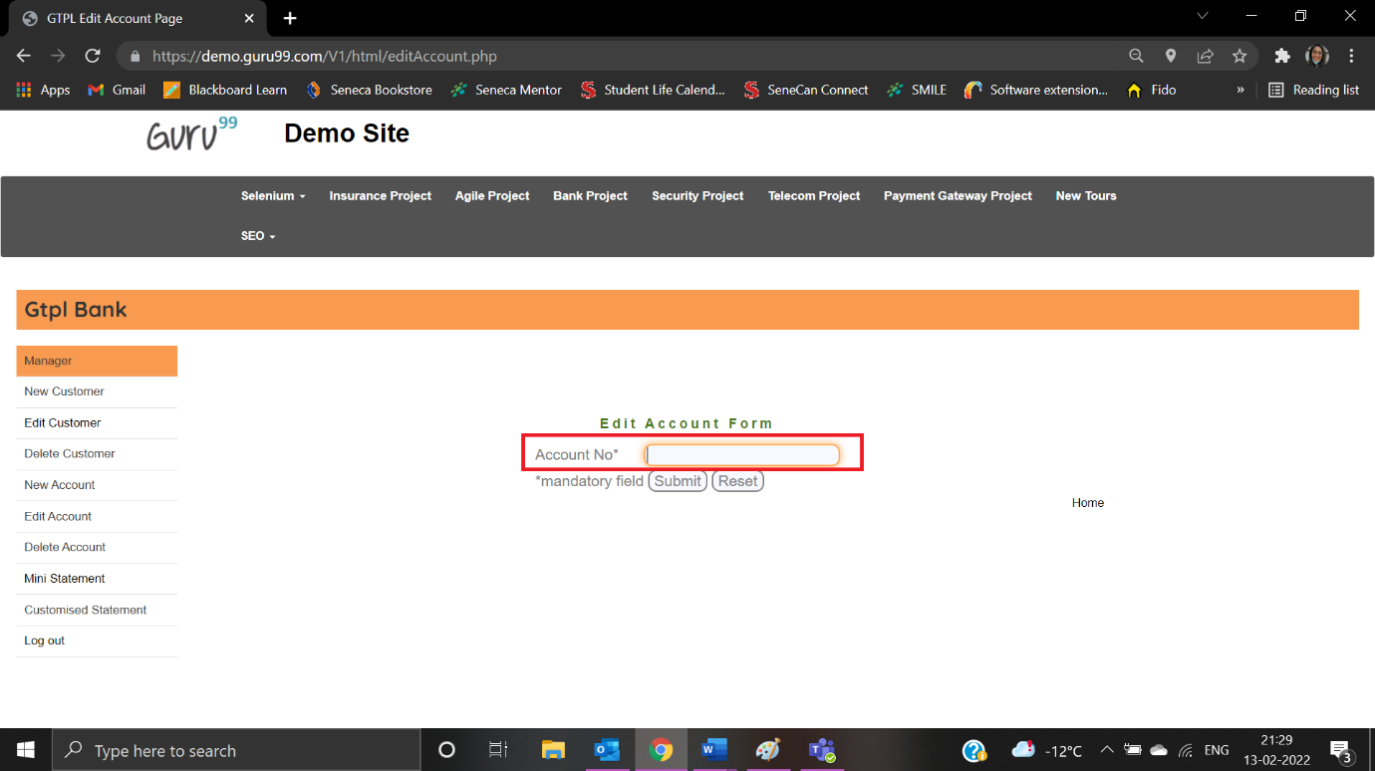

Error message is displayed:

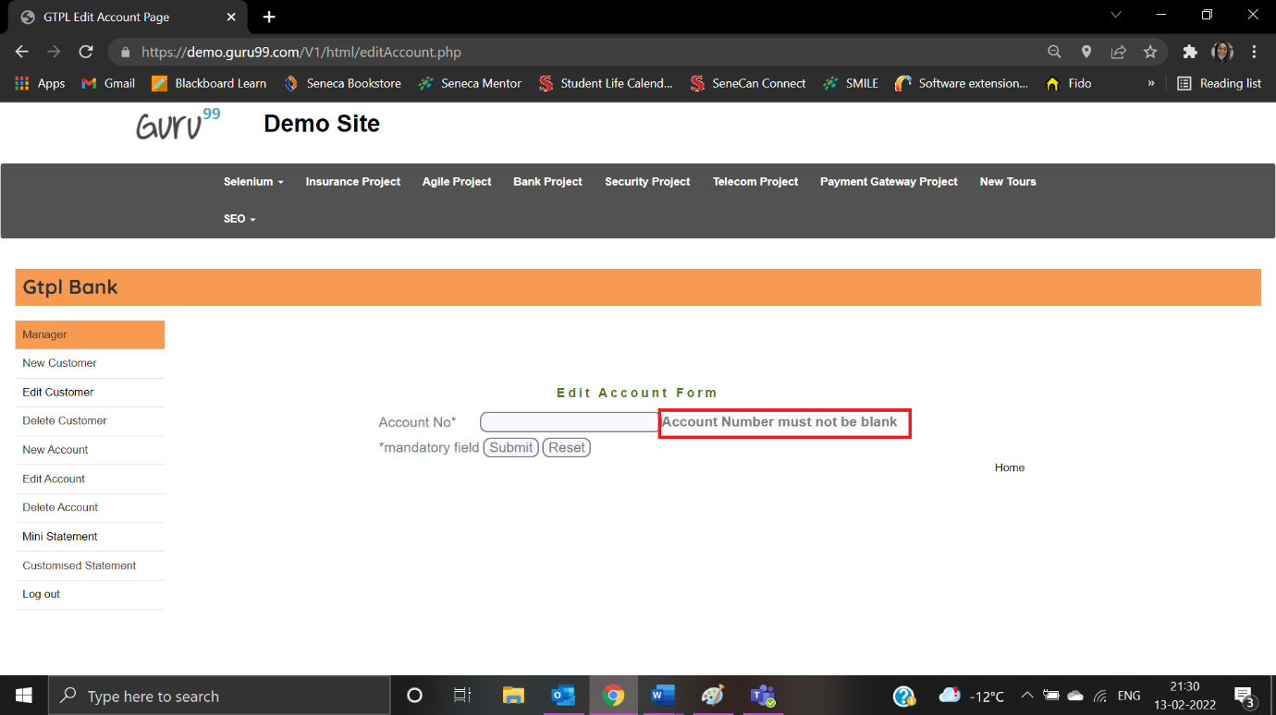

|  |  |
| --- | --- |
| Test Case ID: TEA2 | Test Result: Passed |
| Details: Special characters are not allowed | |

User enters account number as “7878787&88”:

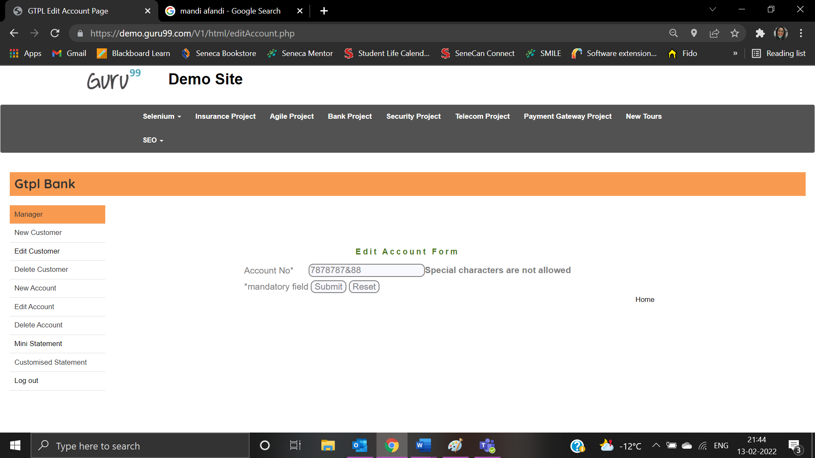

Error message is displayed:

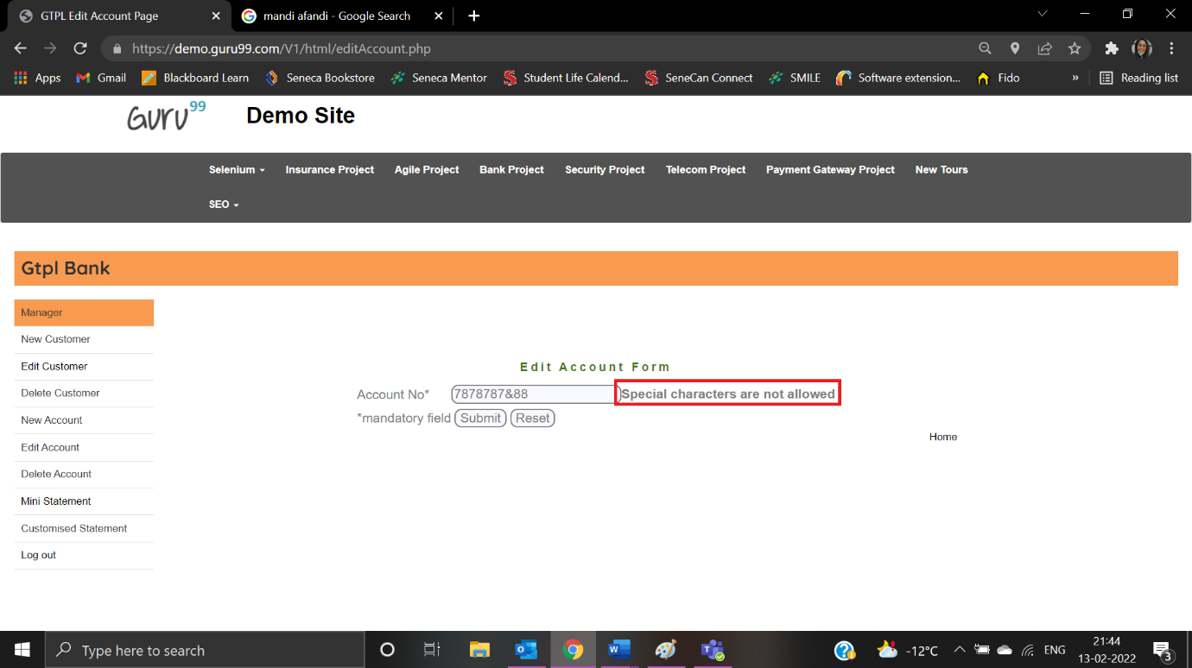

|  |  |
| --- | --- |
| Test Case ID: TNA1 | Test Result: Passed |
| Details: Letter characters are not allowed | |

User enters account number as “78782HJ556”:

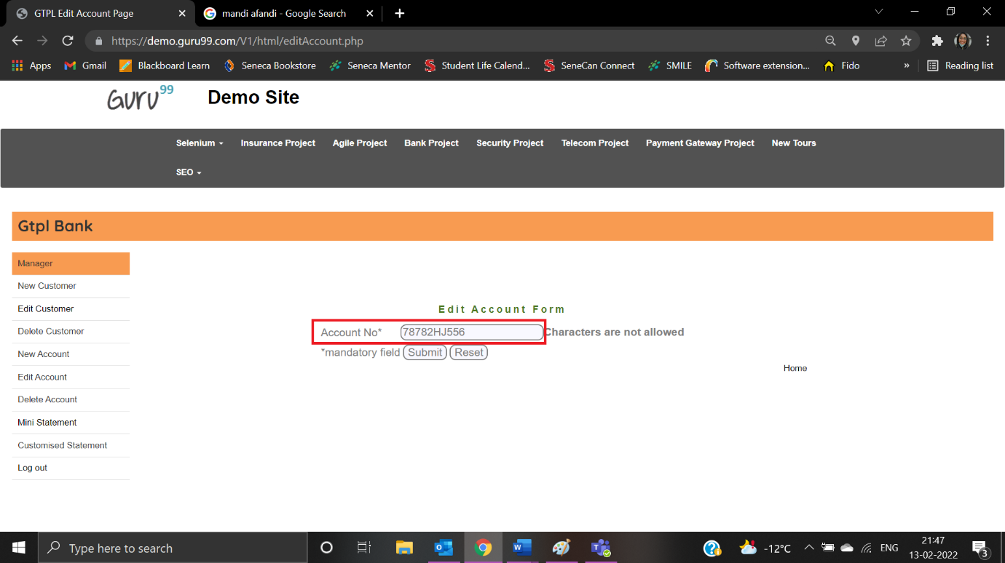

Error message is displayed:

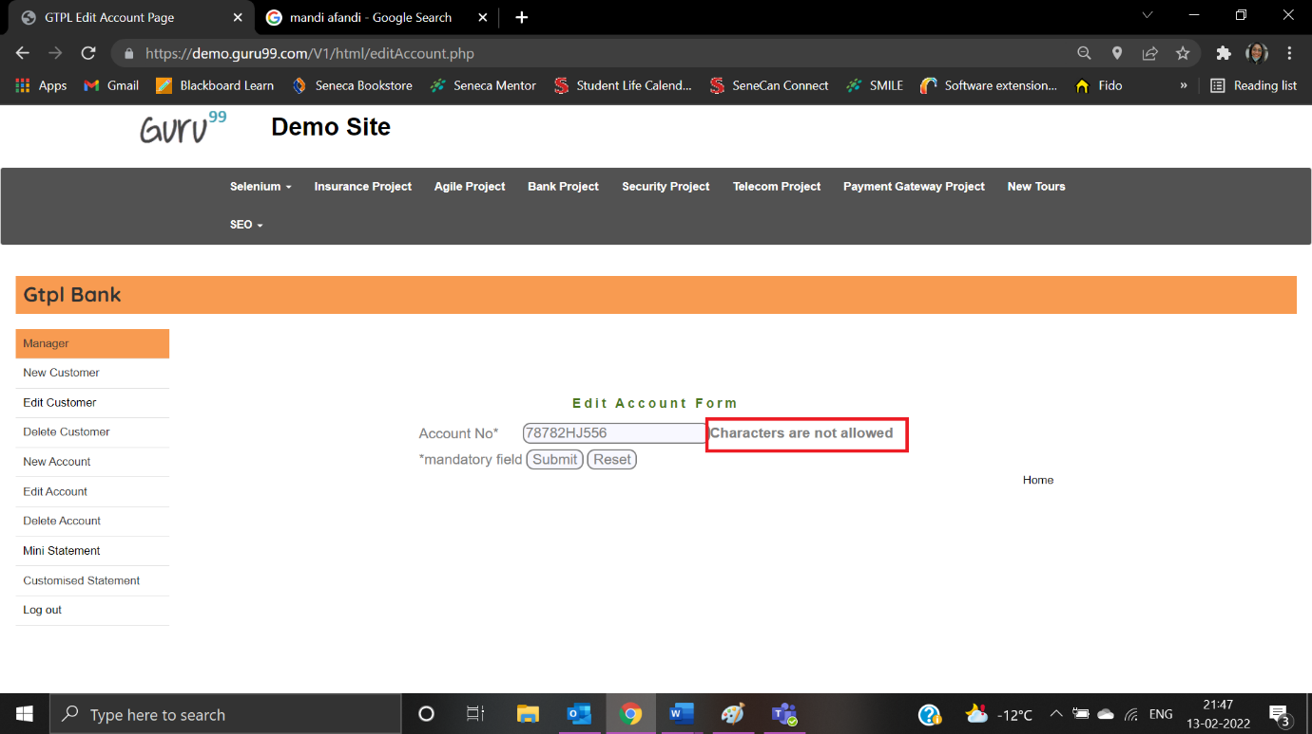

**Edit Customer form**

|  |  |
| --- | --- |
| Test Case ID: TEC1 | Test Result: Passed |
| Details: Customer Id - Customer ID is required | |

User clicks on Edit Customer:

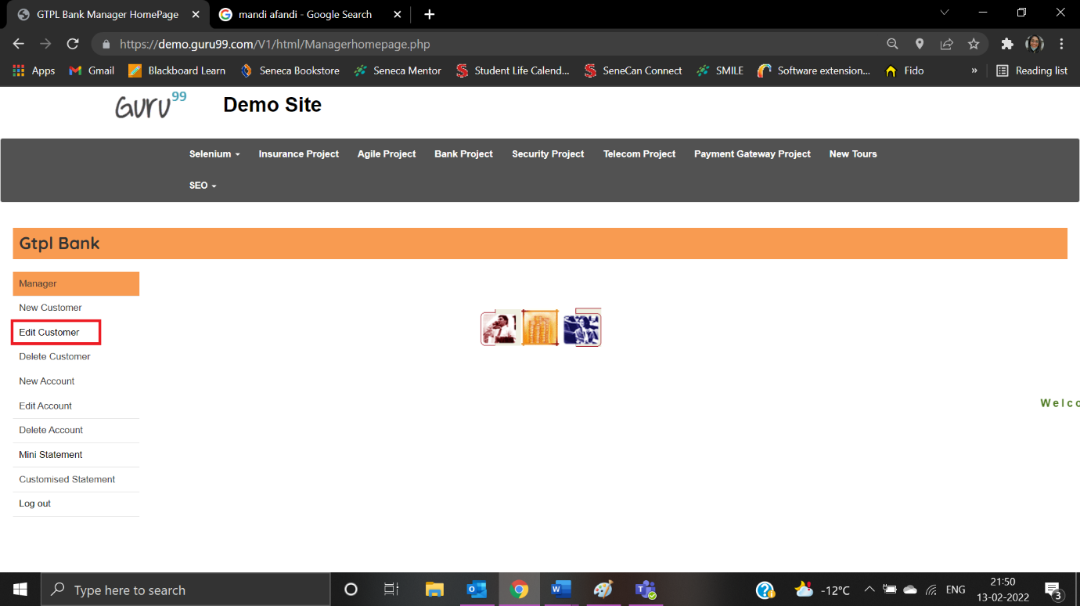

User is navigated to Edit Customer Form:

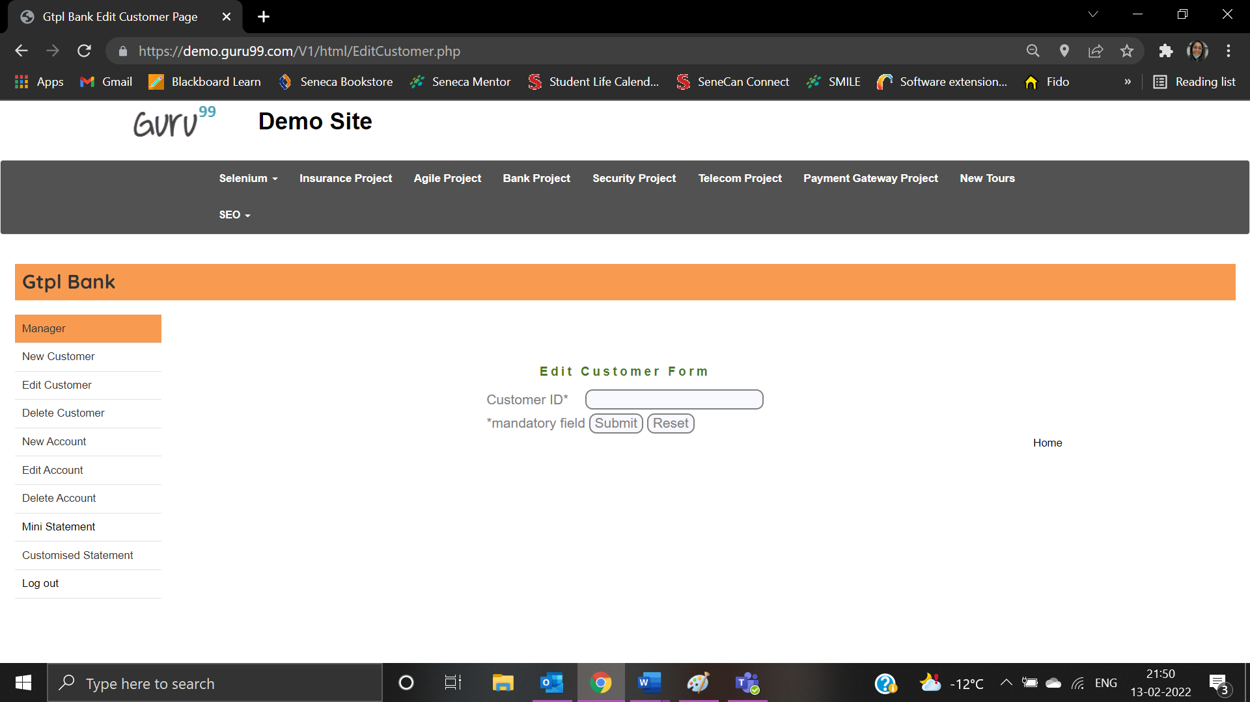

Customer ID field is left blank:

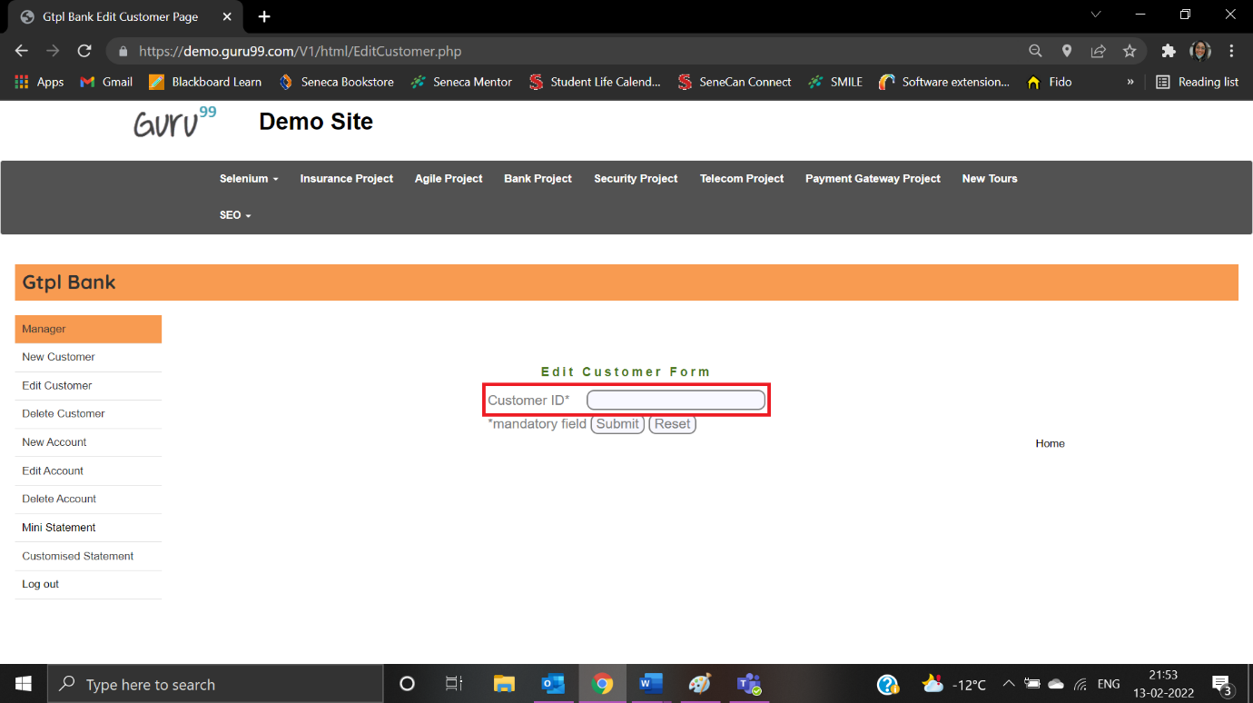

Error message is displayed:

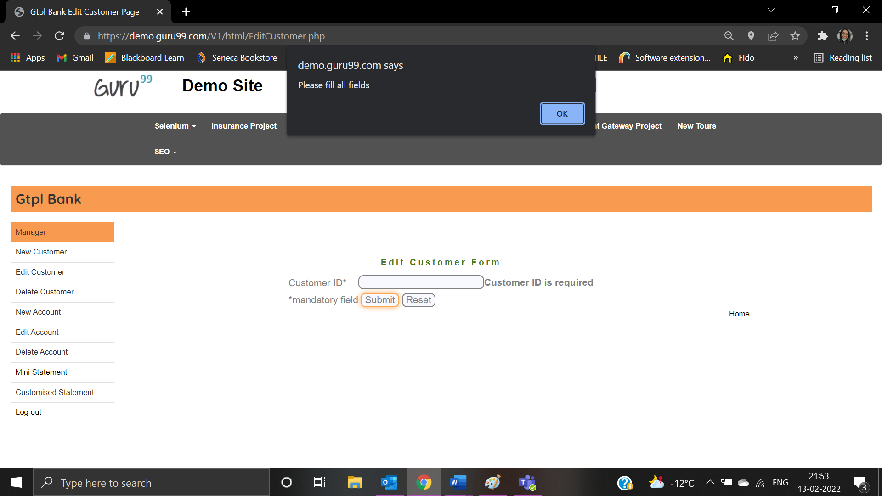

|  |  |
| --- | --- |
| Test Case ID: TEC2 | Test Result: Passed |
| Details: Customer Id - Special characters are not allowed | |

User enters customer id as “4361467@76”:

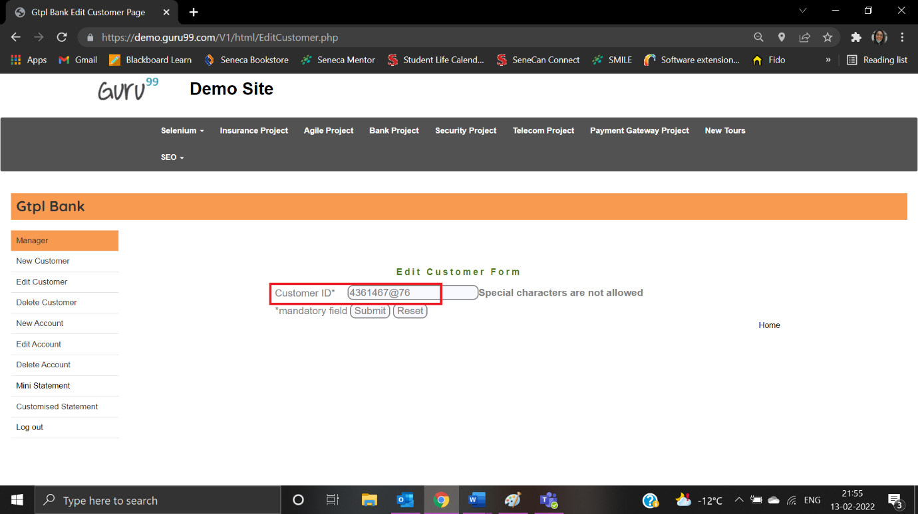

Error message is displayed:

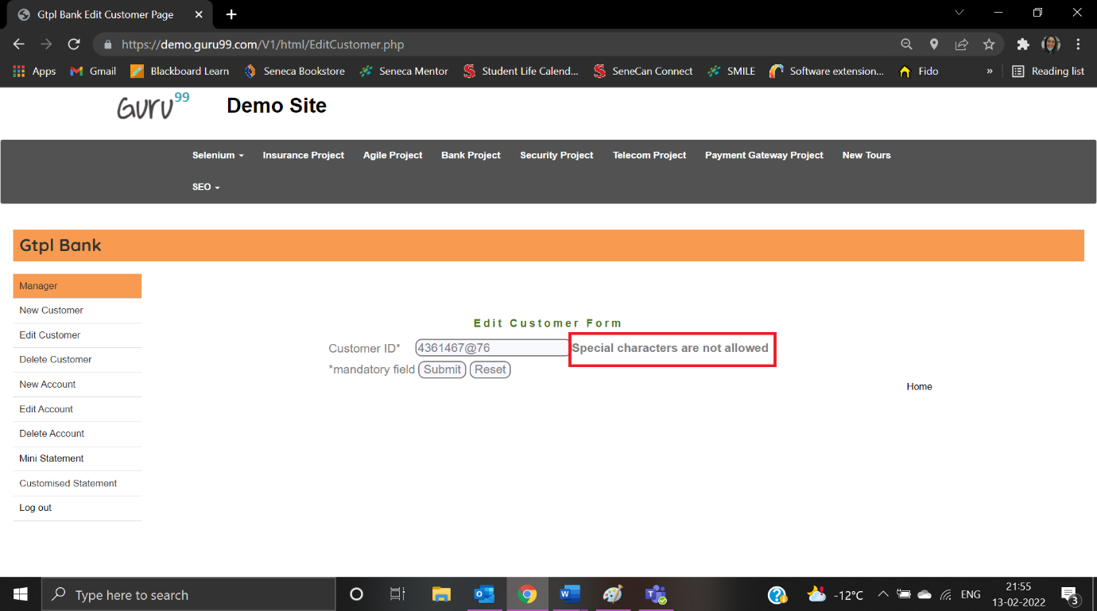

|  |  |
| --- | --- |
| Test Case ID: TEC3 | Test Result: Failed |
| Details: Customer Id - Characters are not allowed | |

User enters customer id as “4353G766”:

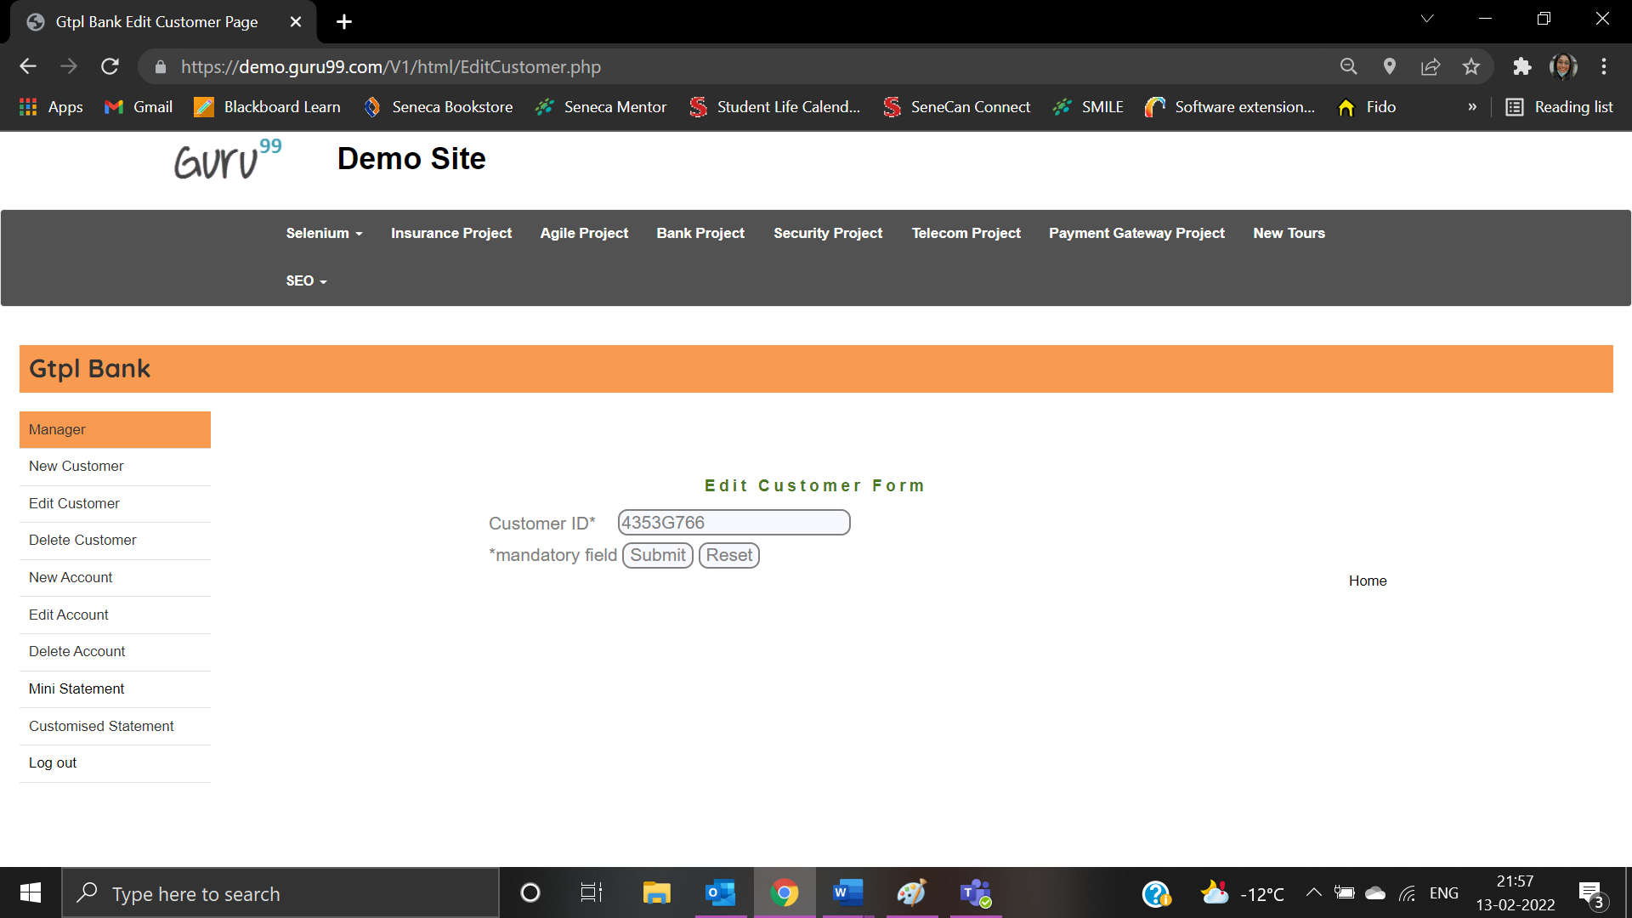

Error message is not displayed:



|  |  |
| --- | --- |
| Test Case ID: TC10 | Test Result: Failed |
| Details: Customer Id – The first character cannot have space | |

User enters customer id as “ 9865377”:

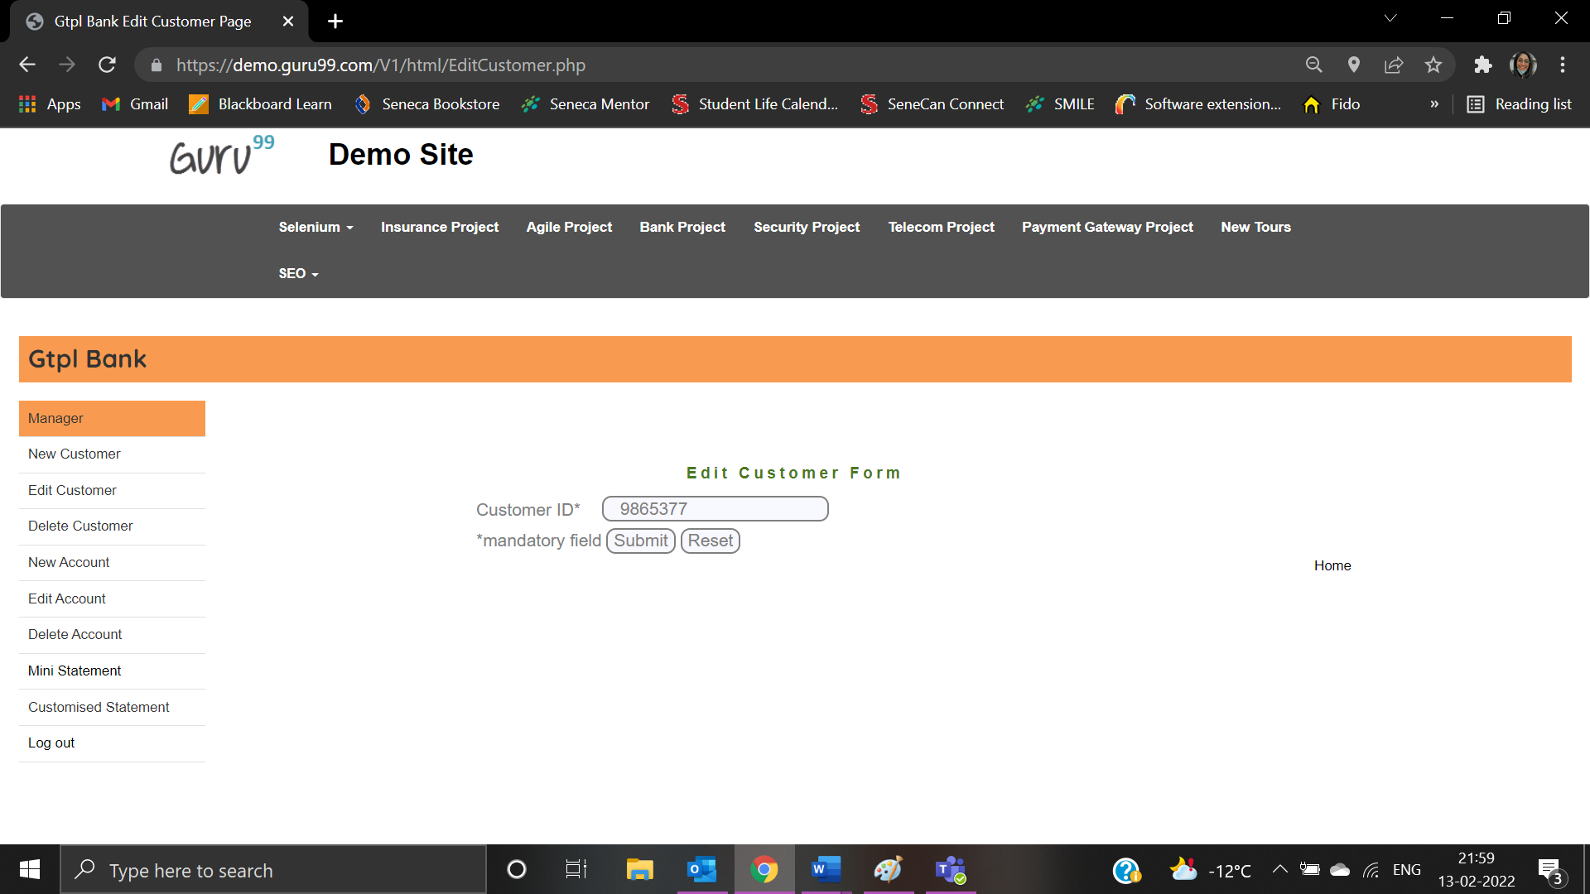

Error message is not displayed:



**Mini Statement Page**

|  |  |
| --- | --- |
| Test Case ID: TMS1 | Test Result: Passed |
| Details: Account Number must not be blank | |

User clicks on Mini Statement:

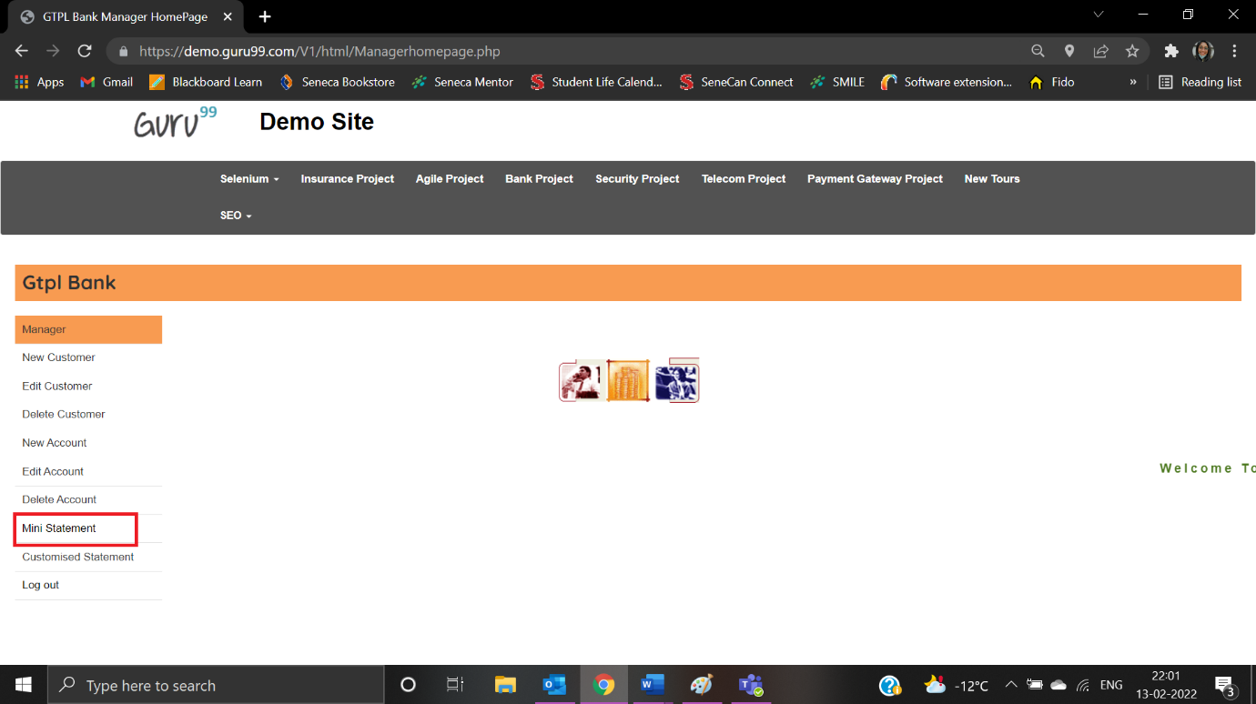

User navigates to Mini Statement Form:

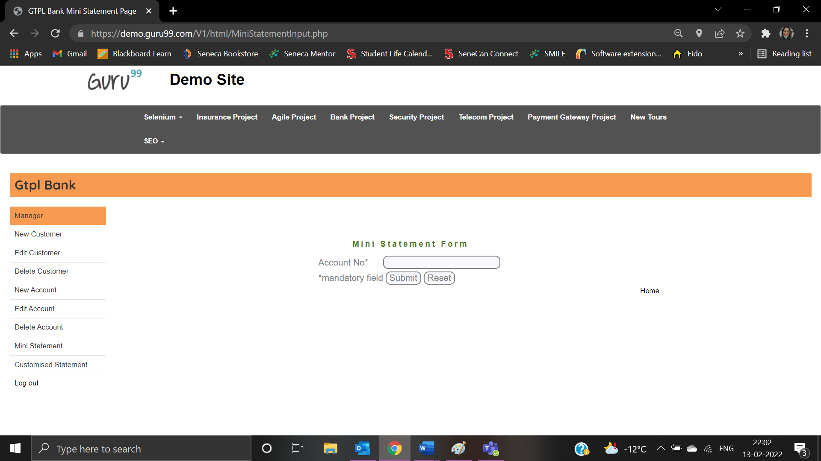

User left account number as blank:

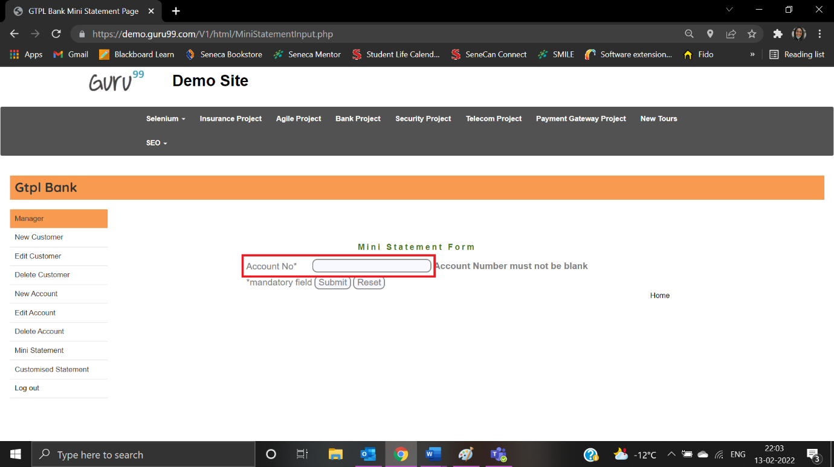

Error message is displayed:

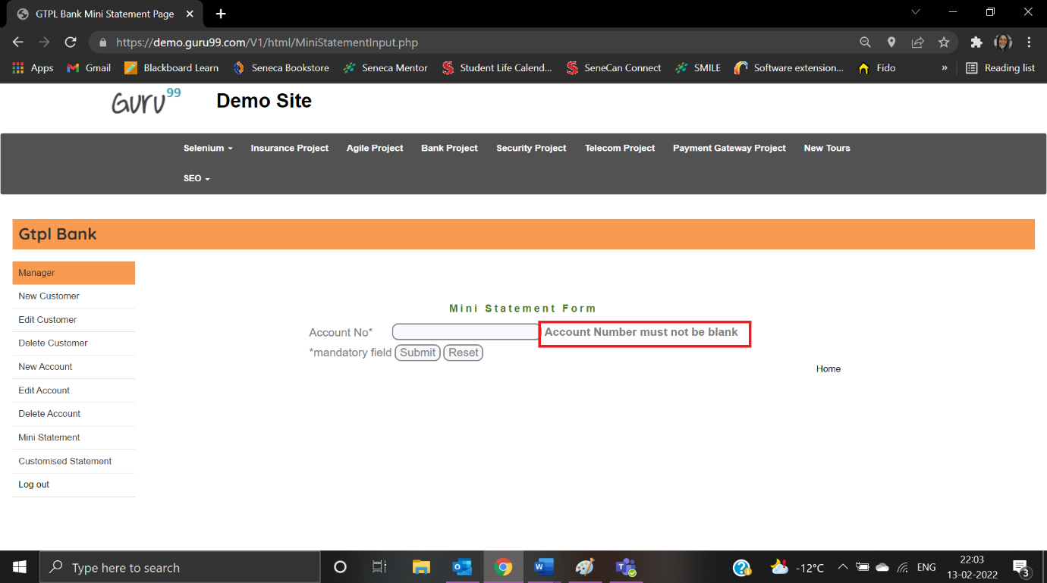

|  |  |
| --- | --- |
| Test Case ID: TNA1 | Test Result: Passed |
| Details: Special characters are not allowed | |

User enters “246624*67”:

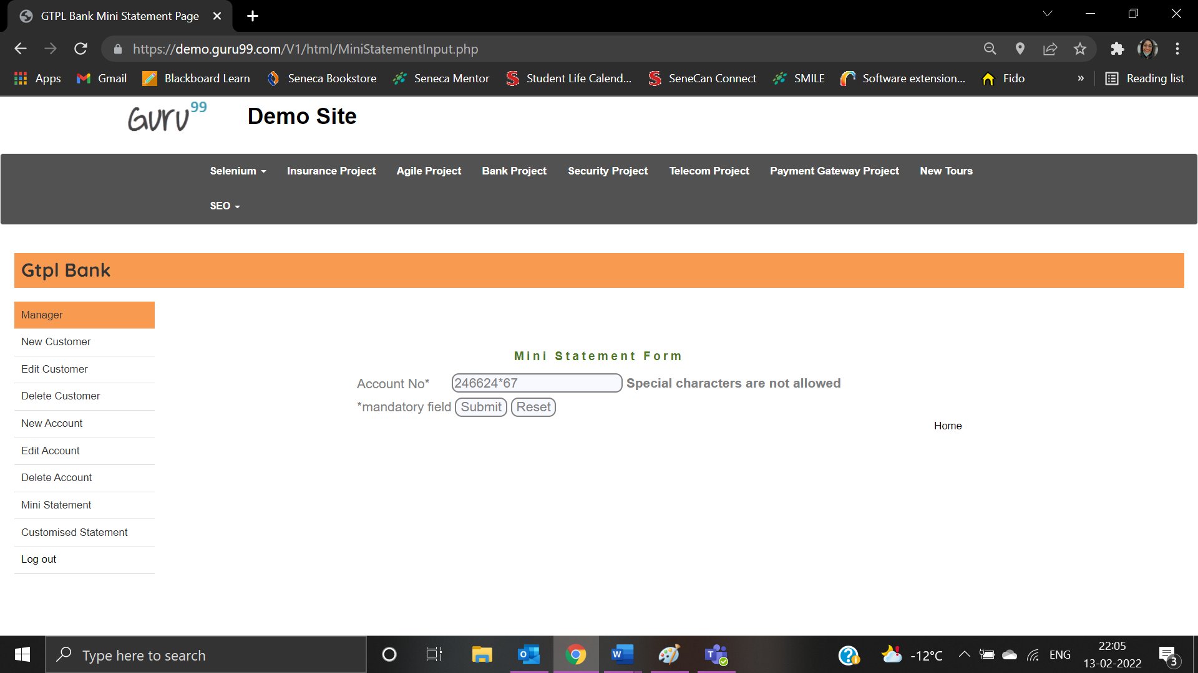

Error message is displayed:

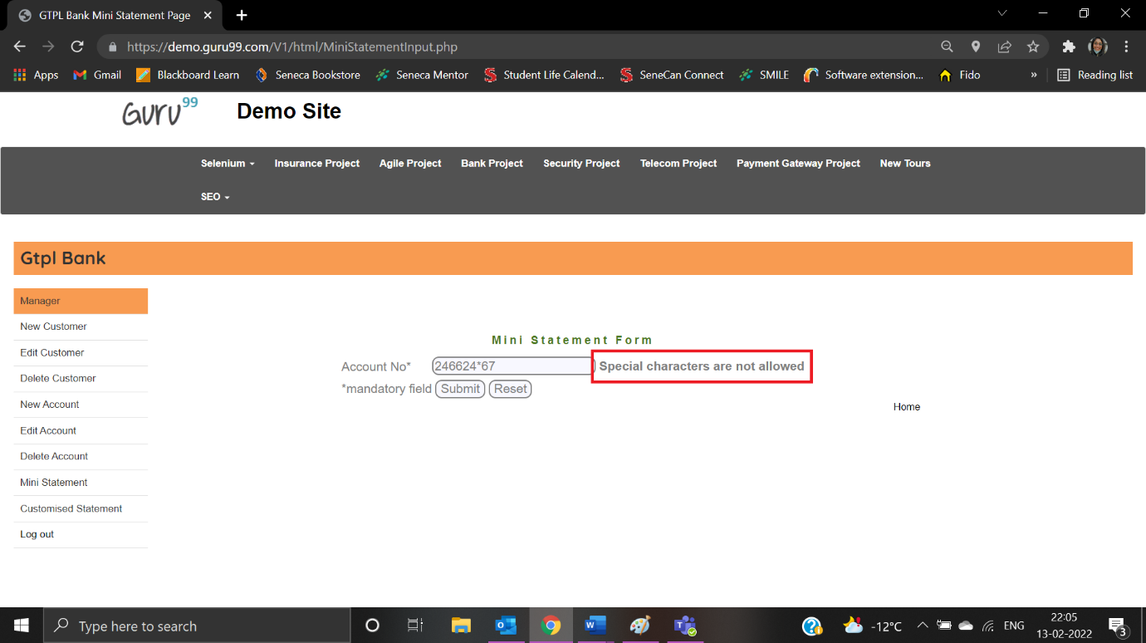

|  |  |
| --- | --- |
| Test Case ID: TMS3 | Test Result: Passed |
| Details: Characters are not allowed | |

User enters “4553AG676”:

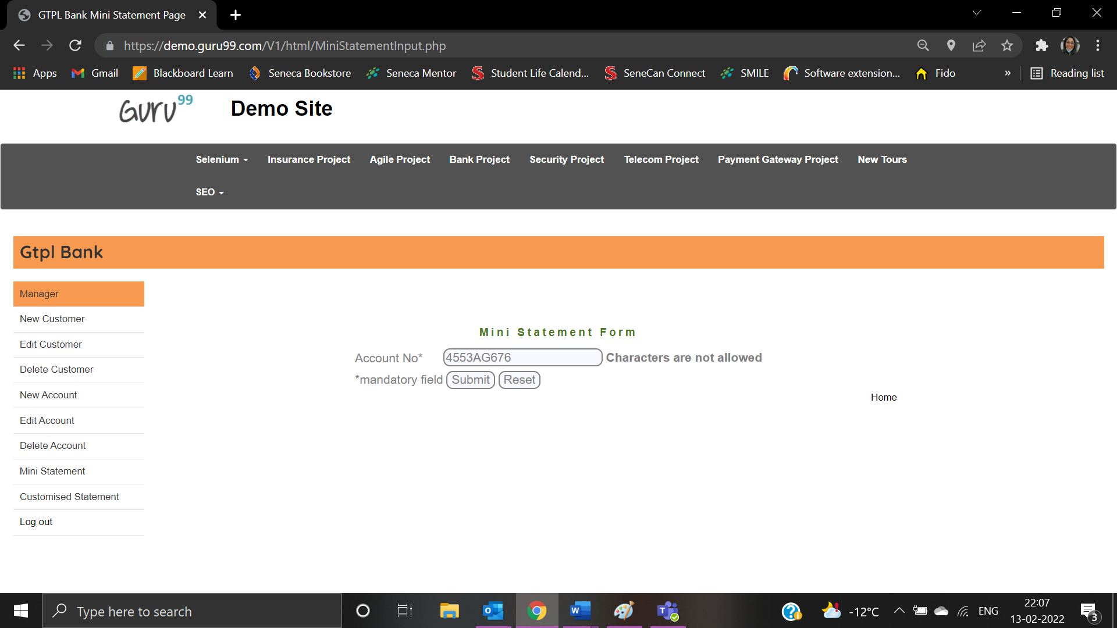

Error message is displayed:

